NAME:………………………………………….ADMNO……………………..CLASS……

**MATHEMATICS**

**PAPER 1**

**2 ½ H FORM 4 TERM 1 OPENER (ENTRY) EXAM**

INSTRUCTIONS TO DANDIDATES

1. Write your name, index number and class.

2. The paper contains two sections: Section I and II

3. Answer ALL questions in section I and ONLY FIVE questions from section II.

4. All working and answers must be written on the question paper in the spaces provided below each question.

5. Marks may be awarded for correct working even if the answer is wrong.

6. Negligence and slovenly work will be penalized.

7. Non-programmable silent electronic calculators and mathematical tables are allowed for use.

8. This paper consists of 15 printed pages. Candidates should check to ensure that all pages are printed as indicated and no questions are missing

FOR EXAMINER’S USE ONLY

SECTION 1

|  |  |  |  |  |  |  |  |  |  |  |  |  |  |  |  |  |
| --- | --- | --- | --- | --- | --- | --- | --- | --- | --- | --- | --- | --- | --- | --- | --- | --- |
| 1 | 2 | 3 | 4 | 5 | 6 | 7 | 8 | 9 | 10 | 11 | 12 | 13 | 14 | 15 | 16 | TOTAL |
|  |  |  |  |  |  |  |  |  |  |  |  |  |  |  |  |  |

**GRAND TOTAL**

SECTION II

|  |  |  |  |  |  |  |  |  |
| --- | --- | --- | --- | --- | --- | --- | --- | --- |
| 17 | 18 | 19 | 20 | 21 | 22 | 23 | 24 | TOTAL |
|  |  |  |  |  |  |  |  |  |

121/1

Mathematics

Paper1

**SECTION I**

**Answer all questions in this sections**

1. Remove the brackets and simplify (2mks)

2p – (4q –p) + 3q

1. Evaluate the equation (3mks)

$\frac{3x-1}{4}-\frac{2x+1}{2}=\frac{3}{8 }$

1. Find all the integral values of x which satisfy the inequalities (3mks)

2(3-2x)> 1+3x $≥2x-6$

1. A scientific calculator whose marked price is sh1200 is sold to a customer after allowing him a discount of 18%. If the trader still made a profit of 25%, calculate the profit the trader would have made if no discount was given (3mks)

2

1. The sum of a two digit number is 15. When the digits are reversed the value of the new number exceeds the original number by 9. What is the original number? (4mks)
2. Two similar solids have surface areas 48cm2 and 108cm2 respectively. Find the volume of the smaller solid if the bigger one has a volume of 162cm3 (4mks)
3. (a) Using a ruler and a pair of compasses only, construct a triangle ABC such that AB=4cm BC=6cm and angle ABC=135 $°$ (2mks)

(b) Construct the height of triangle ABC in(a) above taking AB as the base, hence calculate the area of triangle ABC (2mks)

1. Find the values of x and y in (3mks)

$2^{3x+y} x 3^{4x-y}=$ 648

1. A boy whose height is 1.5m stands on a horizontal ground and observes that the top of a flag pole, 10m away, makes angle of elevation of 40 $°$. Calculate the height of the flag post (3mks)
2. A Kenyan bank buys and sells foreign currency as shown in the table below.

|  |  |  |
| --- | --- | --- |
|  | Buying (Ksh) | Selling (Ksh) |
| 1 US dollar | 75.34 | 95.87 |
| 1 UK pound | 124.65 | 125.13 |

A tourist arrived in Kenya with 15000 UK pounds which he converted into Ksh at a commission of 8%. He later used half of the money before changing the balance into dollars at no commission. Calculate to the nearest dollar the amount he received (3mks)

1. The point P(5,4) is mapped ontoP1(9,3) under a translation T. Find the co-ordinates of the image of Q(6,3) under the same translation (3mks)
2. Determine the radius of a uniform cylindrical block 1.4m long and a density of 2.2g/cm3 if the mass is 47432g (π = ${22}/7$) (3mks)
3. Given that Cos (2*x*)0= Sin (2*x* -30)0, calculate the value of x (2mks)
4. Using tables, find the reciprocal of 0.432 and hence evaluate $\frac{\sqrt{0.1225}}{0.432}$ (3 mks)
5. The interior angle of a regular polygon is three and a half times the exterior angle. Determine the sides of the polygon (3mks)
6. Solve the equation (4mks)

$\frac{x+3}{24}=\frac{1}{x-2}$

**SECTION II (ANSWER ONLY FIVE QUESTIONS)**

1. The data below shows marks scored by 48 students in a geography exam

|  |  |  |  |  |  |  |
| --- | --- | --- | --- | --- | --- | --- |
| Marks | 30-39 | 40-49 | 50-59 | 60-69 | 70-79 | 80-89 |
| Students | 6 | 10 | X | 9 | 12 | 2 |

1. Determine the value of x (2mks)
2. State the modal class (1mk)
3. Calculate the mean mark (3mks)
4. Calculate the median mark (4mks)
5. A solid P is made of a cylindrical part and a conical part. The height of the solid is 4.5m. The common radius of the cylindrical part and the conical part is 0.9m. The height of the conical part is 1.5m. Taking $π$ as ${22}/7$
6. Calculate, correct to 1 decimal place
7. The volume of solid P (4mks)
8. The total surface area of solid P (4mks)
9. A square base pillar of side 1.6m has the same volume as solid P. Determine the height of the pillar, correct to 1 decimal place (2mks)
10. Nyongesa is a sales executive earning a salary of Ksh120,000 and a commission of 8% for the sales in excess of Ksh1,000,000. If in January he earned a total of Ksh480,000 in salaries and commission.
11. Determine the amount of sales he made in the month of January (4 mks)
12. If the total sales in the month of February increased by 18% and the month of March dropped by 30% respectively. Calculate
13. Nyongesa’s commission in the month of February (3mks)
14. His total earnings in the month of March (3mks)
15. The average speed of a pick-up was 20km/hr faster than the average speed of a lorry. The pick-up took 45 minutes less than the lorry to cover a distance of 180km.
16. If the speed of the lorry was *x* km/hr.
17. Write expressions in terms of x for the time taken by the lorry and pick-up respectively to cover the distance of 180km (2mks)
18. Determine the speed of the lorry and that of the pick-up (5mks)
19. The distance between towns A and B is 240km. On a certain day the pick-up started from town A at 8.30a.m and the lorry started from town B at the same time. Determine the time that the lorry and pick-up met (3mks)
20. The vertices of a rhombus ABCD are A(1,0), B(5,3) C(K,8) and D(1,5)
21. Determine the equation of the perpendicular bisector of the diagonal BD of the rhombus. Leave your answer in the form y = mx+c (4mks)
22. Determine the value of K in the coordinates of C (K,8) (2mks)
23. Determine the length of diagonal AC and diagonal BD hence find the area of the rhombus to the nearest whole number (4mks)
24. Four towns R,T,K and G are such that T is 84 km directly to the North of R. K is on bearing of 295 $°$ from R at a distance of 60km. G is on a bearing of 340 $°$ from K at a distance of 30km.
25. Using a scale of 1cm represent 10km, make an accurate drawing to show the relative positions of the four towns (5mks)
26. Find
27. Distance and bearing of T from K (2mks)
28. The distance and the bearing of G from T (2mks)
29. The bearing of R from G (1mk)
30. (a) On the grid below plot triangle A(3,6) B(1,4), C(5,5) and its image AI(-5,6)

BI(-3,4) and CI(-4,8) under a rotation (2mks)

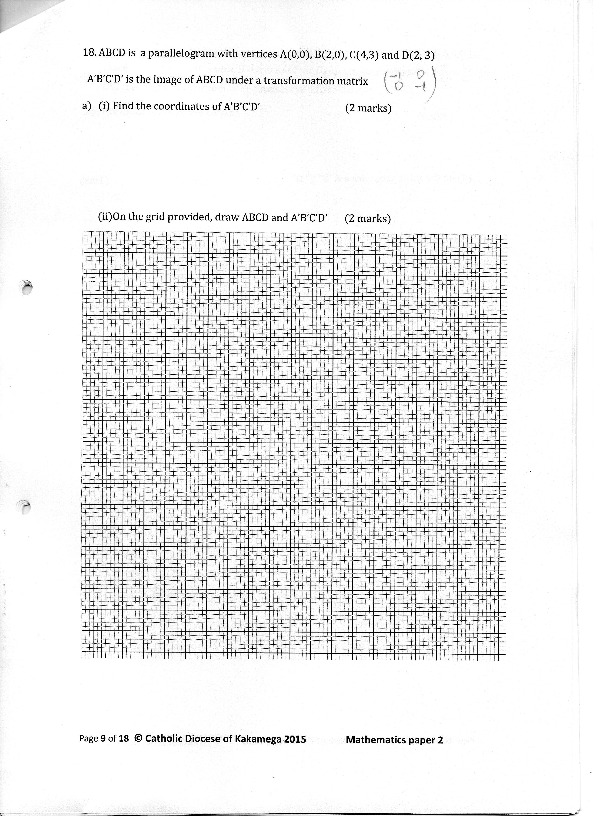

1. Determine the centre and angle of rotation which mapped triangle ABC onto AIBICI (2mks)

b) Triangle AIBICI was translated by the vector $\left(\begin{matrix}1 \\ -10\end{matrix}\right)$ onto triangle AIIBIICII. Draw triangle AIIBIICII on the same grid (2mks)

c) Locate the image of triangle AIBICI under a reflection along the straight line y=x+2. Label the image as AIIIBIIICIII (2mks)

(d) State any pairs of triangles that are (2mks)

1. Oppositely congruent
2. Directly congruent

1. 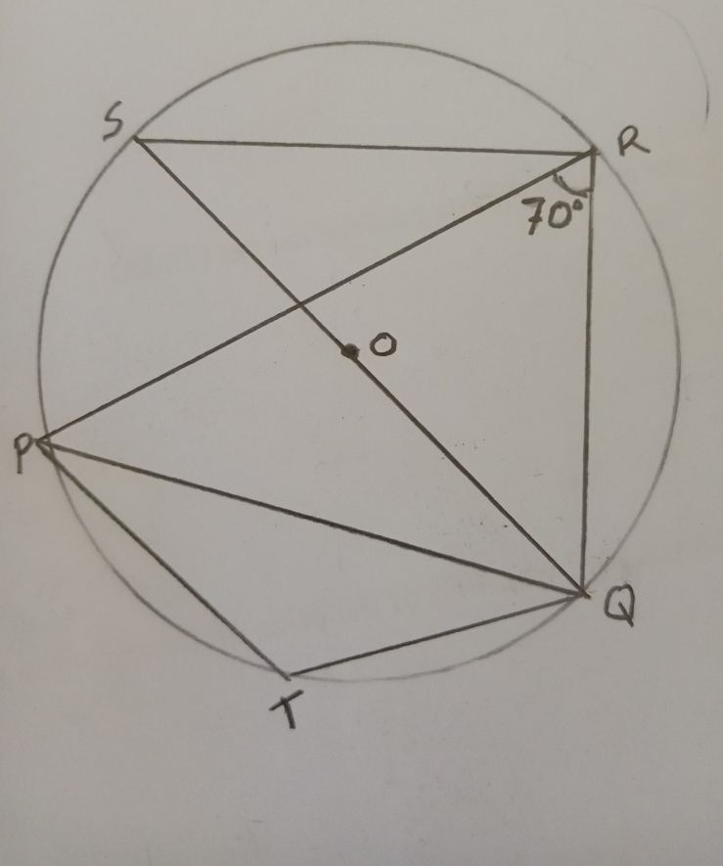In the figure below, PQRS is a cyclic quadrilateral PR=RQ. <PRQ=70 $°$. O is the centre of the circle and QOS is a straight line

Giving reasons for your answers, find the size of angles

1. PRS (2mks)
2. POQ (2mks)
3. RPS (2mks)
4. PSR (2mks)
5. PTQ (2mks)