**Name………………………………………………… Adm. No……………………….**

**School ………………………………………………...**

**121/2**

**MATHEMATICS**

**PAPER 2**

**TIME : 2 ½ Hour**

**FORM 4 TERM 1 OPENER (ENTRY) EXAM 2023**

**INSTRUCTIONS TO CANDIDATES**

1. Write your name and Index number in the spaces provided at the top of this page.
2. The paper contains two sections: Section I and II.
3. Show all the steps in your calculations, giving your answers at each stage in the spaces below each question.
4. Marks may be given for correct working even if the answer is wrong.
5. Non-programmable silent electronic calculators and KNEC Mathematical tables may be used, except where stated otherwise.

### Section I FOR EXAMINER’S USE ONLY

|  |  |  |  |  |  |  |  |  |  |  |  |  |  |  |  |  |  |
| --- | --- | --- | --- | --- | --- | --- | --- | --- | --- | --- | --- | --- | --- | --- | --- | --- | --- |
| **Question** | **1** | **2** | **3** | **4** | **5** | **6** | **7** | **8** | **9** | **10** | **11** | **12** | **13** | **14** | **15** | **16** | **TOTAL** |
| **Marks** |  |  |  |  |  |  |  |  |  |  |  |  |  |  |  |  |  |

## Section II

|  |  |  |  |  |  |  |  |  |  |
| --- | --- | --- | --- | --- | --- | --- | --- | --- | --- |
| **Question** | **17** | **18** | **19** | **20** | **21** | **22** | **23** | **24** | **TOTAL** |
| **Marks** |  |  |  |  |  |  |  |  |  |

**Grand Total**

*This paper consists of 16 printed pages.*

#### Candidates should check the question paper to ensure that all pages are printed as indicated

*and no questions are missing*

**SECTION A (50MARKS)**

1. Express 1080 and 1000 in their prime factors, hence evaluate (3mks)

1080

3 1000

2. Simplify 3x2 – 4xy + y2 (3mks)

9x2 – y2

3. Use logarithms in all your steps to work out. (4mks)

4968

3 87.36 ÷ 6.258

4. Nteei walks for 2 ½ hours in the morning at km/hr and for ½ x hours in the afternoon at 6km/hr. This makes 38 ½ km altogether. How far did she walk in the morning. (3mks)

5. Given that Cos θ = 15/17 and 2700 < θ < 3600. Find without using tables the values of sine θ and tangent θ. (3mks)

6. On the figure below ABX is a tangent, Angle CAB=170 and Angle ACB = 360. Calculate angle CBX and angle DBC. (3mks)

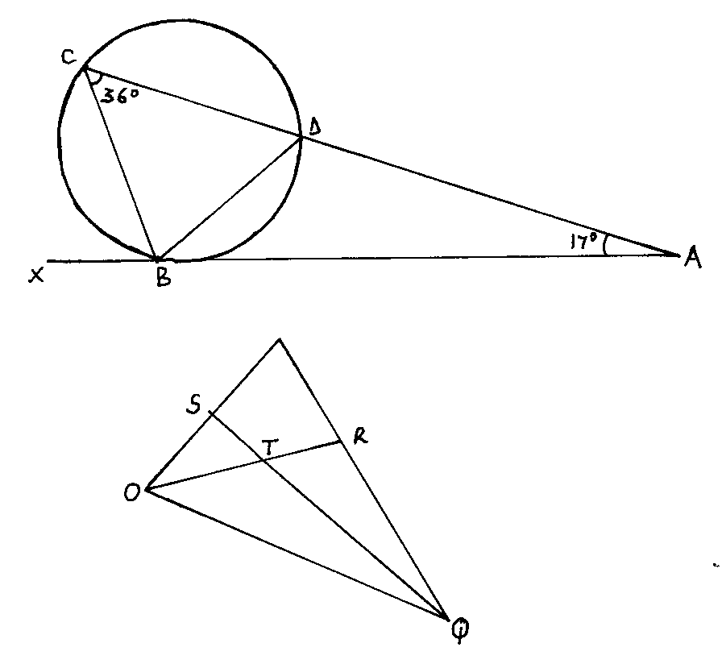

7. What is the sum of the roots of the equation. (3mks)

x2 + 3

= 4

x

8. Ole Koikoi is a real estate agent who is entitled to a commission on all properties bought through him. During a certain month he sold 2 mansions at sh. 2.54 million each, 4 flats at sh. 582,000 each and 5 bungalows at sh. 354,000 each. If he was paid a total commission of sh. 458,900. Calculate the percentage rate of commission he was paid. (4mks)

9. It takes 20 men 10 days to lay 300 metres of pipes. Find how many days it would take 15 men to lay 270 metres of pipes working at the same rate. (3mks)

10. A cylindrical tank of diameter 1.4m and height 1.2m is one-quarter full of water. This water is transferred to an empty rectangular container measuring 1.2m long and 70cm wide. Calculate the height of the water in the container in centimeters. (3mks)

11. Give the integral values of x which satisfies the following inequalities.

4 < 3x – 2

15 – 2x > 4. (4mks)

12. The average mark scored by the first 27 students in a mathematics test is 52. The average mark scored by the remaining 37 is 58. Calculate the mean mark for the whole class. (4mks)

13. Nkini bought 3 skirts and 2 sweaters at a total cost sh. 1575. If he had bought 2 shirts and 3 sweaters he would have spent sh. 225 more. Find the cost of 5 skirts and 2 sweaters. (4mks)

14. The straight line whose equation is 2y = 3x + 6 meets the x-axis and the y-axis at P and Q respectively. Write down the coordinates of P and Q. (3mks)

15. Nairobi and Eldoret are 351 km apart. A bus leaves Nairobi towards Eldoret at an average speed of 66km/h. At the same time a car leaves Eldoret traveling at an average speed of 104km/hr towards Nairobi. Along the way the car stopped for 10 minutes to repair a puncture, then resumed the journey traveling at the same average speed. How far from Nairobi did they meet. (4mks)

16. A number P is divided by 12,15 and 18. In each case the remainder is 5. Find the smallest value of P. (3mks)

**SECTION II ( 50 MARKS)**

**Answer ANY FIVE questions**

17. a) A bucket is in the shape of a frustum of a cone. Its diameters at the top and at the bottom are 36cm and 28cm respectively. Its depth is 20cm. What is the full capacity of the bucket in litres. (6mks)

b) The above container was filled with water and later transferred to a cylinder of height 92cm. Determine to 1dp the radius of the cylinder. (4mks)

18. The cost of making a table consist of transport, labour and raw material in the ratio 4:2:6 respectively. During an inflation year the transport cost increased by 6%, the labour by 9% and raw materials by 20%.

a) Find the percentage increase in producing a table. (6mks)

b) What was the old price of a table if the new price is Kshs. 680.00. (2mks)

1. How much would Raisa have saved if she buys a dozen of tables at the old price? (2mks)

19. a) Narok Teachers College uses three buses A,B and C. On any day the probability of the buses operating are 0.75, 0.4 and 0.5 respectively. Use a tree diagram to find the probability that on a given day.

(i) All the buses are not operating. (2mks)

(ii) Only one bus is operating. (2mks)

(iii) At least one bus is working. (2mks)

b) A bag contains 5 red balls and 3 white ones. If two balls are picked one at a time, find the probability that a red and a white ball is picked?

i) Without replacement. (2mks)

ii) With replacement. (2mks)

#### 20. The figure shows a triangle OPQ in which OP= **p** and OQ=**q**. Points S and R are mid points of OP and PQ respectively. Lines OR and SQ intersect at T such that OT:TR=2:1 and ST=hSQ.

P

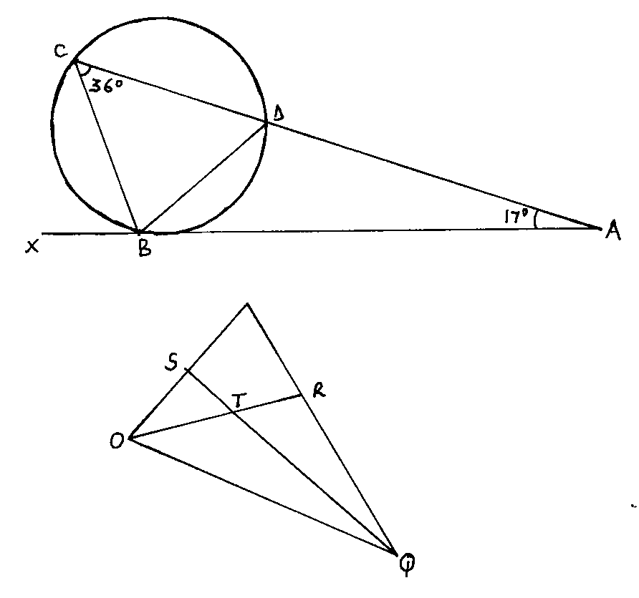

a) Express the following vectors in terms of P and q.

(i) PQ

ii) SQ

iii) OR

b) Using triangle OST and the fact that ST=hSQ, express vector ST in two ways and hence find the value of h. (4mks)

c) Express vector TQ in terms of P and q and state the ratio ST:TQ. (3mks)

1. (a) Complete the table below (2 mks)

|  |  |  |  |  |  |  |  |  |  |  |
| --- | --- | --- | --- | --- | --- | --- | --- | --- | --- | --- |
| X | -5 | -4 | -3 | -2 | -1 | 0 | 1 | 2 | 3 | 4 |
| X2 | 25 | 16 | 9 | 4 |  | 0 | 1 | 4 | 9 | 16 |
| 3x |  | -12 | -9 |  | -3 | 0 |  | 6 | 9 |  |
| +1 | +1 | +1 | +1 | +1 | +1 | +1 | +1 | +1 | +1 | +1 |
| Y | 11 |  | 1 |  |  | 1 |  | 11 |  | 29 |

(b) Draw the graph of y = x2 + 3x + 1 on the grid provided (4 mks



1. Use your graph to solve
2. X2 + 2x – 2 = 0 (2 mks)
3. X2 + 3x – 4 = 0 (2 mks)

22. In June of a certain year, an employee’s basic salary was sh. 17000. The employee was also paid a house allowance of sh. 6000 a commuter allowance of sh. 2500 and a medical allowance of sh. 1800. In July of that year, the employee’s basic salary was raised by 2%.

a) Calculate the employee’s:

(i) Basic salary for July (2mks)

(ii) Total taxable income of July that year (2mks)

b) In that year, the Income Tax Rates were as shown in the table below:

|  |  |
| --- | --- |
| **Monthly taxable income**  **(Sh)** | **% rate of tax per shilling** |
| **Up to 9680** | 10 |
| **9681-18800** | 15 |
| **18801-27920** | 20 |
| **27921-37040** | 25 |
| **37041and above** | 30 |

Given that the monthly personal relief was sh. 1056 calculate the net tax paid by the employee. (6mks)

23.a) Given the series 2+4+18+36+……16384:

(i) Identify the type of series (1mk)

(ii) Find the number of terms in the series (3mks)

(iii) Calculate the sum of the terms in the series (3mks)

b) The first three consecutive terms of an increasing geometric progression are: 3,x and 5 $\frac{1}{3}$  . Find the value of x (3mks)

24. (a) Using a ruler and a pair of compass only construct triangle ABC in which AB = 14cm,

BC = 7cm and ABC = 37.50 (4 mks)

1. Drop a perpendicular from A to BC produced and measure its height (2 mks)
2. Find the area of triangle ABC (2 mks)
3. Measure angle ACB and BAC (2 mks)