**NAME___________________________________ADM_________FORM______**

**231/3**

**BIOLOGY FORM 4**

**TERM 1 OPENER (ENTRY) EXAM**

**TIME: 1¾ HOURS**

**INSTRUCTIONS TO CANDIDATES**

1. *Write your Name, Admission Number, and Class in the spaces provided above.*

*2. This paper contains* ***THREE Sections.*** *Answer* ***ALL*** *the questions in the spaces provided* ***IN THIS PAPER****.*

*3.* ***ALL*** *the answers must be clear and precise.*

*4. Answer all the questions using correct English.*

**FOR EXAMINER’S USE ONLY**

|  |  |  |
| --- | --- | --- |
| **SECTION** | **MAX. SCORE** | **CANDIDATE’S SCORE** |
| 1 | 13 |  |
| 2 | 13 |  |
| 3 | 14 |  |
| TOTAL | 40 |  |

**This paper consists of 5 printed pages. Candidates should check the question paper to ascertain that all pages are printed as indicated and no questions are missing.**

1. You are provided with two pieces of petioles of kale each 4cm long, two solutions labeled **J** and **K** in separate beakers, means of timing, and a scalpel.
2. Using a scalpel, split halfway through the middle of each piece of the petiole longitudinally.
3. Place one piece in liquid **J** and the other in liquid **K**.
4. Allow the setup to stand for 30 minutes
5. Remove the pieces after 30 minutes. Examine the appearance of the pieces at the end of the experiment. Also, press the pieces gently between your fingers to feel them. Record your observations in the table below. (4mks)

|  |  |
| --- | --- |
| A piece placed in; | Observation |
| Solution J |  |
| Solution K |  |

1. Account for the observations above made in the pieces. (6mks)

|  |  |
| --- | --- |
| A piece placed in; | Account |
| Solution J |  |
| Solution K |  |

1. Identify the physiological process is represented in the experiment above? (1mk)

…………………………………………………………………………………………..

1. Give two importance of the physiological process identified in (c) above in plants. (2mks)

…………………………………………………………………………………………………………………………………………………………………………………………………………………………………………………………………………………………………………………………………………………………………………

1. You are provided with photos of specimens labeled A, B, C, D, E, F, G and H. A dichotomous key shown below can be used to identify them.

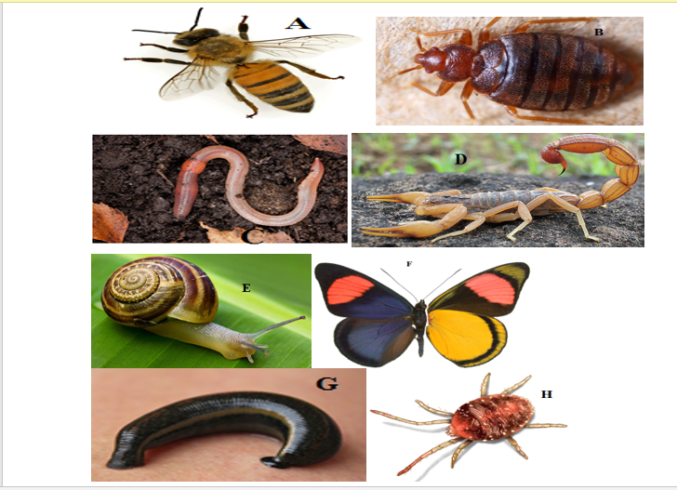

1. a) Jointed legs present **go to 2**

b) Jointed legs absent **go to 6**

2. a) Three pairs of legs **go to 3**

b) More than three pairs of legs **go to 5**.

3. a) Wings present. **go to 4**

b) Wings absent. **Cimicidae**

4. a) Two pairs of wings **Lycaenidae**

b) One pair of wings **Apoidea**

5. a) Antennae present ………………………………………………………………... **Scorpionoidea.**

b) Antennae Absent. **Acari**

6. a) Shell Present **Gastropoda**

b) Shell Absent **Go to 7**

7. a) Prominent c1itellum **Megadrilacea**

b) No clitellum visible **Hirudinea.**

1. Use the dichotomous key to identify each of the animal specimens provided. In each case, show in sequence the steps in the key that you followed to arrive at the identity of each specimen. (12marks)

|  |  |  |
| --- | --- | --- |
| Specimen | Steps Followed | Identity |
| A |  |  |
| B |  |  |
| D |  |  |
| E |  |  |
| F |  |  |
| H |  |  |

1. Name the phylum into which organisms in photographs A, B, D, F, and H belong. (1mk)

………………………………………………………………………………………….

1. You are provided with olive oil, liquids labeled **L1** and **L2**, and Irish potato. Label test tubes A and B. Place 2cm3 of distilled water into each test tube. Add 8 drops of olive oil into each test tube. To test tube A, add 8 drops of liquid **L1**. Shake both test tubes. Allow them to stand for 2 minutes.

(i) Record your observations Test Tube A (1mk)

………………………………………………………………………………………………

Test Tube B (1mk)

………………………………………………………………………………………………

(ii) Name the process that has taken place in test tube A (1mk)

………………………………………………………………………………………………

(iii) State the significance of the process named in (a) above (1mk)

………………………………………………………………………………………………

(v) Name the digestive juice in humans that has the same effect on oil as liquid L1 (1mk)

………………………………………………………………………………………………

(v) Name the region of the alimentary canal into which the juice is secreted (1mk)

………………………………………………………………………………………………

1. Label a test tube C. Place 2cm3 of liquid **L2** into the test tube. Add a drop of iodine solution into the test tube. Record your observation. (1mk)

………………………………………………………………………………………………

1. Suggest the identity of **L2** (1mk) …………………………………………………………………………………………
2. Label another two test tubes as D and E. Then cut a cube whose sides are 1cm3 from the Irish potato. Cut the cube into two halves. Crush one-half using pestle and mortar to obtain a paste. Place the paste into a test tube labeled D and the other half into a test tube labeled E. add 3cm3 into each test tube D and E.

Record your observations in test tubes D and E (2mks)

…………………………………………………………………………………………………………………………………………………………………………………

1. Account for the result in (c) above (3mks)

……………………………………………………………………………………………………………………………………………………………………………………………………………………………………………………………………………………………………………………………………………………………………………………………………………………………………………………………………

1. Write down a word equation for the reaction responsible for your observation in (c) above. (1mk)

……………………………………………………………………………………….

***THIS IS THE LEST PRINTED PAGE***