**FORM 3 TERM 1 OPENER(ENTRY)**

**CHEMISTRY**

**FORM THREE**

**TIME:2 HOURS**

**INSTRUCTIONS**

Answer all questions in spaces provided

1. Identify and state the use of the apparatus represented below. (2mks)



Name…………………………………………………………………… Use………………………………………………………………………

1. The diagram below shows a set-up of apparatus used to separate immiscible liquids.

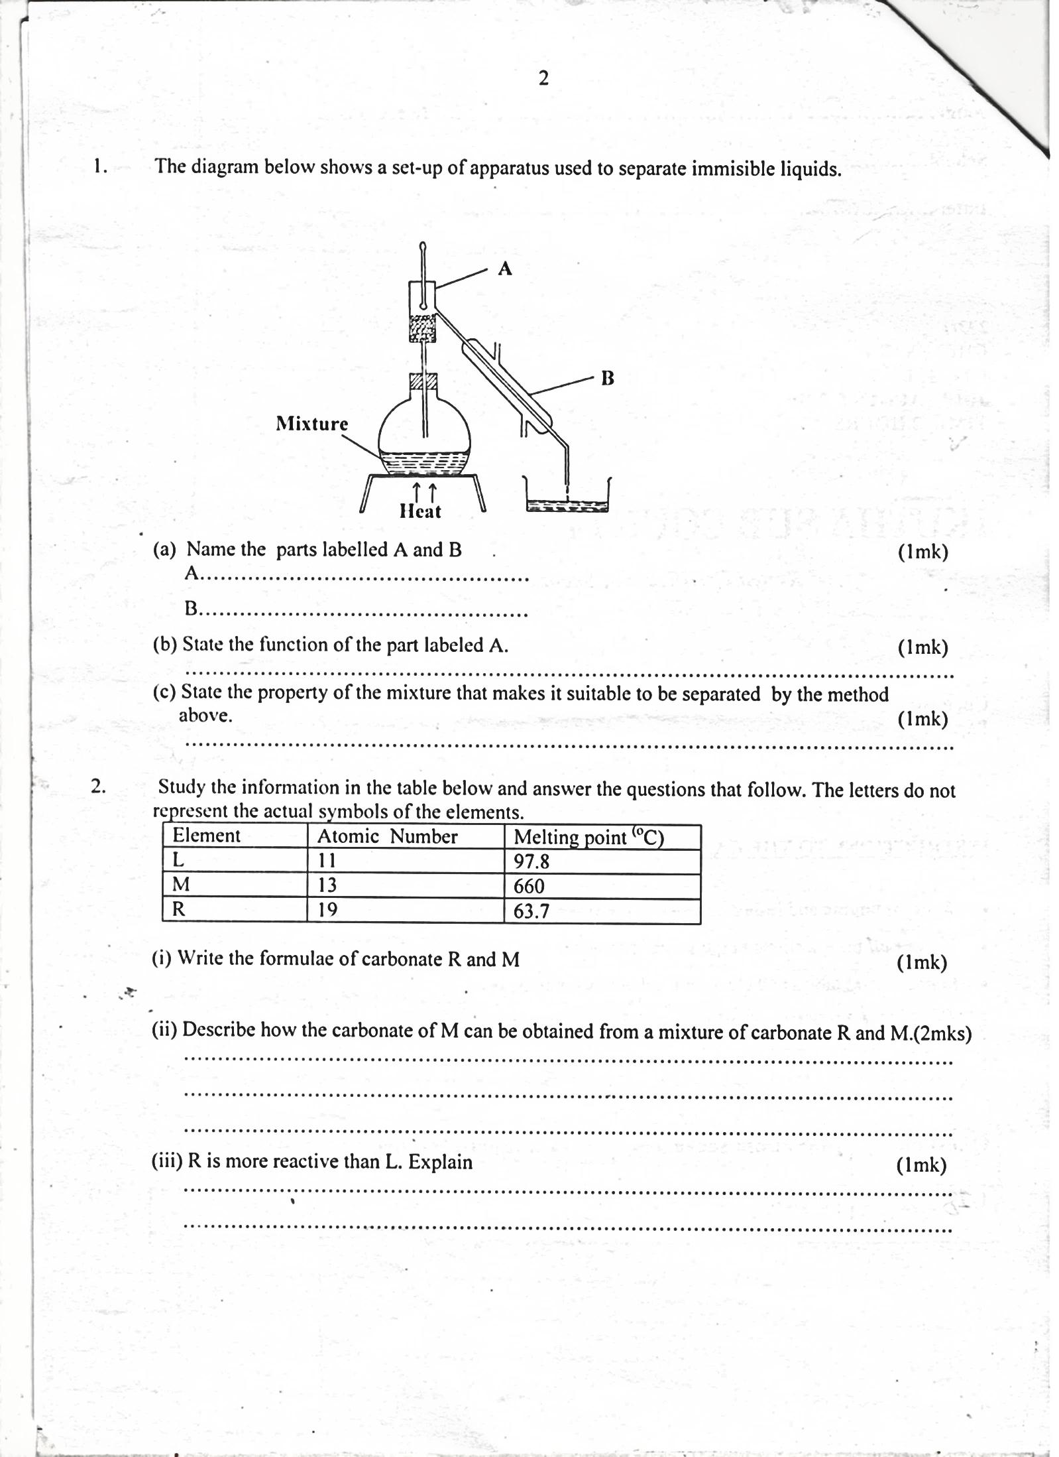

**Mixture**

(i)Name the parts labelled A and B. (2mks)

A _______________________________________________________________________

B ______________________________________________________________________

(ii)State the function of the part labelled A . (1mk)

(iii)State the property of the mixture that makes it suitable to be separated by the method above. (1mk)

1. Four metals are labelled P, Q, R and S (not actual symbols). Metal P displaces metal S from its oxide but cannot displace R from its oxide. Q when mixed with the oxide of R and heated, a reaction occurs.Arrange the metals in order of reactivity, starting with the most reactive. (2mks)

………………………………………………………………………………………………

1. Solutions R, S and T have pH values shown in the table below:

|  |  |
| --- | --- |
| Solution | pH value |
| R | 1.0 |
| S | 6.5 |
| T | 8.0 |

a) What do you deduce about the nature of solution R? (1mk)

(b) Which solution would react most vigorously with sodium hydrogen carbonate (1mk)

(c) Which solution is likely to be ammonia solution? (1mk)

1. The diagram below shows the appearance of two pieces of paper placed in different parts of anon-luminous flame of a Bunsen burner and removed quickly before they caught fire.

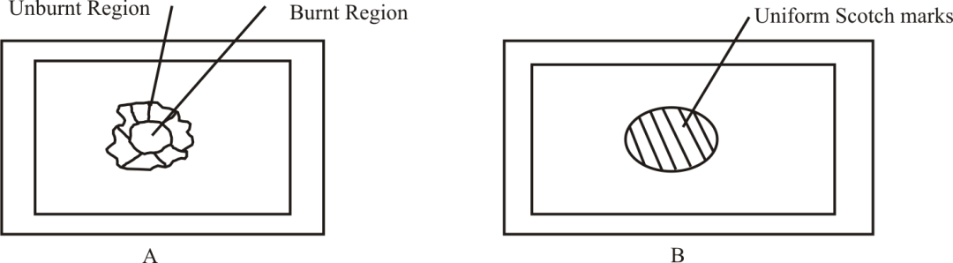

(a) State and explain the observation made in a diagram A (2mks)

(b)Which diagram is as a result of the paper having been put at the part of the flame which is better for heating? Explain (2mks)

1. 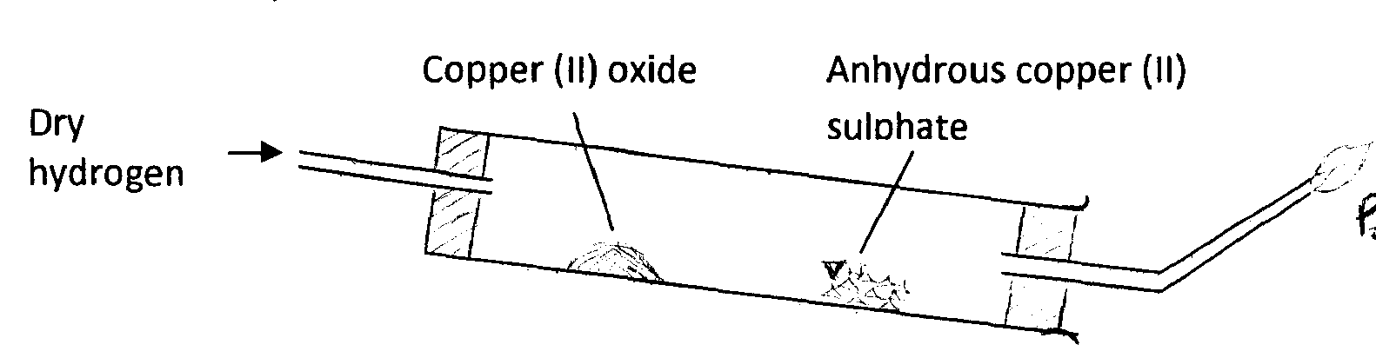The following diagram was used to study a property of hydrogen gas. Study it and answer the questionsthat follow.

Point Z

i)Name the missing condition in the above set-up. (1mk)

ii)Explain why the combustion tube is clumped in a slanting position. (1mk)

iii)Before lighting the gas at the end of the delivery tube, hydrogen must be let to pass through until all the air is driven out. Explain (2mks)

v)State t**hree** observations that occur in the combustion tube. (3mks)

v)Why was hydrogen gas burnt at point Z? (1mk)

vi) Why should the supply of hydrogen gas be continued while the apparatus cool.(1mk)

vii.) What would be observed if the experiment was repeated using lead (II) oxide?(1mk)

viii) Nameone other chemical property of hydrogen gas. (1mk)

1. The following chromatogram was obtained in an experiment to investigate the components present in certain dyes.

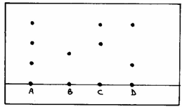

a) Which two dyes when mixed would produce A? (1mk)

b) Which dye is pure? (1mk)

c)Indicate on the diagram the solvent front. (1mk)

1. The curve shown below was obtained when solid naphthalene was heated to boiling.

A

B

C

D

E

Temp. °C

Time (mins)

(a)Explain in molecular terms the changes occurring in portions.

(i) AB. (2mks)

(ii) DE. (2mks

(b) What is the significance of portion BC? (1mk)

1. In the industrial preparation of oxygen, state:

a)How dust particles are removed from air. (1mk)

b) Why carbon (IV) oxide is removed before the mixture is cooled to -25 $℃$.(1mk)

1. Give two reasons why a luminous flame is not used for heating purposes. (2mks)
2. The diagram below shows an iron bar which supports a bridge. The iron bar is connected to a piece of magnesium metal.

**Iron bar**

**Magnesium metal**

**Copper wire**

**Soil**

Explain why it’s necessary to connect the piece of magnesium metal to the iron bar. (2mks)

1. If aqueous lead (II) nitrate is added to aqueous solution potassium iodide, a bright yellow precipitate is formed.

i)Write down the formula of the precipitate formed. (1mk)

ii) Write the ionic equation for the reaction above. (1mk)

1. 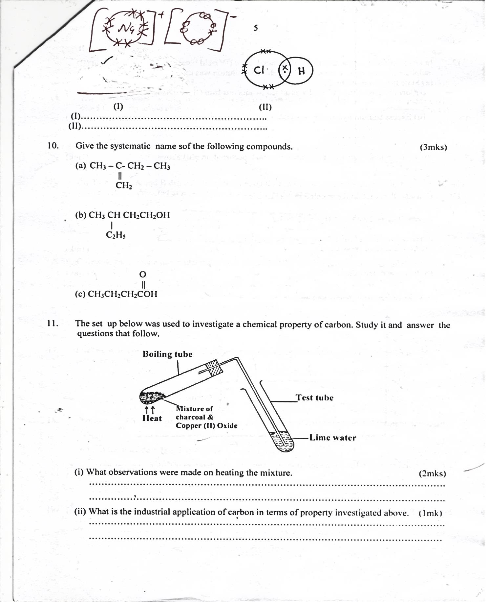The set up below was used to investigate a chemical property of carbon. Study it and answer the questions that follow

i) What observations were made on heating the mixture? (2mks)

ii)What is the industrial application of carbon in terms of property beinginvestigated above? (1mk)

1. 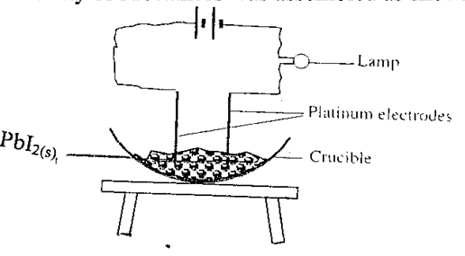A set-up to investigate electrical conductivity of substances was assembled as shown below.The bulb did not light.

(a) What was missing in the set-up? (1mk)

(b) The bulb lit when the omission was corrected. Explain. (2 mks)

1. The diagram below shows a ‘jiko’ when in use. Study it and answer the questions that follow

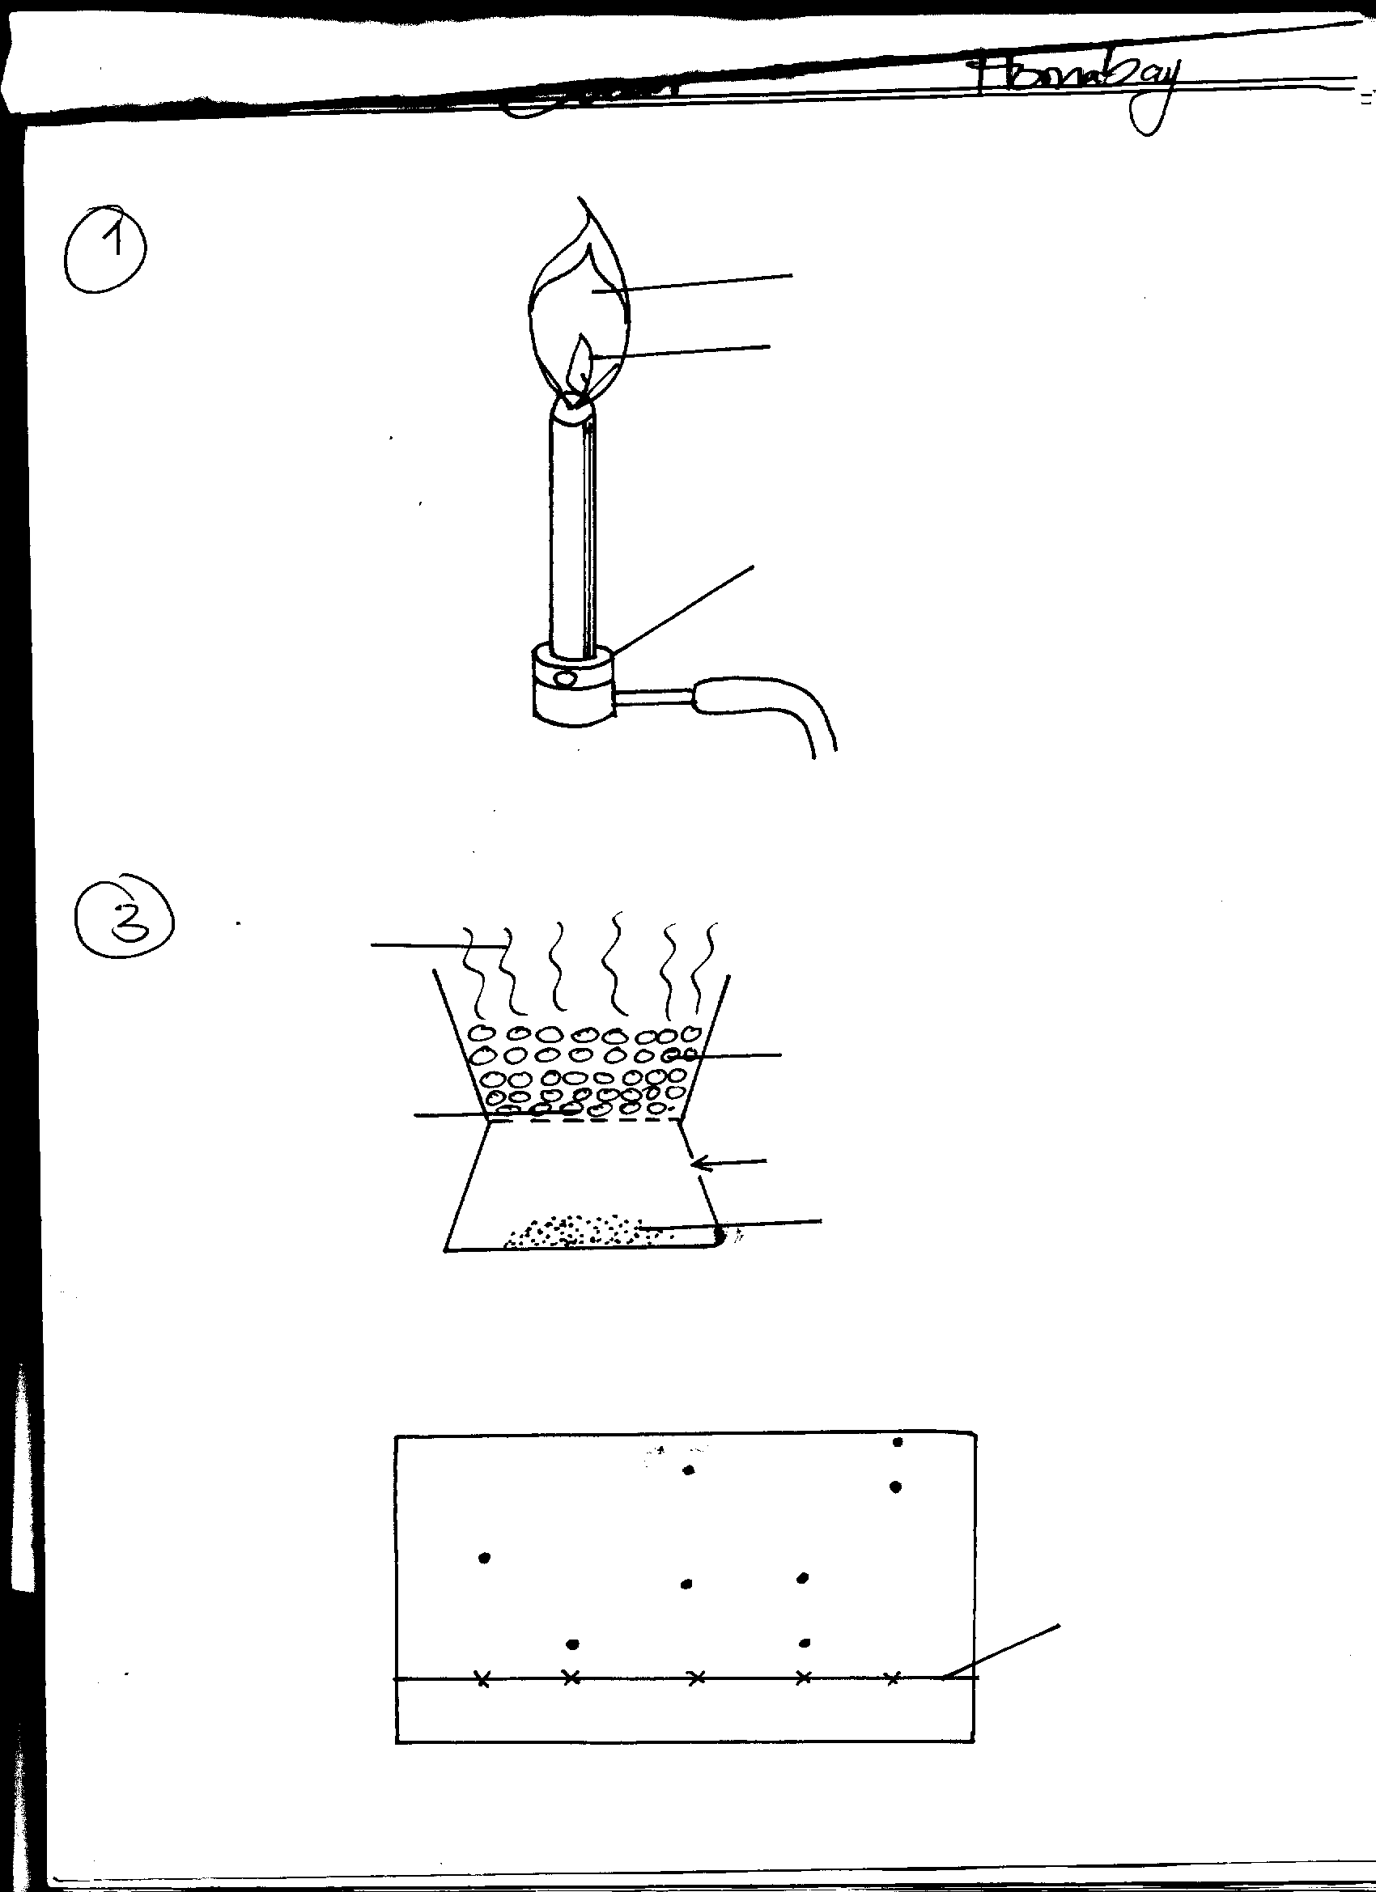

**Region B**

**Region A**

**Burning charcoal**

**Air**

**Ash**

(a) Identify the gas formed at region B (1mk)

(b) State and explain the observation made at region B (2mks)

1. Element K has two isotopes 20K and 22K with relative abundance of 90% and 10% respectively.

a) What are isotopes? (1mk)

b) Determine the relative atomic mass of element K. (2mks)

1. A certain element Y has atomic number 15 and mass number of 31.

(a) Calculate the number of neutrons in the element. (1mk)

(b) Write the electron arrangement of the ion formed by element Y. (1mk)

(c)How would the atomic size of the above element compare with another atom X whose atomic number is 11 and mass number 23? Explain. (1mk)

1. Diamond and graphite are allotropes of carbon.

(i)What are allotropes? (1mk)

(ii)In terms of structure and bonding explain why diamond is used in drilling through hard rocks while graphite is a lubricant (2mks)

1. Describe how the following reagents can be used to prepare lead (II) sulphate. Solid potassium sulphate, solid Lead (II) carbonate, dilute nitric acid and distilled water (3mks)
2. The simplified flow chart shows some of the steps in the manufacture of sodium carbonate by the Solvay process

G

**Step II**

**Ammonium Chloride and sodium hydrogen carbonate**

**BRINE**

**Sodium hydrogen carbonate**

**Carbon (IV)** oxide

**Step III**

**Sodium carbonate**

1. Identify substance G.(1mk)

b) Name the process – taking place in step II (1mk)

c)Write an equation for the reaction, which takes place in step III. (1mk)

1. The diagram below shows the bonding between boron chloride and ammonia

**Cl H**

**| |**

**Cl – B N - H**

**| |**

**Cl H**

1. Name the types of bonds that exist in the molecule. (1mk)
2. How many electrons are used for bonding in the molecule? (1mk
3. The grid below represents a section of the periodic table. Study it and answer the questions that follow:

|  |  |  |  |  |  |  |  |
| --- | --- | --- | --- | --- | --- | --- | --- |
|  |  | | | | | | L |
| A |  |  | D | M | G | I |  |
| B | C | E |  | F | H | J |  |
| N |  |  |  |  |  | K |  |

a) Give the formula of the compound formed between C and M. (1mk)

b) Which element form a stable trivalent cation (1mk)

c) Identify the most reactive halogen and give a reason for your answer. (2mks)

d) Explain how the melting point of J and K compare. (1mk)

e) Explain the differences in atomic and ionic radius of K (1mk)

f) How does the atomic radius of C and J compare? Explain. (1mk)

g) Write the electron arrangement of the following ions (1mk)

K-………………………………………………….

C2+……………………………………………………

h) Element B is a soft substance and can easily be cut with a knife while element E is very hardExplain. (1mk)

1. Write equations to show the effect of heat on the following

(a)Sodium hydrogen carbonate (2mks)

(b)Silver nitrate (2mks)

(c)Anhydrous iron(II) sulphate (2mks)

1. In terms of structure and bonding explain the following observations

(a)Melting point of aluminium is higher than that of sodium (2mks)

(b)Boiling point of water is higher than that of hydrogen sulphide gas(2mks)

1. The set up shown was carried out to investigate how Sodium metal reacts with chlorine gas. Study it and answer the questions that follow.

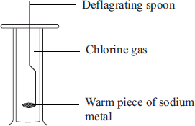

i)State **two** observations that would that made in the gas jar. (2mks)

ii)Write an equation for the reaction that would occur. (2mks)

iii)Name **one** use of the product formed. (1mk)

1. Calcium hydroxide is used to test for Carbon (IV) while sodium hydroxide solution is not. Explain. (2mks)
2. (i)State Charles law. (1mk)

(ii)A bicycle tube contains 300cm3 of air at 200C.What would be the volume of air at 400C?(2mks)

1. A fixed mass of a gas occupies 105cm3 at -14oC and 650mmHg. At what temperature will it have a volumeof 15cm3 if pressure is adjusted to 690mmHg? (3mks)