121

**MATHEMATICS**

**TIME: 2½ HRS**

**TERM 1 OPENER (ENTRY) EXAM**

FORM THREE

**MATHEMATICS**

**Time: 2½ hours**

**INSTRUCTIONS TO CANDIDATES**

1. Write your name and admission number in the spaces provided above.

2. Sign and write the date of examination in the spaces provided above.

3. This paper consists of **two** sections: **I** and **II**

 4. Answer **all** the questions in Section **I** and any **five** questions from Section **II**.

5. Show all the steps in your calculations giving your answers at each stage in the spaces below each question.

6. Marks may be given for correct working even if the answer is wrong.

7. Candidates should check the question paper to ascertain that al the pages are printed as indicated and that no questions are missing.

 FOR EXAMINER’S USE ONLY

**SECTION I**

|  |  |  |  |  |  |  |  |  |  |  |  |  |  |  |  |  |
| --- | --- | --- | --- | --- | --- | --- | --- | --- | --- | --- | --- | --- | --- | --- | --- | --- |
| 1 | 2 | 3 | 4 | 5 | 6 | 7 | 8 | 9 | 10 | 11 | 12 | 13 | 14 | 15 | 16 | Total |
|  |  |  |  |  |  |  |  |  |  |  |  |  |  |  |  |  |

**SECTION II**

|  |  |  |  |  |  |  |  |  |
| --- | --- | --- | --- | --- | --- | --- | --- | --- |
| 17 | 18 | 19 | 20 | 21 | 22 | 23 | 24 | Total  GRAND TOTAL |
|  |  |  |  |  |  |  |  |  |

1

**SECTION I (50 MKS)**

**Answer all the questions in this section.**

1. Evaluate (3mks)

$\frac{-16÷4+18 ×6-3 ×8}{48 ÷6 ×2}$

1. Use tables of reciprocals to find the value of (3mks)

$\frac{5}{0.0829}$- $\frac{14}{0.581}$

1. The volume of two similar cylinders are 4752cm3 and 1408cm3. If the area of the curved surface of the smaller cylinder is 352cm2, find the area of the curved surface of the larger cylinder (4mks)
2. An irregular 6 sided polygon has 2 of its interior angles equal to 2x each, 3 angles equal to x each and one angle equal to 20 $°$. Calculate the value of X (3mks)
3. 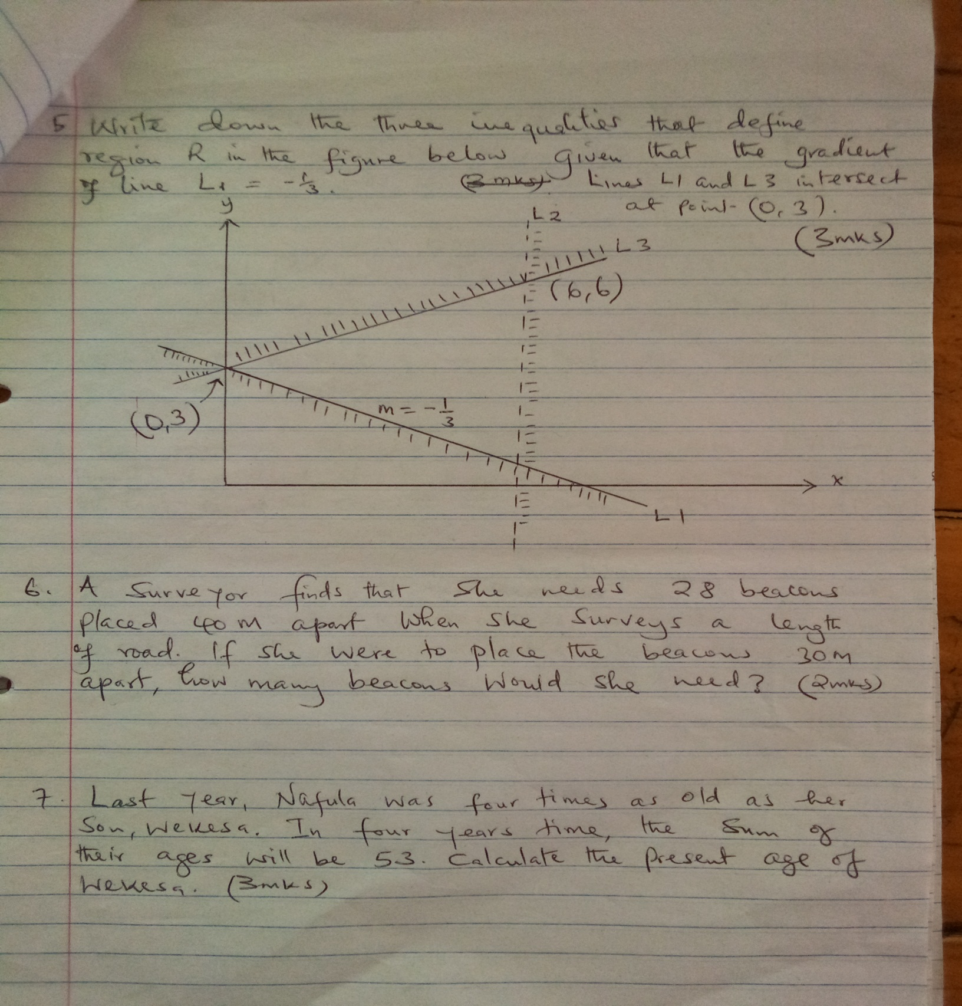Write down the three inequalities that define the region enclosed in the figure below given that the gradient of line L1= - ⅓. Lines L1 and L3 intersect at point (0,3) (3mks)
4. A surveyor finds that she needs 28 beacons placed 40m apart when she surveys a length of road. If she were to place the beacons 30m apart, how many beacon s would she need? (2mks)
5. Last year, Nafula was four times as old as her son, Wekesa. In four years time, the sum of their ages will be 53. Calculate the present age of Wekesa (3mks)
6. A Kenyan company received US dollars 100,000. The money was converted into Kenya Shillings in a bank which buys and sells foreign currencies as shown below.

Buying selling

1 US dollar 77.24 77.44

1 sterling pound 121.93 122.23

1. Calculate the amount of money in Kenya shillings that the company received (2mks)
2. The company changed all the money into sterling pounds and used it to buy a car in Britain. Calculate the cost of the car to the nearest sterling pound (2mks)
3. Kariuki spent $\frac{1}{8}$ of his monthly salary on school fees and a third of the remainder on rent. He then spent ¾ of what remained on food. If he was finally left with sh.1470, calculate his monthly salary (3mks)
4. 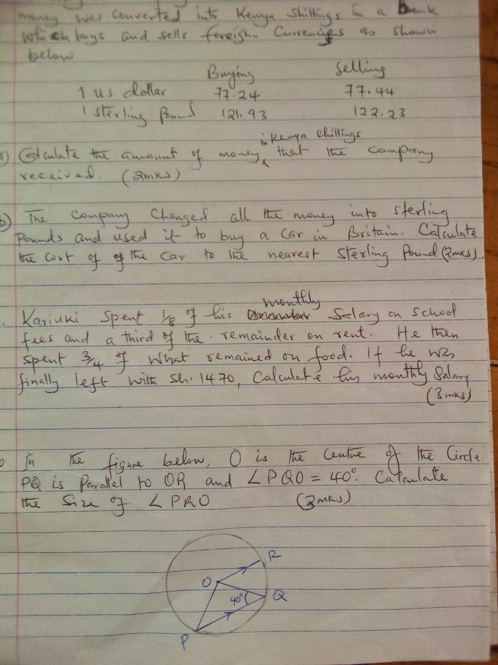In the figure below, O is the centre of the circle. PQ is parallel to OR and <PQO=40 $°$. Calculate the size of <PRO (3mks)
5. Solve for x in the equation (3mks)

9x + 32x – 1= 53

1. The diagonal of a rectangular garden measures 11 $\frac{1}{4}$ metres its width measures 6 $\frac{3}{4}$ metres. Calculate the perimeter of the garden (3 mks)
2. Jane and Mary live 40km apart. Jane sets from her home at 8.00am and cycles towards Mary’s home at 16km/hr. At exactly 8.30am Mary started from her home and cycled at 8 km/hr towards Jane’s home. At what time did they meet? (3mks)
3. Jackson broke 4 beakers and 3 test tubes while Makori broke 2 beakers and 5 test tubes, during a practical lesson in the laboratory. If Jackson was charged sh475 and Makori sh325 for the breakages, find the amount Eunice would pay if she broke 2 beakers and 6 test tubes (4mks)
4. The position vector **p** of a point P is $\left(\begin{matrix}3 \\ 6\end{matrix}\right)$ and the position vector **q** of a point Q is $\left(\begin{matrix}-3 \\ 2\end{matrix}\right)$. Find the vector PQ (3 mks)
5. 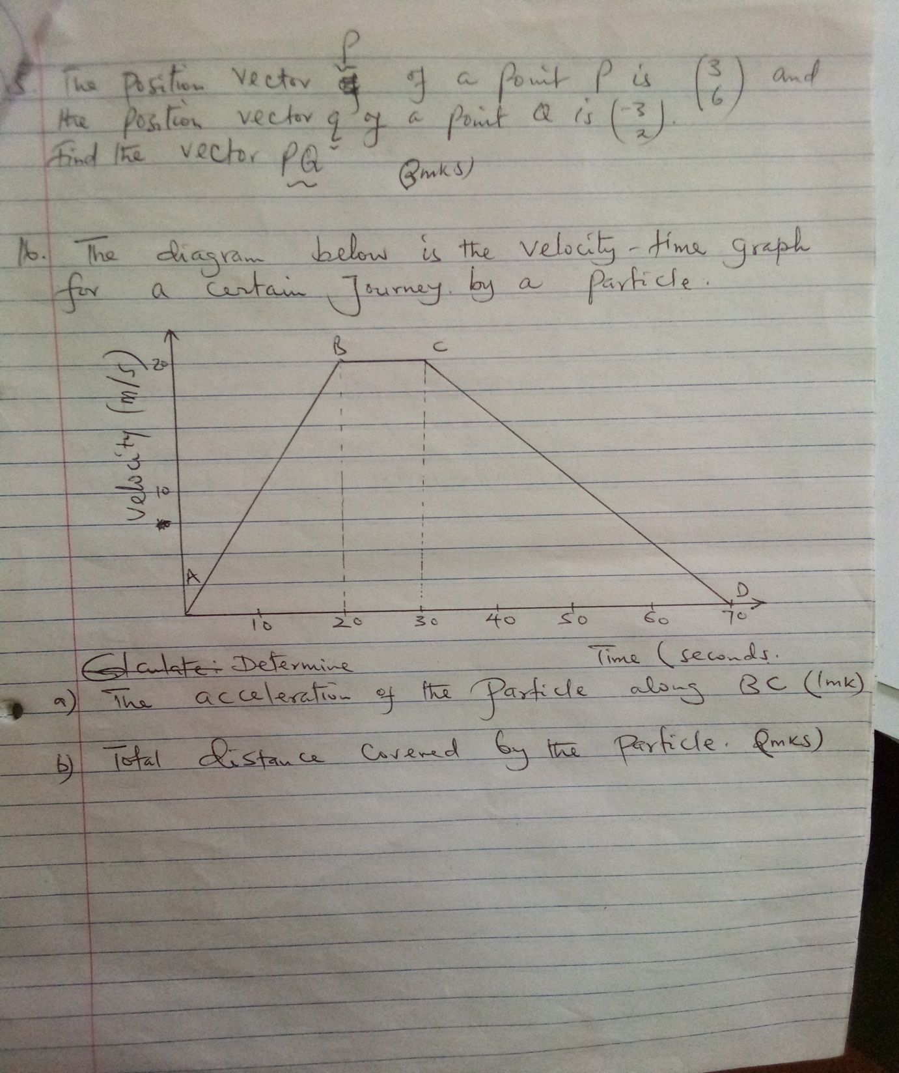The diagram below is the velocity time graph for a certain Journey by a particle.

Determine

1. The acceleration of the particle along BC (1mk)
2. Total distance covered by the particle (2mks)

**Section II(Answer any five questions in this section**

1. A cylindrical container has a hemispherical top. The cylinder and the hemisphere are of radius 7cm. The cylindrical part is 30cm tall. Taking $π$ = ${22}/7$, Calculate:
2. The area of the circular base (2mks)
3. The area of the curved cylindrical surface (2mks)
4. The area of the hemispherical surface (2mks)
5. The surface area of a similar container whose cylindrical part is 1.6m high (3mks)
6. A straight line passes through the points (8,-2) and (4,-4)
7. Write the equation of this line in the form ax+by+c=0 where a,b and c are integers (3mks)
8. If the line in (a) above cuts the x-axis at point P, Determine the co-ordinates of point P (3mks)
9. Another line which is perpendicular to the line in (a) above passes through point P and cuts the y axis at point Q. Determine the co-ordinates of point Q (3mks)
10. Find the length of QP (2mks)
11. The marks below were scored by 50 students in a mathematics test.

62 46 71 59 75 62 60 46 71 51

71 66 50 73 49 57 49 66 45 52

46 72 69 66 59 49 50 68 59 58

73 49 68 49 70 69 74 68 67 57

53 66 61 52 61 58 61 64 50 46

1. Make a cumulative frequency distribution table using a class interval of 5 and starting with the class 45 - 49 (3mks)
2. State the modal class (1mk)
3. Calculate the mean mark (3mks)
4. Calculate the median (3mks)
5. Two airports A and B are such that B are such that B is 500km due east of A. Plane A and plane B lift off from the airports A and B respectively at exactly the same time. Plane A flies on a bearing of 030 $°$ at 360 km/hr and plane B flies on a bearing of 315 $°$ at 240km/hr. They land after flying for 90 minutes.
6. Using a scale of 1cm to represent 100km make a scale drawing to show the final positions of the two planes (6 mks)
7. Use the scale drawing to find the distance between the two planes after the flight. (2mks)

1. Determine the bearing of plane A from plane B after the flight (2mks)
2. A watch tower stands directly across the street, 40 metres from an electric pole. The angle of depression of the top of the electric pole from the top of the watch tower is 25.8 $°$, and the angle of elevation of the top of the watch tower from the foot of the electric pole is 43.5 $°.$

Calculate to 2 decimal places:

1. The height of the watch tower (2mks)
2. The difference in height between the watch tower and the electric pole (3mks)
3. The angle of elevation of the top of the electric pole from the foot of the watch tower.

(3mks)

1. The distance between the top of the electric pole and the top of the watch tower (2mks)
2. A sector of a circle of radius 42cm subtends an angle of 120 $°$ at the centre of the circle.

Taking π = $\frac{22}{7}$

1. Calculate
2. The area of the sector (2mks)
3. The length of the arc (2mks)
4. The sector is folded into an inverted right cone. Calculate:
5. The base radius of the cone (2mks)
6. The vertical height of the cone correct to one decimal place (2mks)
7. Determine to 2 decimal places the capacity of the cone in litres (2mks)

12

1. (a) On the grid provided, plot the points A(2,3), B(1,1) C(4,1) and D(2,2). Join the points carefully to form quadrilateral ABCD (2mks)

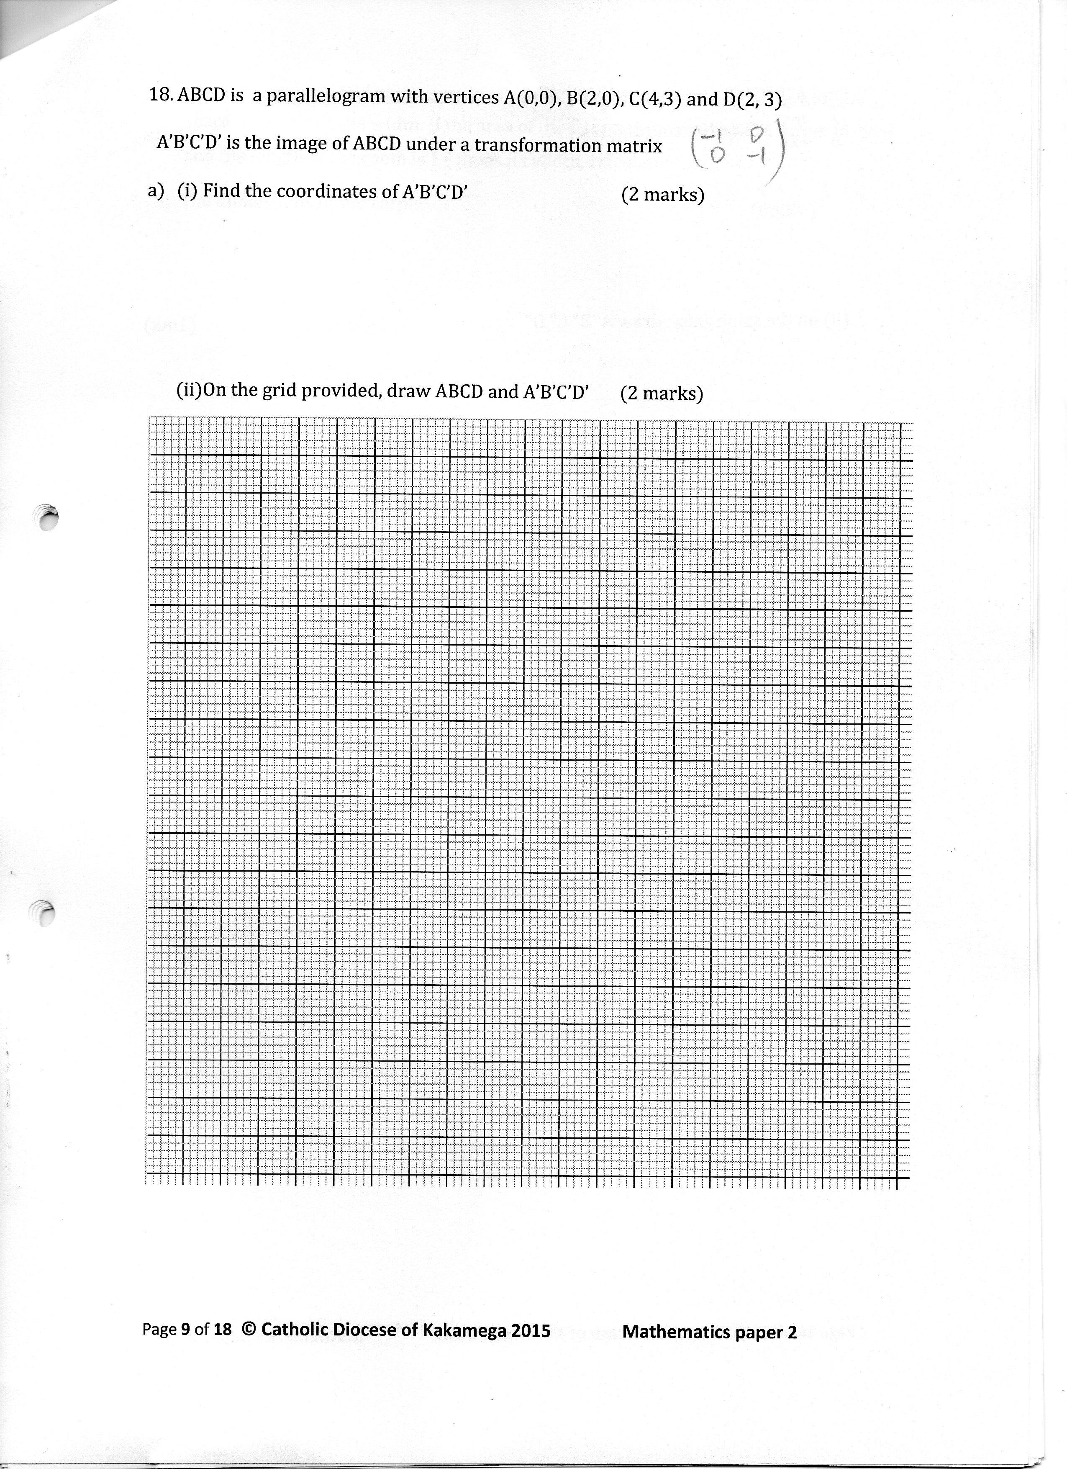

(b) On the same grid locate and plot the points AIBICI DI the image of ABCD under enlargement with centre at the origin and scale factor -2. (2mks)

Draw the quadrilateral AIBICIDI and write the co-ordinates of its vertices (2mks)

(c) Locate and plot points AIIBIICIIDII the image of ABCD under a rotation of positive quarter turn about the origin (2mks)

Draw the quadrilateral AIIBIICIIDII and write the co-ordinates of its vertices (2mks)

1. Amina bought a second hand car and then later sold it through a sales agent who charged 5% commission on the price at which he sold the vehicle. She received sh475,000 from the agent after he had deducted his commission. Amina made a profit of 25% on the price at which she had bought the car.
2. Calculate the price at which the sales agent sold the vehicle (3mks)
3. Determine the amount Amina paid for the car (2mks)
4. If the amount Amina paid was 40% of the price of the car when new, find its price when new (3mks)
5. Express as a percentage the amount Amina received to the price of the car when new

(2mks)