**FORM 3 TERM 1 OPENER(ENTRY)**

**PHYSICS**

**FORM THREE**

**TIME: 2 HOURS**

**Answer all the questions in the spaces provided.**

1. Mechanics is one of the branches of Physics. State what it deals with. (1 mk)

2. An object weighs 49N on earth where acceleration due to gravity is 9.8N/kg. Find the acceleration due to gravity on another planet where the same object weighs 40.5N. (2 marks

3. The figure below shows a burette partially filled with a liquid to 2.8cm3. The burette was

initially filled to the mark 0.0. If the quantity of the liquid removed has a mass of 22g,

determine the density of the liquid. (3 mks)

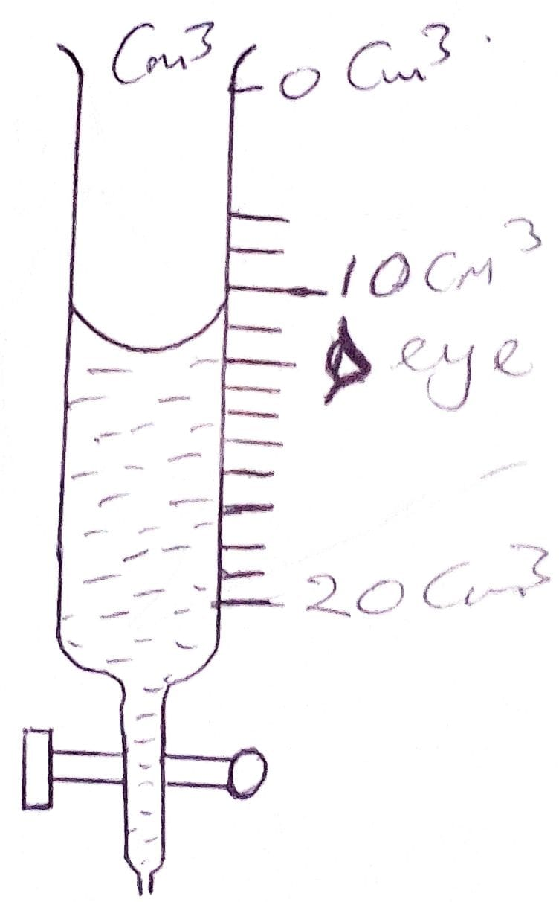

4. (a) Give two forces that determine the shape of liquid drop on a solid surface. (2 mks)

(b) Give a reason why the weight of a body varies from place to place. (1 mk)

5. Hygienic butchery in Nakuru town is owned by Mr. Evans Juma. Juma has a beam balance

and masses of 0.5kg and 2kg. State how he would meausre 1.5kg of meat on the balance at

once.

(2 mks)

6. A solid weighs 16.5N on the surface of the moon. The force of gravity on the moon is

1.7kg-1. Determine the mass of the solid. (3 mks)

7. State two ways of reducing surface tension of a liquid. (2 mks)

8. State ONE reason of fitting wide tyes on a vehicle that moves on earth roads. (1 mk)

9. Determine two factors that determine the pressure at a point in a liquid. (2 mks)

10. Explain the cause of random motion of smoke particles as deserved in Brownian motion

experiment using a smoke cell. (2 mks)

11. Brownian motion of smoke particles can be demonstrated by using the apparatus shown in

the figure below. To observe the motion, some smoke is enclosed in the smoke cell and then

observed through the microscope.

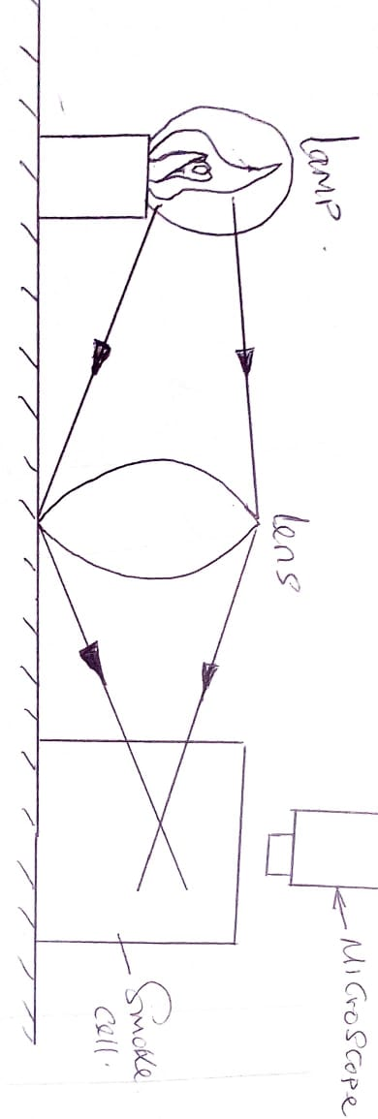

(a) Explain the role of the smoke particles, lens and microscope in the experiment as

follows:-

(i) Smoke particles - (2 mks)

(ii) Lens –

(iii) Microscope –

12. The figure below shows a flask filled with water. The flask is fitted with a cork through

which a tube is inserted. When the flask is cooled, the water level rises slightly and then

falls steadily. Explain this observation. (4 mks)

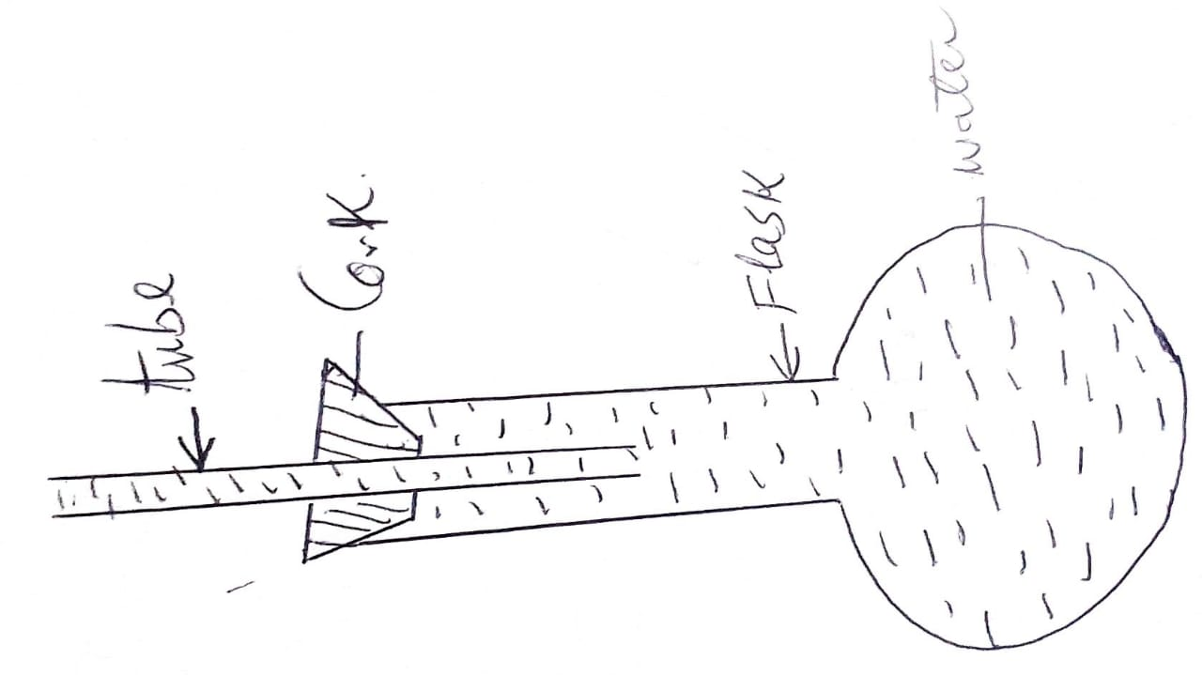

13. The figure below shows the shape of a bi-metallic strip after it has cooled below room

temperature

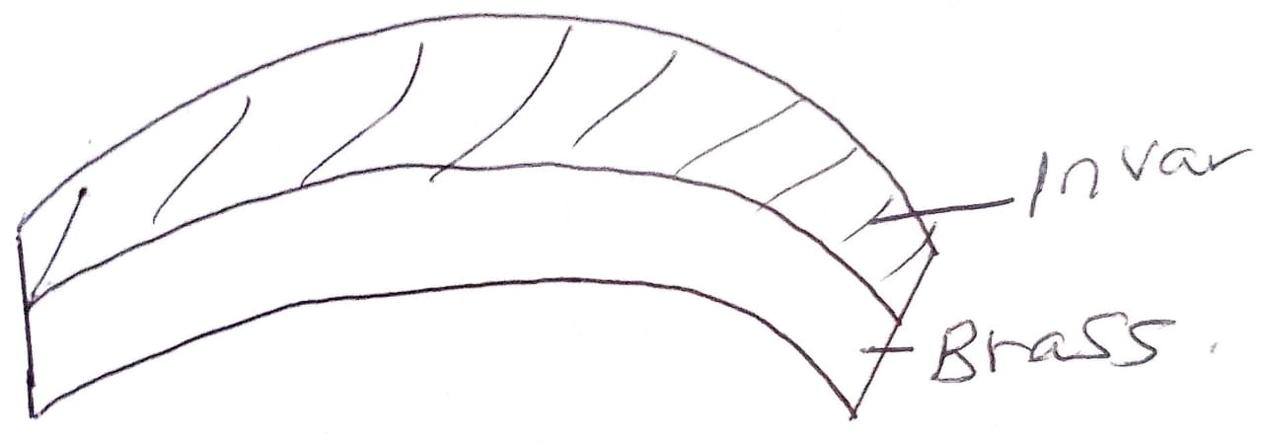

Explain why the strip curved as shown. (3 mks)

**- Brass contracts more than invar. It therefore becomes shorter than invar and ends**

**up being o**

**n the inner side of the curve. (3 mks)**

14. In the set up shown below, water near the top of the boiling tube boils while at the bottom it

remains cold.

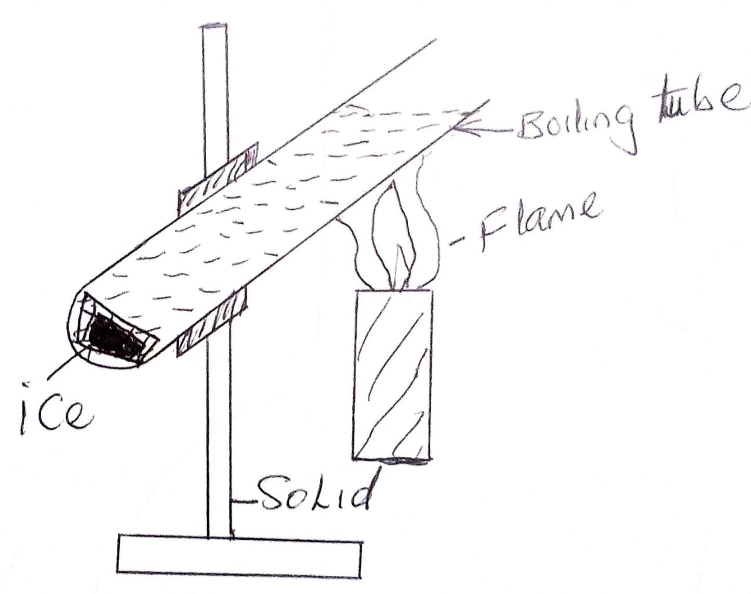

Give a reason for the observation. (3 mks)

**- Water and glass are poor conductors of heat**

**- Water heated at the top forms an upward hot convection current, hence water below**

**remain cold.**

**- The ice below remains unmolted.**

15 . State three ways in which a mercury based thermometer can be modified to read very small

temperature changes. (3 mks)

**- Making the capillary bore narrower**

**- Making the glass bulb with a thin wall**

**- Reducing the size of the bulb**

16. (a) Name the instrument that would be most suitable for measuring the thickness of one

sheet of this question paper. (1 mk)

**- Micrometer screw gauge**

(b) State the assumptions made when calculating the size of a molecule in the oil drop

experiment. (3 mks)

**- That the oil drop is spherical in shape**

**- That the oil drop spread until it is one cell thick**

**- That the film formed is cylindrical in shape**

17. (a) In an experiment to estimate the diameter of an oil molecule, an oil drop of diameter

0.05cm spreads over a circular patch of diameter 20cm. Determine:-

(i) The volume of the oil drop. 3 mks)

` (ii) The area of the patch covered by the oil. (3 mks)

**Area = = x 102, = 314cm2**

(iii) The diameter of the oil molecule. (3 mks)

**Volume of oil drop = volume of oil patch**

**6.54 x 10-5 = 314 x d**

**d = 2.08 x 10-7cm**

(b) State the three sources of error to the above experiment. (3 mks)

**- Measuring the diameter of the oil drop**

**- Measuring the diameter of the patch**

**- Getting drop of a right size.**

18. (a) A uniform metre rule is pivoted at its centre. Two weights of 20N and 10N

are suspended at the 20cm and 100cm marks respectively. Determine the position at

which a 10N weight should be suspended in order to balance the system. (3 mks)

Since the system is balanced, then

cm = A/cm

10 x x + 10 x 0.5 = 0.3 x 20N

x = 0.1m or 10cm from the centre

(b) Draw a balanced level diagram to illustrate the answer in (a) above. (3 mks)

Show positions of forces(20N,10N and 10N)

19. What do you understand about the following terms:-

(a) Moment of a force. (2 mks)

**Is the product of Force(N) and its perpendicular distance from its centre of gavity.**

(b) Equilibrium state. (2 mks)

**When the sum of c/momemnts is equal to the sum of it’s a/c moment about the pivot.**

(c) Law of moments . (2 mks)

20. The figure below represents a rock balanced at point O. G is the centre of gravity of the rock.

Use this information to answer questions (a) and (b)

(a) Draw and label on the figure, the forces acting on the rock. (2 mks)

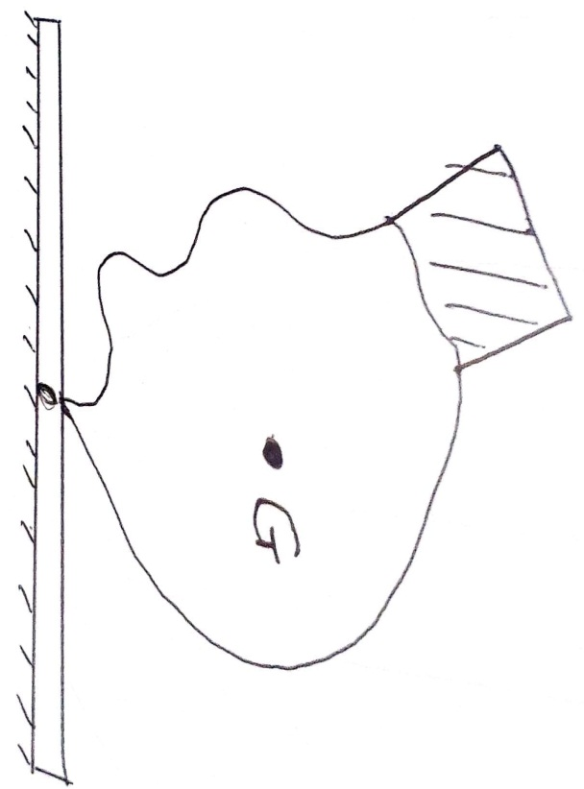

(b) If the portion of the rock represented by the shaded part is chopped off, explain why

the rock may topple to the right. (2 mks)

21. The figure below shows a uniform metre rule pivoted at the 20cm mark. It is balanced by a

weight of 2N suspended at the 5cm mark.

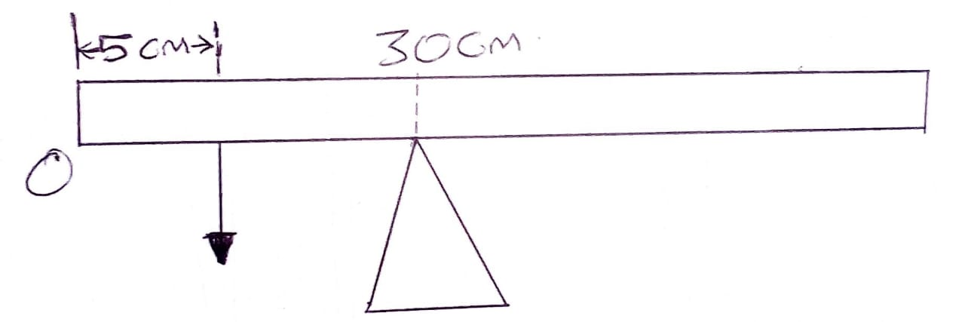

Determine the weight of the rule. (3 mks)

22. The figure below represents a bunsen burner. Explain how air is drawn into the burner when

the gas tap is opened. (3 mks)

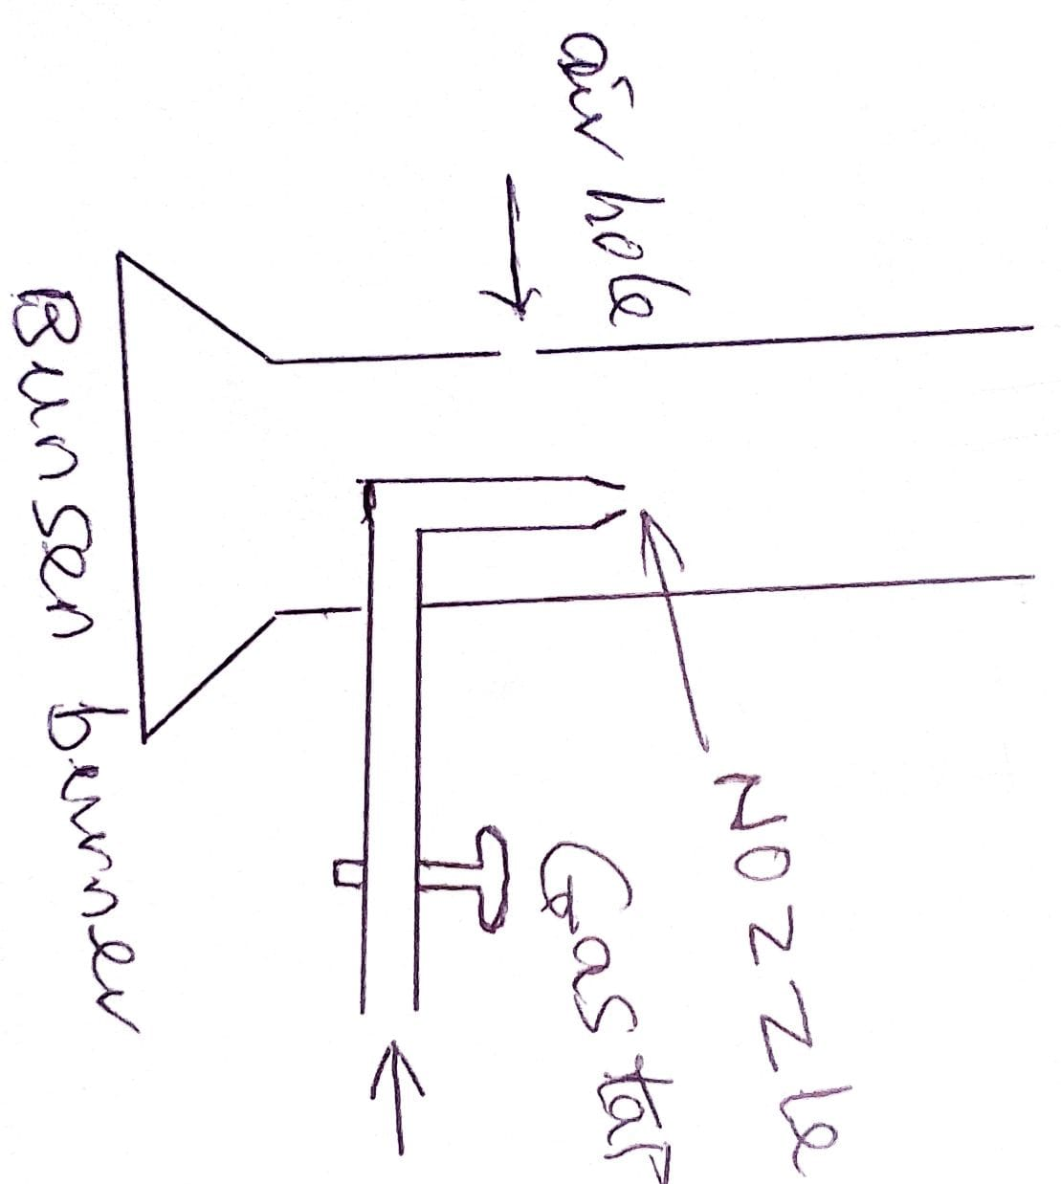

(b) State two assumptions made in deriving the equation of continuity (2mk)

23 . (a) State the reason why the speed of water at the narrow tube/section of a river is higher

than at the wider section. (2 mks)

(b) State Hooke’s law (1 mk)

(c) Water flows through a pipe at a speed of 5m/s. Given that the flow rate at the constriction is 0.05m3/s, find the cross-section area of the pipe in cm2

(3mks)

24. (a) State two factors that affect the strength of an electromagnet. (3 mks)

(b) State three factors which affect the speed of sound in air. (3 mks)

(c) Explain why the walls of studio are padded with woolen materials. (2 mks)

25. Define each of the following terms as used in Physics:-

(a) Wavelength (2 mks)

(b) Frequency (2 mks)

(c) Amplitude (2 mks)