**FORM 4 TERM 1 OPENER(ENTRY)**

**AGRICULTURE PP1**

**FORM FOUR**

**TIME:2 HOURS**

**NAME………………………………………… CLASS……………………..**

**INSTRUCTIONS TO CANDIDATES**

* Write your name class and admission number in the spaces provided above.
* This paper consists of THREE sections A,B and C.
* Answer ALL questions in section A and B.
* Answer any TWO questions in Section C.
* Answers to all questions must be in spaces provided.
* Candidates should check the question paper to ascertain that all the pages are printed as indicated and that no questions are missing.

**SECTION A (30MARKS)**

1. What does land reform program include? (2 marks)

______________________________________________________________________________________________________________________________________________________________________________________________________________________________________________________________________________________________________________________________________________________________________________________________________

1. State four objective of land redistribution (2 marks)

______________________________________________________________________________________________________________________________________________________________________________________________________________________________________________________________________________________________________________________________________________________________________________________________________

1. Name four type of soil erosion (2 marks)

______________________________________________________________________________________________________________________________________________________________________________________________________________________________________________________________________________________________________________________________________________________________________________________________________

1. State role of trees in soil and water conservation (2marks)

______________________________________________________________________________________________________________________________________________________________________________________________________________________________________________________________________________________________________________________________________________________________________________________________________

1. Name four weed control methods (2marks)

______________________________________________________________________________________________________________________________________________________________________________________________________________________________________________________________________________________________________________________________________________________________________________________________________

1. Give four advantages of tillage in weed control (2 marks)

______________________________________________________________________________________________________________________________________________________________________________________________________________________________________________________________________________________________________________________________________________________________________________________________________

1. Name four part of a plant that can be damaged by insect with biting and chewing mouth parts (2 marks)

______________________________________________________________________________________________________________________________________________________________________________________________________________________________________________________________________________________________________________________________________________________________________________________________________

1. State four factors affecting the efficiency of pesticides (2 marks)

______________________________________________________________________________________________________________________________________________________________________________________________________________________________________________________________________________________________________________________________________________________________________________________________________

1. State four maize diseases in Kenya (2 marks)

______________________________________________________________________________________________________________________________________________________________________________________________________________________________________________________________________________________________________________________________________________________________________________________________________

1. Name four high altitude grass pasture in Kenya (2marks)

______________________________________________________________________________________________________________________________________________________________________________________________________________________________________________________________________________________________________________________________________________________________________________________________________

1. Identify four reasons for top dressing pasture (2marks)

______________________________________________________________________________________________________________________________________________________________________________________________________________________________________________________________________________________________________________________________________________________________________________________________________

1. State four factors to determine the quality of hay (2 marks)

______________________________________________________________________________________________________________________________________________________________________________________________________________________________________________________________________________________________________________________________________________________________________________________________________

1. Name four type of land slide (2marks)

______________________________________________________________________________________________________________________________________________________________________________________________________________________________________________________________________________________________________________________________________________________________________________________________________

1. State four methods of breaking seed dormancy (2marks)

______________________________________________________________________________________________________________________________________________________________________________________________________________________________________________________________________________________________________________________________________________________________________________________________________

1. Name four factor influencing crop rotation (2 marks)

______________________________________________________________________________________________________________________________________________________________________________________________________________________________________________________________________________________________________________________________________________________________________________________________________

**SECTION B (20 marks)**

1. The diagram below show two weeds study them and answer the question that follows.

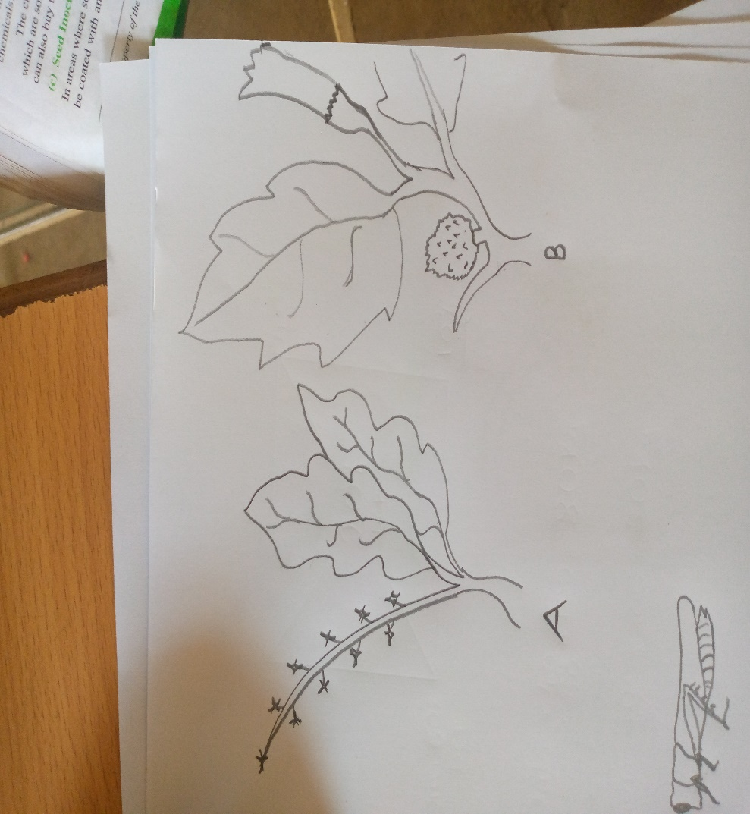

1. Identify weed A and B. (2 marks)

**A______________________________**

**B______________________________**

1. What are the harmful effect of weed A and B to the farmer (2 marks)

**A___________________________________________________________________**

**B___________________________________________________________________**

1. What is the morphological classification of both weed A and B (1 mark)

***________________________________________________________________________________________________________________________________________***

1. (a) Identify the crop represented by the diagram below (1 mark)

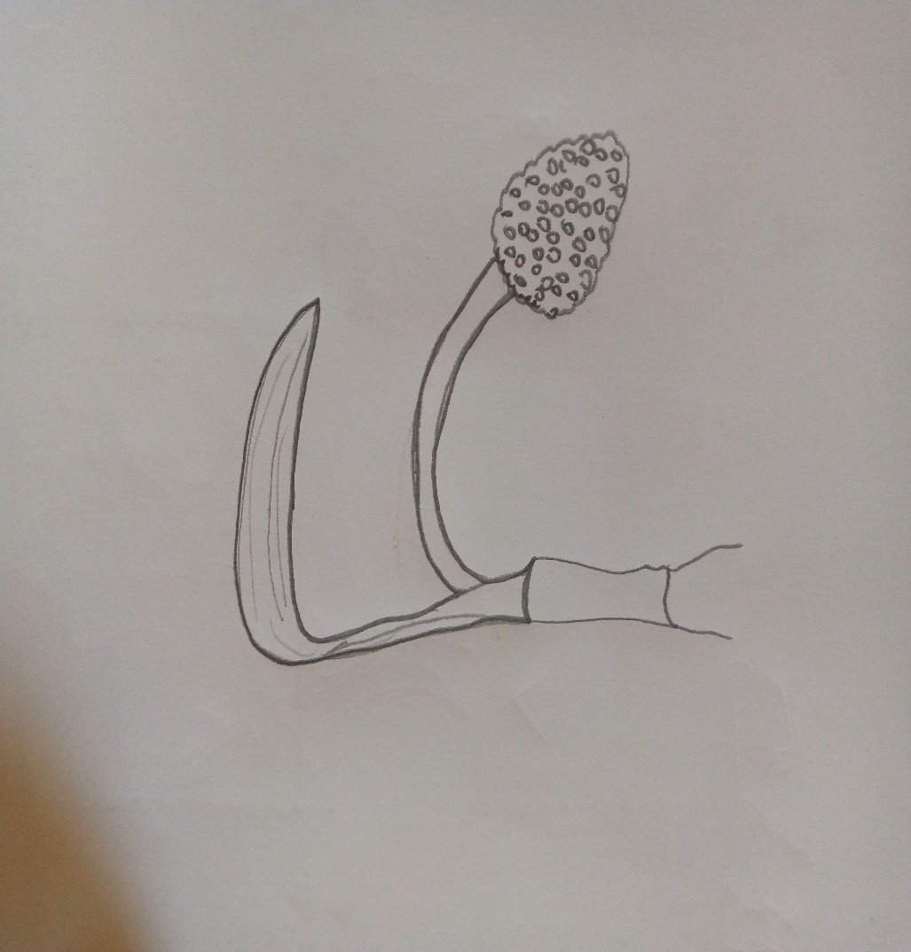

____________________________________________________________________________________________________________________________________________________________

(b) name two pest and two diseases that can attack the crop named above (4 marks)

**Pest ______________________________________**

**______________________________________**

**Diseases __________________________________**

**__________________________________**

1. Study the diagram below and answers the question that follows.

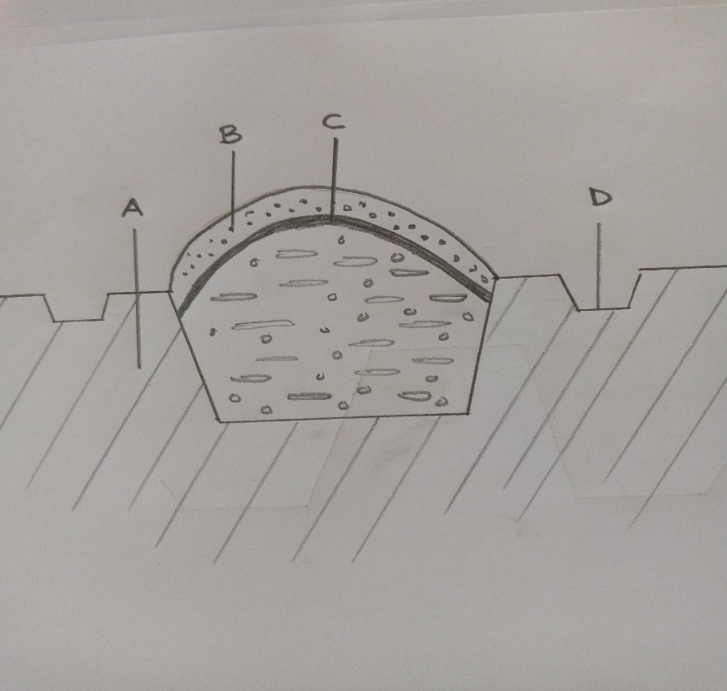

1. Identify the structure below (1 mark)

________________________________________________________________________________________________________________________________________

1. Lebel part A, B, C and D (4 marks)

**A____________________________________**

**B____________________________________**

**C____________________________________**

**D____________________________________**

1. Study the diagram below and answer the question that follows.

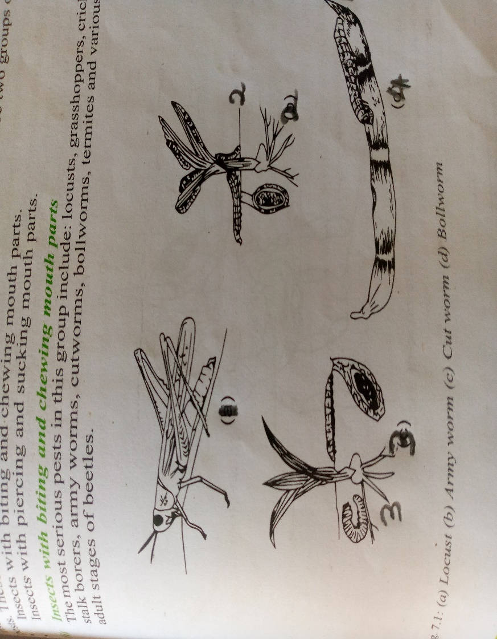

a) identify the type of classification of the pest represented by the cycle above (1 mark)

______________________________________________________________________________

b) name pest 1,2,3 and 4 (4 marks)

**1__________________________**

**2__________________________**

**3__________________________**

**4__________________________**

**SECTION C (40MKS)**

***Answer any two Questions in this section***

20. (a) Describe harvesting of pyrethrum under the following sub-headings

(i) Procedure (4mks)

(ii) Precautions (6mks)

(b) Describe the safety measures observed when handling farm herbicides (10mks)

21. Describe the production of Rhodes grass (Chloris gayana) under the following sub-headings

(a) Land preparation (5mks)

(b) Pasture establishment (8mks)

(c) Maintenance (7mks)

22. (a) State and explain the uses of farm records to a farmer (10 mks)

(b) Explain how the following land reforms are carried out

(i) Land consolidation (5mks)

(ii) Land adjudication and registration (5mks)