**FORM 3 TERM 1 OPENER(ENTRY)**

**AGRICULTURE**

**FORM THREE**

**TIME:2 HOURS**

***ANSWER ALL QUESTION IN THE SPACE PROVIDED***

1. Name three sources of water to the animals’ body (3 mark)

________________________________________________________________________________________________________________________________________________________________________________________________________________________________________________________________________________________________________________________

1. Name four source of carbohydrates for animals (4 marks)

____________________________________________________________________________________________________________________________________________________________________________________________________________________________________________________________________________________________________________________________________________________________________________________________________________________________________________________________________________________

1. (a) Distinguish between a feedstuff and a feed (2 marks)

______________________________________________________________________________________________________________________________________________________________________________________________________________________________________________________________________________________________________________________________________________________________________________________________________

(b) list two type of concentration (2 marks)

________________________________________________________________________________________________________________________________________________________________________________________________________________________________________________________________________________________________________________________

1. Using the Pearson’s square method, compute a 100kg ration with 20% DCP from oats which contains 10%DCP and simsim seed cake containing 60%DCP. (4 marks)
2. Define the term parasitism (1 mark)

__________________________________________________________________________________________________________________________________________________________________________________________________________________________________________

1. State five effects of parasites in livestock (5 marks)

__________________________________________________________________________________________________________________________________________________________________________________________________________________________________________________________________________________________________________________________________________________________________________________________________________________________________________________________________________________________________________________________________________________________________

1. What is the intermediate host of liver fluke? (1 mark)

____________________________________________________________________________________________________________________________________________________________

1. Describe the life cycle of three host tick (7 marks)

________________________________________________________________________________________________________________________________________________________________________________________________________________________________________________________________________________________________________________________________________________________________________________________________________________________________________________________________________________________________________________________________________________________________________________________________________________________________________________

1. Why is it important to keep animals healthy (6 mark)

__________________________________________________________________________________________________________________________________________________________________________________________________________________________________________________________________________________________________________________________________________________________________________________________________________________________________________________________________________________________________________________________________________________________________

1. Name five pre disposing factors of livestock diseases (5 mark)

____________________________________________________________________________________________________________________________________________________________________________________________________________________________________________________________________________________________________________________________________________________________________________________________________________________________________________________________________________________

1. Name and give example of type of vegetables (12 marks)

__________________________________________________________________________________________________________________________________________________________________________________________________________________________________________________________________________________________________________________________________________________________________________________________________________________________________________________________________________________________________________________________________________________________________

1. What are the characteristic of a good store (7 marks)

________________________________________________________________________________________________________________________________________________________________________________________________________________________________________________________________________________________________________________________________________________________________________________________________________________________________________________________________________________________________________________________________________________________________________________________________________________________________________________

1. State five factors influencing crop rotation (5 marks)

***__________________________________________________________________________________________________________________________________________________________________________________________________________________________________________________________________________________________________________________________________________________________________________________________________________________________________________________________________________________________________________________________________________________________________***

1. List six steps of transplanting tree seedling (6 marks)

__________________________________________________________________________________________________________________________________________________________________________________________________________________________________________________________________________________________________________________________________________________________________________________________________________________________________________________________________________________________________________________________________________________________________

1. State fIVE factors to determine spacing in crop production (5 marks)

__________________________________________________________________________________________________________________________________________________________________________________________________________________________________________________________________________________________________________________________________________________________________________________________________________________________________________________________________________________________________________________________________________________________________

1. The diagram below a cow suffering from a certain deficiency.

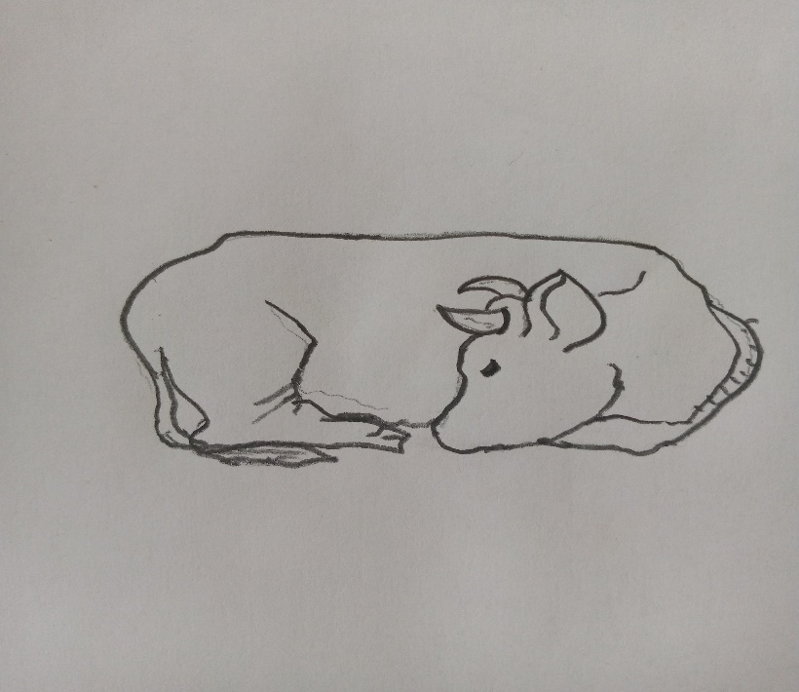

1. Name the disease the animal is suffering from. (1mark)

________________________________________________________________________________________________________________________________________

1. Which two minerals is the animal lacking (2 mark)?

____________________________________________________________________________________________________________________________________________________________________________________________________________

1. What is the symptom of the oesteomalacia (4 marks)?

____________________________________________________________________________________________________________________________________________________________________________________________________________________________________________________________________________________________________________________________________________________

1. The diagram below shows a pest attacking tomato fruit

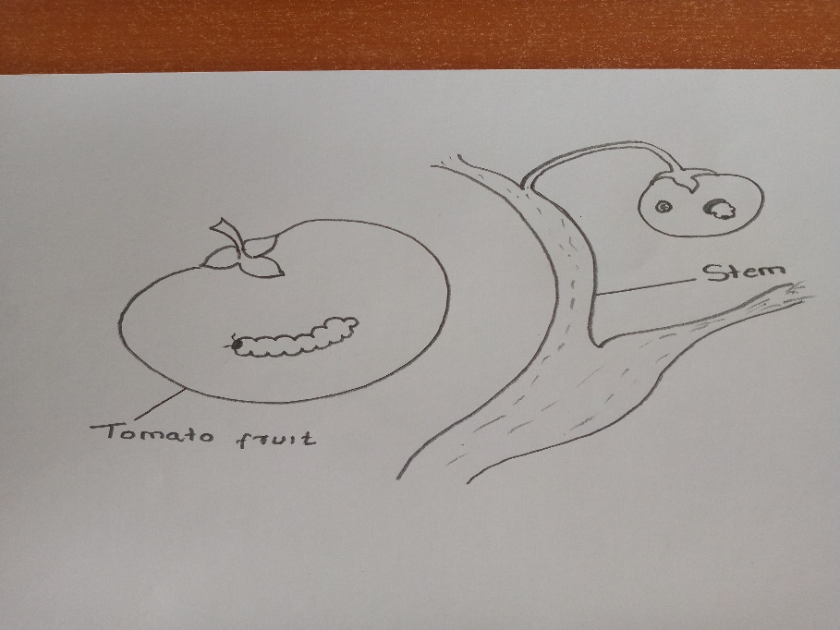

1. Identify the pest (1 MARK)

________________________________________________________________________________________________________________________________________

1. Name 4 other crops that can be attacked by the above-named pest (4 MARK)

____________________________________________________________________________________________________________________________________________________________________________________________________________________________________________________________________________________________________________________________________________________

1. The diagram below shows a plant been trained. study it and answer the question that follows

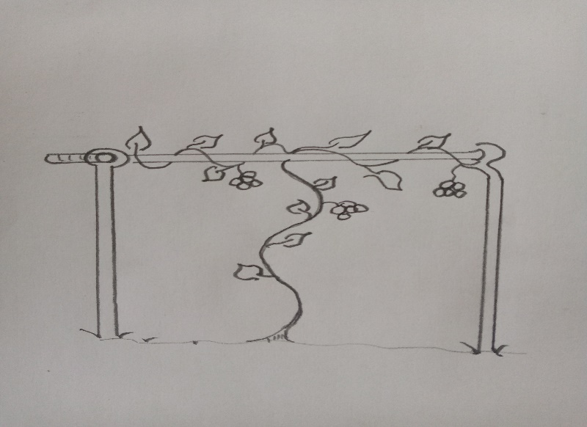

1. Identify the practice (1mark)

________________________________________________________________________________________________________________________________________

1. Give reasons for practicing the above method (1 marks)

________________________________________________________________________________________________________________________________________

1. Give one example of crop trained by the above method (1 mark)

________________________________________________________________________________________________________________________________________

1. Name two other methods of training plants with weak stem (2 marks)

____________________________________________________________________________________________________________________________________________________________________________________________________________

1. Draw and name two methods of soil sampling (2marks)
2. Describe general soil sampling procedure (6 marks)

__________________________________________________________________________________________________________________________________________________________________________________________________________________________________________________________________________________________________________________________________________________________________________________________________________________________________________________________________________________________________________________________________________________________________