**KENYA EDUCATORS CONSULTANCY EXAMS**



**JUNIOR SECONDARY SCHOOL**

**GRADE 7 END TERM 1 EXAM– 2023**

**PRE-TECHNICAL & PRE-CAREER STUDIES**

**Time: 2 hours**

Name………………………………... School…………

**INSTRUCTIONS TO CANDIDATES:**

.*Do not open the booklet until you are told to do so.*

*.Read each question carefully.*

*.Answer ALL the questions.*

*.Write your answers, in either blue or black ink, in the spaces provided in the booklet*

**FOR EXAMINERS ONLY**

|  |  |  |
| --- | --- | --- |
| **Questions**  **1-28**  **Out of 100 marks** | **Candidate Score** | **Candidate performance level** |

1. Define the term personal safety. ***(2mks)***

………………………………………………………………………………………………………………………………………………………………………………………………………………………………………………………………………………………………

1. Explain the meaning of the following terms as used in Pre-technical studies
2. Safety ***(2mks)***

………………………………………………………………………………………………………………………………………………………………………………………………………………………………………………………………………

1. Hazard ***(2mks)***

………………………………………………………………………………………………………………………………………………………………………………………………………………………………………………………………………

1. State the actions that one may take and result into harm, discomfort or sickness in their day to day life. ***(3mks)***

………………………………………………………………………………………………………………………………………………………………………………………………………………………………………………………………………………………………………………………………………………………………………………………………

1. John a standard 8 student is a disastrous student while at home. State 5 hazards that may come to the student’s personal safety. ***(5mks)***

………………………………………………………………………………………………………………………………………………………………………………………………………………………………………………………………………………………………………………………………………………………………………………………………………………………………………………………………………………………………………………………………………………………………………………………………………………………………………………………………………………………………………………………………………………………………………………………………………………………………………………………………………………………………………………………………………………………………………………………………

1. Discuss any 2 forms of expected safety behavior common to both a farmer and a nurse. ***(2mks)***

………………………………………………………………………………………………………………………………………………………………………………………………………………………………………………………………………………………………………………………………………………………………………………………………………………………………………………………………………………………………

1. Define the following terms;
2. Occupation ***(2mks)***

………………………………………………………………………………………………………………………………………………………………………………………………………………………………………………………………………

1. Career ***(2mks)***

………………………………………………………………………………………………………………………………………………………………………………………………………………………………………………………………………

1. Study the pictures below and answer the questions that follows.

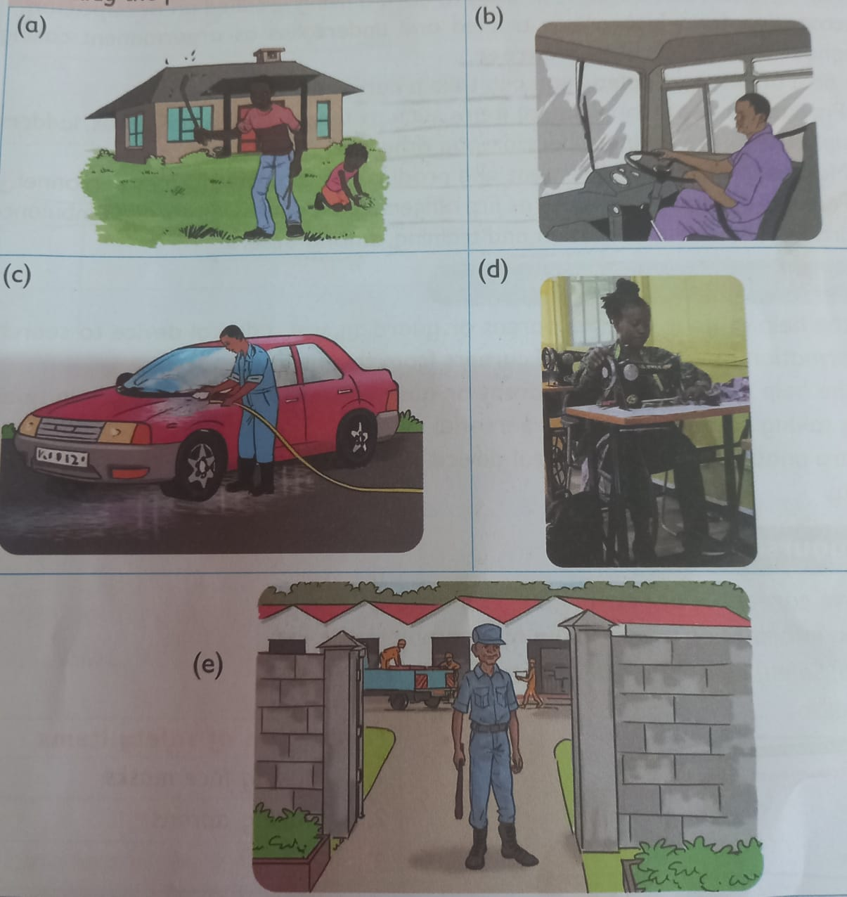

Which activity is each of the people in the picture doing? ***(5mks)***

a……………………………………………………………………..

b……………………………………………………………………..

c……………………………………………………………………..

d…………………………………………………………………….

e…………………………………………………………………….

1. In the field of personal safety, state any 3 career opportunity for a student to venture into in the future. ***(3mks)***

………………………………………………………………………………………………………………………………………………………………………………………………………………………………………………………………………………………………………………………………………………………………………………………………………………………………………………………………………………………………

1. Personal safety is very important in our day-to-day life. Plan and stay. Kindy state and atleast 4 of these importance. ***(4mks)***

………………………………………………………………………………………………………………………………………………………………………………………………………………………………………………………………………………………………………………………………………………………………………………………………………………………………………………………………………………………………………………………………………………………………………………………………………………………………………………………………………………………………

1. Define the term injury. ***(2mks)***

………………………………………………………………………………………………………………………………………………………………………………………………………………………………………………………………………………………………

1. State any 3 common injuries that occur in your locality. ***(3mks)***

………………………………………………………………………………………………………………………………………………………………………………………………………………………………………………………………………………………………………………………………………………………………………………………………………………………………………………………………………………………………

1. What is first aid? ***(2mks)***

………………………………………………………………………………………………………………………………………………………………………………………………………………………………………………………………………………………………

1. The set of items used to give immediate medical treatment to injured person is called? ***(1mk)***

………………………………………………………………………………………………………………………………………………………………………………………………

1. Jane a Grade 7 student met Stacy a Grade 3 student in their school with an injury on her hand on her way home. Give the procedure Jane will take to administer first aid to Stacy. ***(5mks)***

………………………………………………………………………………………………………………………………………………………………………………………………………………………………………………………………………………………………………………………………………………………………………………………………………………………………………………………………………………………………………………………………………………………………………………………………………………………………………………………………………………………………………………………………………………………………………………………………………………………………………………………………………………………………

1. Define the term metal as used in Pre-technical studies. ***(2mks)***

………………………………………………………………………………………………………………………………………………………………………………………………………………………………………………………………………………………………………………………………………………………………………………………………

1. State any 5 types of renewed types of metal. ***(5mks)***

………………………………………………………………………………………………………………………………………………………………………………………………………………………………………………………………………………………………………………………………………………………………………………………………………………………………………………………………………………………………………………………………………………………………………………………………

1. What is non-ferrous metals? ***(2mks)***

………………………………………………………………………………………………………………………………………………………………………………………………………………………………………………………………………………………………

1. State 4 physical properties of ferrous metals. ***(4mks)***

………………………………………………………………………………………………………………………………………………………………………………………………………………………………………………………………………………………………………………………………………………………………………………………………………………………………………………………………………………………………………………………………………………………………………………………………

1. List any 5 safety items found in first aid kit. ***(5mks)***

………………………………………………………………………………………………………………………………………………………………………………………………………………………………………………………………………………………………………………………………………………………………………………………………………………………………………………………………………………………………………………………………………………………………………………………………

1. Give any 4 safety measures to minimize burns at home. ***(4mks)***

………………………………………………………………………………………………………………………………………………………………………………………………………………………………………………………………………………………………………………………………………………………………………………………………………………………………………………………………………………………………………………………………………………………………………………………………………………………………………………………………………………………………

1. Give at least 4 reasons why it is important to observe safety so as to reduce injuries in our day -to-day activities. ***(4mks)***

………………………………………………………………………………………………………………………………………………………………………………………………………………………………………………………………………………………………………………………………………………………………………………………………………………………………………………………………………………………………

1. List 3 states in which materials exist. ***(3mks)***

………………………………………………………………………………………………………………………………………………………………………………………………………………………………………………………………………………………………………………………………………………………………………………………………

1. State any 4 physical properties of materials. ***(4mks)***

………………………………………………………………………………………………………………………………………………………………………………………………………………………………………………………………………………………………………………………………………………………………………………………………………………………………………………………………………………………………

1. The crossword puzzle below has names of common materials used to do different jobs. Look for atleast 4 names and write them down

|  |  |  |  |  |  |  |
| --- | --- | --- | --- | --- | --- | --- |
| **L**  **Q**  **G**  **A**  **S**  **S**  **N** | **E**  **L**  **W**  **A**  **S**  **V**  **P** | **A**  **K**  **O**  **T**  **X**  **P**  **L** | **T**  **I**  **O**  **U**  **B**  **A**  **M** | **H**  **N**  **D**  **K**  **V**  **P**  **X** | **E**  **L**  **I**  **T**  **X**  **E**  **T** | **R**  **E**  **B**  **B**  **U**  **R**  **M** |

1. Name 3 items that can be made from the following metals.
2. Metals ***(3mks)***

……………………………………….

……………………………………….

……………………………………….

1. Aluminum. ***(3mks)***

……………………………………….

……………………………………….

……………………………………….

1. State any 4 general rules and safety to be observed during handling of materials.

***(4mks)***

………………………………………………………………………………………………………………………………………………………………………………………………………………………………………………………………………………………………………………………………………………………………………………………………………………………………………………………………………………………………………………………………………………………………………………………………

1. Study the picture below and identify the type of injury illustrated by each of the pictures. ***(3mks)***

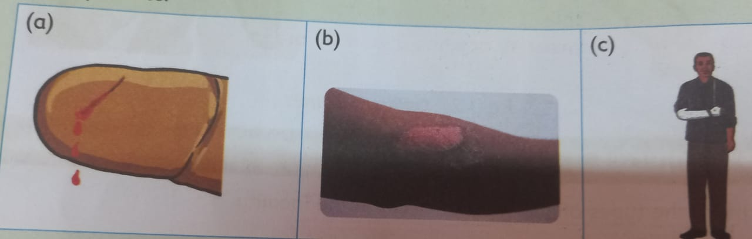

a……………………………………………………

b……………………………………………………

c…………………………………………………….

1. Give any 4 differences between metallic and non-metallic materials. ***(4mks)***

|  |  |
| --- | --- |
| **Metallic materials** | **Non-metallic materials** |
| i)  ii)  iii)  iv) |  |

**THIS IS THE LAST PRINTED PAGE**