**NAME …………………………………………………………………………..**

**ADM NO: ……………………….**

**DATE:……………………………**

**SIGNATURE:……………….......**

**AGRICULTURE**

**FORM TWO (2)**

**TIME: 2 HOURS**

**BRAIN QUEST SERIES FORM 2 END OF YEAR** **EXAMS 2023**

**INSTRUCTIONS TO ALL CANDIDATES**

1. **This paper consists of three sections A, B and C.**
2. **Answer all questions in sections A, B and C.**
3. **All answer must be written in the spaces provided.**

**FOR EXAMINERS USE ONLY**

|  |  |  |  |
| --- | --- | --- | --- |
| **SECTION** | **QUESTION** | **MAXIMUM SCORE** | **CANDIDATE SCORE** |
| **A** | **1-19** | **50** |  |
| **B** | **20-24** | **20** |  |
| **C** | **25-26** | **30** |  |
| **TOTAL** | | **100** |  |

**SECTION A (50 MARKS) ATTEMPT ALL QUESTIONS**

1. Give two reasons why farmers are engaged to practice organic farming. 2mks
2. Give two advantages of intensive system of farming. 2mks
3. Name three forms of horticulture practiced in Kenya. 3mks
4. List three physical weathering agents in the soil formation process. 3mks
5. State two mechanical methods of separating soil particles. 2mks
6. Give two roles of soil micro-organisms that are beneficial to crops. 2mks
7. Explain three factors that influence the type of irrigation to be used in a farm. 3mks
8. Give four reasons for treating water for use in the farm. 2mks
9. State three disadvantages of using plastic pipes to convey water. 3mks
10. State four factors that affect the quality of farmyard manure. 4mks
11. State any four characteristics of a fertile soil. 4mks
12. Give tow reasons for carrying out the following operations in the land preparation.

a) Rolling 2mks

b) Lavelling 2mks

1. State four factors that influence the number of secondary cultivations in seedbed preparations. 2mks
2. Give four reasons for keeping livestock health record in the farm. 4mks
3. What is meant by preference and choice as used in agriculture. 1mk
4. State two ways by which soil PH may affect crop production. 2mks
5. Give the meaning of the following terms;-

a) Nitrogen fixation into the soil 1mk

b) Phosphorous fixation in the loss of soil fertility. 1mk

1. Give three reasons for planting crops at the correct spacing . 3mks
2. Name the plant part used for vegetative propagation of each of the following plants.

a) Cassava ½ mk

b) Sisal ½ mk

c) Pyrethrum ½ mks

d) Sweet potatoes ½ mks

**SECTION B (20 MARKS) ANSWER ALL THE QUESTIONS**

20. Study the diagram below and answer the questions that follow.

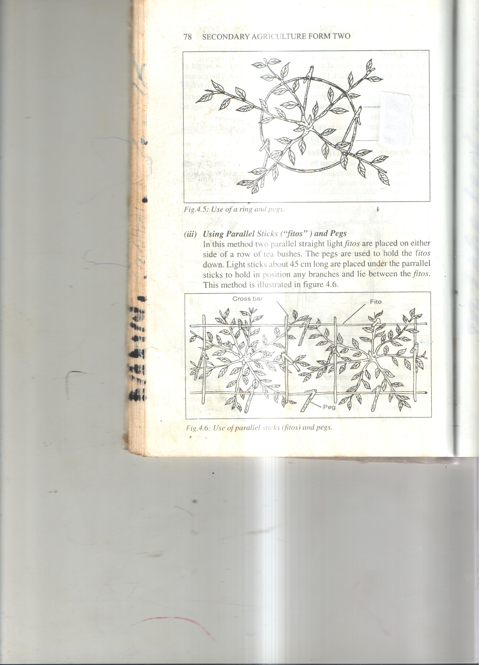

a) Identify the method of frame formation in production shown above. 1mk

b) Apart the above method, give two other methods of frame formation in tea production. 2mks

c) Give two disadvantages of multiple stem pruning system in coffee. 2mks

1. The following are metal work tools and equipments. Study them and answer the questions that follow.

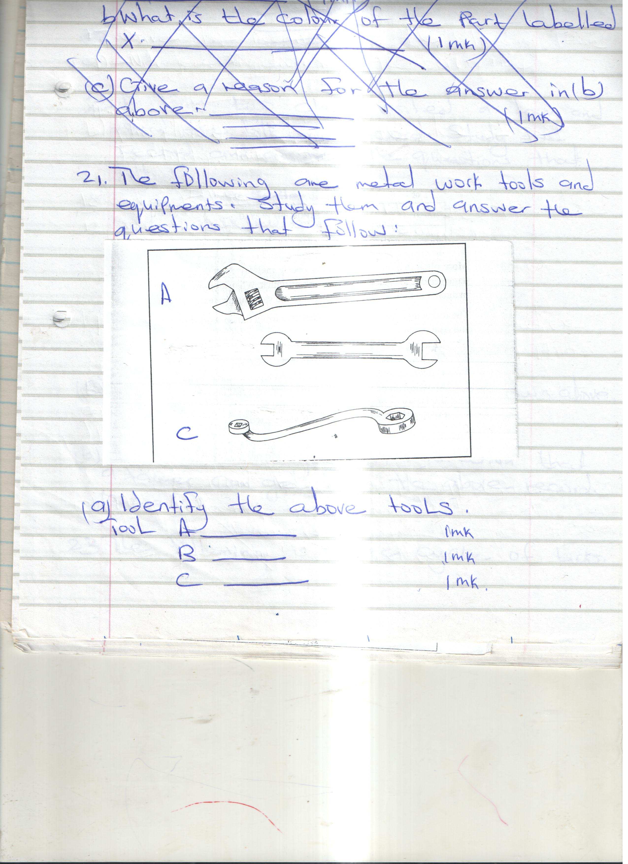

a) Identify the above tools.

Tool A _________________ 1mk

Tool B ________________ 1mk

Tool C ________________ 1mk

b) State the functional advantage of tool C compared to tool B. ½ mk

c) State the advantage of tool A compared to tool C and B. ½ mk

1. A Form two class visited a farm and found the following record. Study the record and answer the questions that follow.

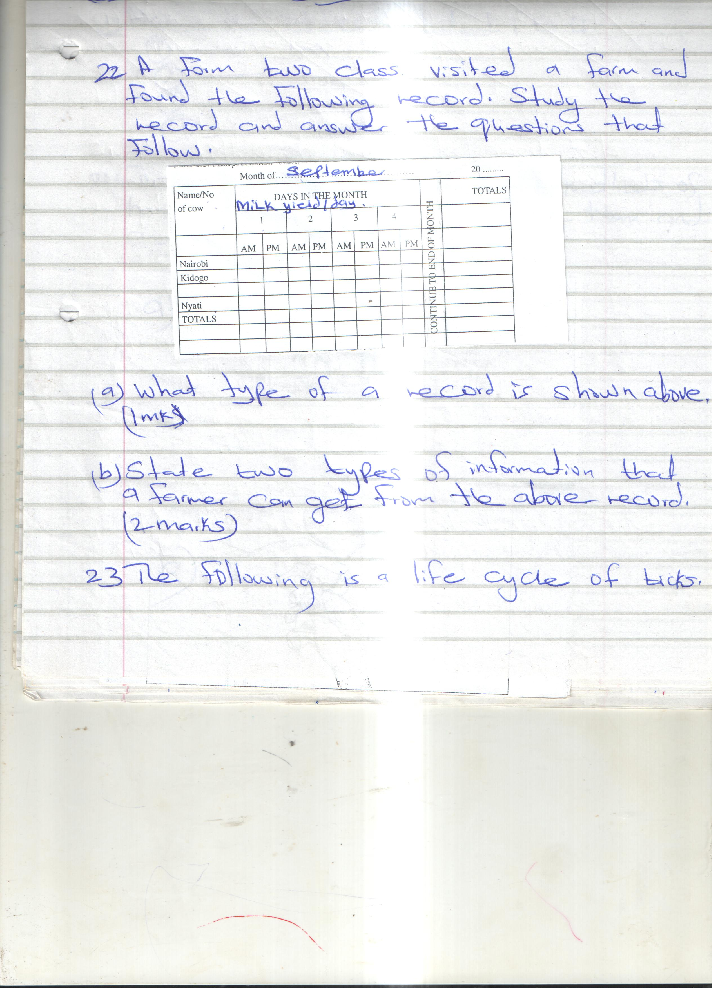

a) What type of a record is shown above. 1mk

b) State two types of information that a farmer can get from the above record. 2mks

1. The following is a life cycle of ticks

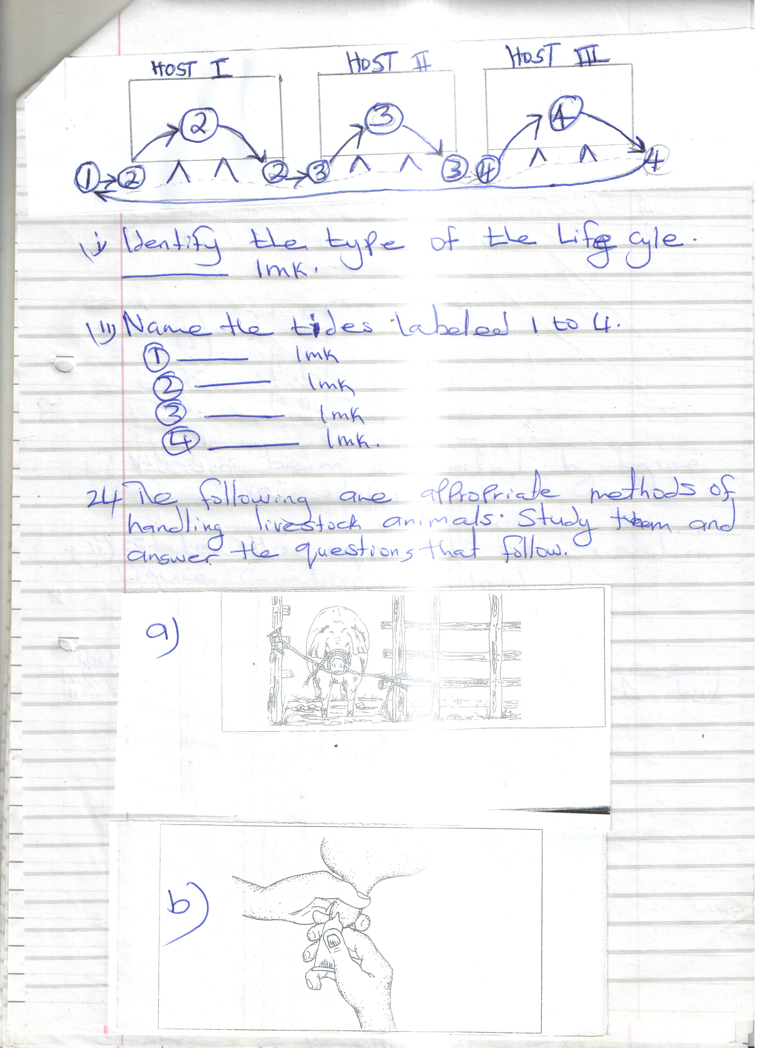

i) Identify the type of the life cycle. 1mk

ii) Name the tides labeled 1 to 4.

1 _____________ 1mk

2 _____________ 1mk

3 ______________ 1mk

4 _________________ 1mk

1. The following are appropriate methods of handling livestock animals. Study them and answer the questions that follow.





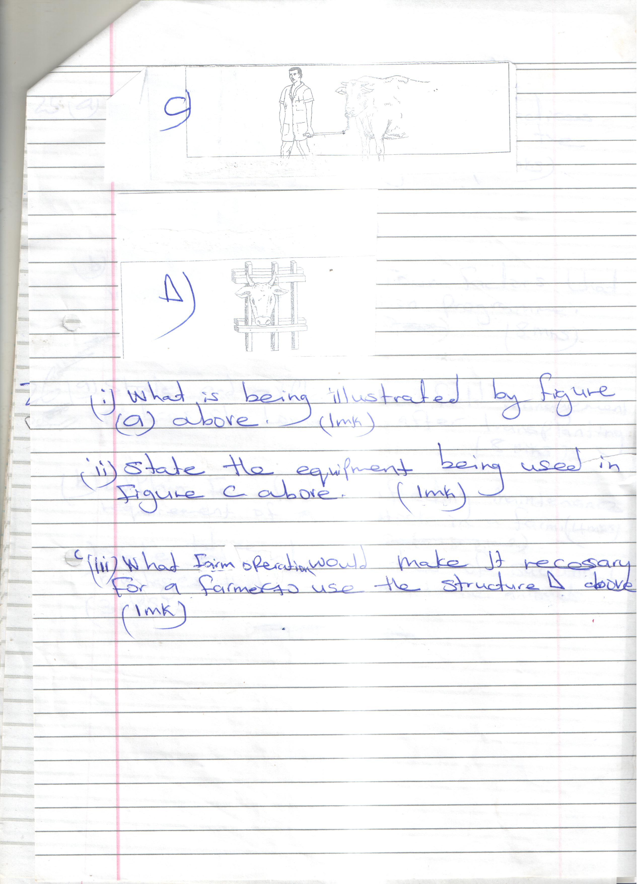



i) What is being illustrated by figure (a) above. 1mk

ii) State the equipment being used in figure C above. 1mk

iii) What farm operation would make it necessary for a farmers use the structure D above. 1mk

**SECTION C (30 MARKS)**

**ANSWER BOTH QUESTIONS IN THE SPACES PROVIDED**

1. a) State and explain all the practices carried out in a nursery while the seedlings are growing. 7mks

b) State and explain four factors that influence a crop rotation programme. 8mks

1. a) State and explain the field management practices of tomatoes after transplanting. 8 mks

b) Explain four factors affecting maintenance requirement of livestock in a farm. 4mks

c) State three characteristics of succulent roughages that are given to the animals. 3mks