**QUALITY ASSUARANCE SERIRS FORM 1 END TERM 3 EXAMS 2023**

**AGRICULTURE (QUESTION PAPER)**

**FORM ONE**

**TIME 2HOURS**

**Name**: …………………………………………………………. **Adm** **No**: ……………….

**School**: ……………………………………………………….. **Class**: …………………..

**Signature**: …………………………………………………….. **Date**: …………………...

**INSTRUCTIONS TO ALL CANDIDATES:**

1. ***Write your name and admission number in the spaces provided.***
2. ***This paper consists of section A, B and C.***
3. ***Answer all questions in section A, B and C in the spaces provided.***

***FOR EXAMINER USE ONLY***

|  |  |  |  |
| --- | --- | --- | --- |
| **SECTION** | **QUESTIONS** | **MAXIMUM SCORE** | **CANDIDATE SCORE** |
| **A** | **1-16** | **50** |  |
| **B** | **17-20** | **20** |  |
| **C** | **21-22** | **30** |  |
|  | **TOTAL** | **100** |  |

**SECTION A (50 MARKS) ANSWER ALL QUESTIONS.**

1. Differentiate between olericulture and pomoculture as used in crop production.(2mks)

**…………………………………………………………………………………………………………………**

**…………………………………………………………………………………………………………………**

**…………………………………………………………………………………………………………………**

**…………………………………………………………………………………………………………………**

1. List four methods of farming.(4mks)

**…………………………………………………………………………………………………………………**

**…………………………………………………………………………………………………………………**

**…………………………………………………………………………………………………………………**

**…………………………………………………………………………………………………………………**

**………………………………………………………………………………………………………………… ………………………………………………………………………………………………………………..**

1. State four advantages of organic farming. (4mks)

**…………………………………………………………………………………………………………………**

**…………………………………………………………………………………………………………………**

**…………………………………………………………………………………………………………………**

**…………………………………………………………………………………………………………………**

**………………………………………………………………………………………………………………… ………………………………………………………………………………………………………………..**

1. Give four advantages of intensive farming.(4mks)

**…………………………………………………………………………………………………………………**

**…………………………………………………………………………………………………………………**

**…………………………………………………………………………………………………………………**

**…………………………………………………………………………………………………………………**

1. List three physical weathering agents in the soil formation process.(3mks)

**…………………………………………………………………………………………………………………**

**…………………………………………………………………………………………………………………**

**…………………………………………………………………………………………………………………**

**………………………………………………………………………………………………………………… ………………………………………………………………………………………………………………..**

1. State two mechanical methods of separating soil particle according to size during soil analysis.(2mks)

**…………………………………………………………………………………………………………………**

**…………………………………………………………………………………………………………………**

**………………………………………………………………………………………………………………… ………………………………………………………………………………………………………………..**

1. State two effects of HIV/AIDS on agricultural production.(2mks)

**…………………………………………………………………………………………………………………**

**…………………………………………………………………………………………………………………**

**…………………………………………………………………………………………………………………**

**………………………………………………………………………………………………………………… ………………………………………………………………………………………………………………..**

1. Distinguish between soil structure and soil texture.(2mks)

**…………………………………………………………………………………………………………………**

**…………………………………………………………………………………………………………………**

**…………………………………………………………………………………………………………………**

**………………………………………………………………………………………………………………… ………………………………………………………………………………………………………………..**

1. Give three reasons for growing crops under optimum temperature conditions (3mks)

**…………………………………………………………………………………………………………………**

**…………………………………………………………………………………………………………………**

**…………………………………………………………………………………………………………………**

1. Give two roles of soil microorganisms that are beneficial to crops. (2mks)

**…………………………………………………………………………………………………………………**

**…………………………………………………………………………………………………………………**

**…………………………………………………………………………………………………………………**

**………………………………………………………………………………………………………………… ………………………………………………………………………………………………………………..**

1. State four biotic factors that influence crop production.(4mks)

**…………………………………………………………………………………………………………………**

**…………………………………………………………………………………………………………………**

**…………………………………………………………………………………………………………………**

**…………………………………………………………………………………………………………………**

**………………………………………………………………………………………………………………… ………………………………………………………………………………………………………………..**

1. Explain how the properties of rainfall influence crop production.(4mks)

**…………………………………………………………………………………………………………………**

**…………………………………………………………………………………………………………………**

**…………………………………………………………………………………………………………………**

**…………………………………………………………………………………………………………………**

**………………………………………………………………………………………………………………… ………………………………………………………………………………………………………………..**

1. Explain four ways in which the government policy improves agricultural production.(4mks)

**………………………………………………………………………………………………………………… ……………………………………………………………………………………………………………….. ………………………………………………………………………………………………………………… ………………………………………………………………………………………………………………..**

1. Give four conditions of the land which may make it necessary to carry out reclamation practices.(4mks)

**…………………………………………………………………………………………………………………**

**…………………………………………………………………………………………………………………**

**…………………………………………………………………………………………………………………**

**…………………………………………………………………………………………………………………**

**…………………………………………………………………………………………………………………**

**…………………………………………………………………………………………………………………**

**………………………………………………………………………………………………………………….**

1. List three methods of treating water for use in the farm.(3mks)

**…………………………………………………………………………………………………………………**

**…………………………………………………………………………………………………………………**

**…………………………………………………………………………………………………………………**

**………………………………………………………………………………………………………………… ………………………………………………………………………………………………………………..**

1. State three aspects of light that affect agriculture.(3mks)

**…………………………………………………………………………………………………………………**

**…………………………………………………………………………………………………………………**

**…………………………………………………………………………………………………………………**

**………………………………………………………………………………………………………………… ………………………………………………………………………………………………………………..**

**SECTION B. (20 MARKS) ANSWER ALL QUESTIONS.**

1. The diagram below shows a set-up of an experiment to study an aspect of soil. The setup was left undisturbed for five hours. Study it and answer the questions that follow.

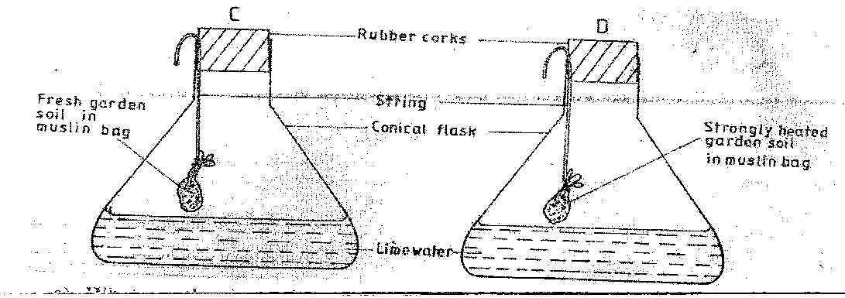

* 1. What was the aim of the experiment.(1mk)

**………………………………………………………………………………………………………………… ………………………………………………………………………………………………………………..**

* 1. State one observation that was made in each of the flask labeled C and D.(2mks)

**…………………………………………………………………………………………………………………**

**…………………………………………………………………………………………………………………**

**………………………………………………………………………………………………………………… ………………………………………………………………………………………………………………..**

* 1. Give a reason for each of your answer in (b) above. (2mks)

**…………………………………………………………………………………………………………………**

**…………………………………………………………………………………………………………………**

1. Study the diagram below and answer question that follow.

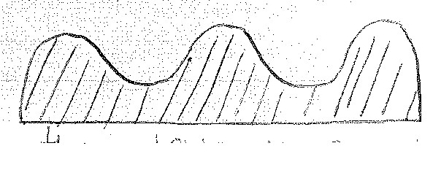

* 1. Identify the tertiary operation above.(1mk)

**………………………………………………………………………………………………………………… ………………………………………………………………………………………………………………..**

* 1. Give two importance of practicing the above tertiary operation.(2mks)

**…………………………………………………………………………………………………………………**

**…………………………………………………………………………………………………………………**

**………………………………………………………………………………………………………………… ………………………………………………………………………………………………………………..**

1. The diagram below represents farm tools and equipments. Study them and answer the questions that follow.

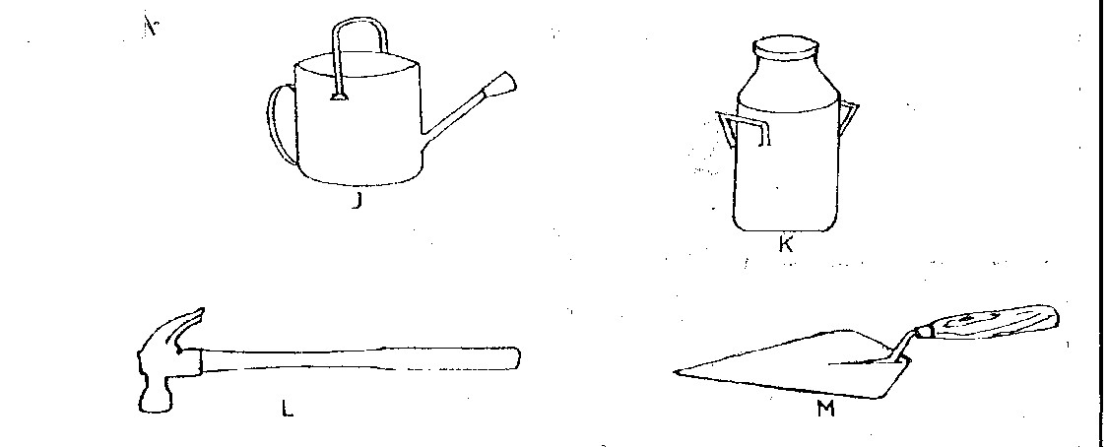

* 1. Identify the tool / equipment labeled J,K and M.

**J ______________________________** (1mk)

**K ______________________________**  (1mk)

**M** **______________________________**  (1mk)

1. State one use of each of the tool equipment labeled K and L.

K (1mk)

**………………………………………………………………………………………………………………… ………………………………………………………………………………………………………………..**

L (1mk)

**………………………………………………………………………………………………………………… ………………………………………………………………………………………………………………..**

1. Give two maintenance practices for the equipment labeled K above.(2mks)

**…………………………………………………………………………………………………………………**

**…………………………………………………………………………………………………………………**

**…………………………………………………………………………………………………………………**

20. The diagram below represents an irrigation system. Use it to answer the questions that follow.

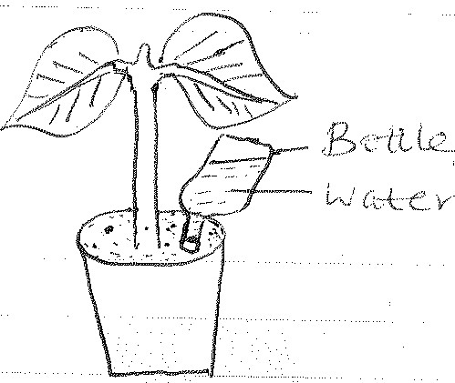

* + 1. Identify the irrigation system show.(1mk)

**………………………………………………………………………………………………………………… ………………………………………………………………………………………………………………..**

* + 1. Give four advantages of the system named in (a) above (4mks)

**…………………………………………………………………………………………………………………**

**………………………………………………………………………………………………………………… ………………………………………………………………………………………………………………… ………………………………………………………………………………………………………………..**

**SECTION C: (30MKS) ANSWER ALL QUESTIONS.**

21.a) Give five main reasons why farmers prepare a seedbed before planting. (5mks)

**…………………………………………………………………………………………………………………**

**…………………………………………………………………………………………………………………**

**………………………………………………………………………………………………………………… ………………………………………………………………………………………………………………..**

**…………………………………………………………………………………………………………………**

**…………………………………………………………………………………………………………………**

**………………………………………………………………………………………………………………….**

* 1. Name three ways of achieving primary cultivation. (3mks)

**…………………………………………………………………………………………………………………**

**…………………………………………………………………………………………………………………**

**…………………………………………………………………………………………………………………**

**…………………………………………………………………………………………………………………**

**………………………………………………………………………………………………………………….**

* 1. State and explain three tertiary operations carried out in the farm to suit production of certain crops. (6mks)

**…………………………………………………………………………………………………………………**

**…………………………………………………………………………………………………………………**

**………………………………………………………………………………………………………………… ………………………………………………………………………………………………………………..**

**…………………………………………………………………………………………………………………**

**…………………………………………………………………………………………………………………**

**……………………………………………………………………………………………………**

* 1. Define the term subsoiling as used in land preparation. (1mk)

**……………………………………………………………………………………………………**

**…………………………………………………………………………………………………………………………………………………………………………………………………………**

22 a) Outline five activities that maybe undertaken in organic farming. (5mks)

**……………………………………………………………………………………………………**

**……………………………………………………………………………………………………**

**…………………………………………………………………………………………………………………………………………………………………………………………………………**

**……………………………………………………………………………………………………**

**…………………………………………………………………………………………………………………………………………………………………………………………………………**

b) State and explain five reasons for maintaining farm tools and equipment. (10mks)

**……………………………………………………………………………………………………**

**……………………………………………………………………………………………………**

**…………………………………………………………………………………………………………………………………………………………………………………………………………**

**……………………………………………………………………………………………………**

**……………………………………………………………………………………………………**

**…………………………………………………………………………………………………………………………………………………………………………………………………………**

**……………………………………………………………………………………………………**

**……………………………………………………………………………………………………**

**……………………………………………………………………………………………………**

**……………………………………………………………………………………………………**

**………………………………………………………………………………………………………**