**QUALITY ASSUARANCE SERIRS FORM 1 END TERM 3 EXAMS 2023**

**231/1 BIOLOGY (QUESTION PAPER)**

**FORM ONE (1)**

**TIME: 2 HOURS**

**Name**: …………………………………………………………. **Adm** **No**: ……………….

**School**: ……………………………………………………….. **Class**: …………………..

**Signature**: …………………………………………………….. **Date**: …………………...

**INSTRUCTIONS TO CANDIDATES:**

* Write your **name** and your **admission number** in the spaces provided above.
* **Sign** and **write** the date of the examination in the spaces provided above.
* Answer **all** the questions in the spaces provided.

**For Examiner’s Use Only:**

|  |  |  |
| --- | --- | --- |
| **QUESTIONS** | **MAXIMUM SCORE** | **CADNIDATE’S SCORE** |
| 1 – 26 | **80** |  |

1. Name the branches of biology that deal with study of: (2mks)
2. Inheritance and variations

…………………………………………………………………………………………………………………..

1. Chemical changes inside living organisms

………………………………………………………………………………………………………………….

2. Name the cell organelles that would be abundant in:

a) White blood cells destroying pathogens (2mks)

…………………………………………………………………………………………………………………………………………………………………………………………………………………………………….

b) Palisade mesophyll cells

……………………………………………………………………………………………………………………………………………………………………………………………………………………………………

3. (a) When observing a specimen through a light microscope, a student noted that the field of view

was dark. Name 2 parts of the microscope that the student should adjust to make the field of view clear (1mk)

……………………………………………………………………………………………………………………………………………………………………………………………………………………………………

(b) A specimen was magnified 1000 times by a light microscope whose eye piece lens magnification is X10. Calculate magnification of objective lens. (2mks)

4. The flow diagram below represents a process of photosynthesis. Study diagram and answer the questions that follow.

Sunlight

H2O

B A Oxygen

C

1. Name the substances labeled (3mks)

A …………………………………………………………………………………………………

B ………………………………………………………………………………………………….

C ………………………………………………………………………………………………….

(b) Write an equation to show the process illustrated above (1mk)

………………………………………………………………………………………………………

5. The following is a diagrammatic representation of protein synthesis. Study and answer the questions that follow.

X

Amino Acid

**+** R+ H2O

Q

1. Name process R (2mks)

………………………………………………………………………………………………………………

(b) Where in the cell does R take place?

………………………………………………………………………………………………………………

(c) Name

(i) Product Q (2mks)

………………………………………………………………………………………………………………

(ii) Part X

……………………………………………………………………………………………………………….

6. (a) Name an element which is a present in proteins but is not in carbohydrates (1mk)

…………………………………………………………………………………………………………………

(b) State two functions of proteins in the human body (2mks)

……………………………………………………………………………………………………………………………………………………………………………………………………………………………………………………………………………………………………………………………………………………….

7. State the functions of the following cell structures. (2mks)

(i) Centriole

…………………………………………………………………………………………………………………………………………………………………………………………………………………………………….

(ii) Contractile vacuole

……………………………………………………………………………………………………………………………………………………………………………………………………………………………………

8. Study the reaction below and answer the questions that follow

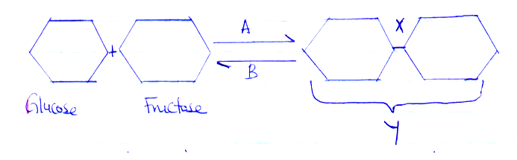

1. What biological processes are represented by A and B (2mks)

A

………………………………………………………………………………………………………………….

B

………………………………………………………………………………………………………………….

(b) Identify the product Y (1mk)

…………………………………………………………………………………………………………………..

9. A solution of sugarcane was boiled with hydrochloric acid; sodium hydrogen carbonate was added to the solution which was then heated with Benedict’s solution. An orange precipitate was formed

(a) Why was the solution boiled with hydrochloric acid? (1mk)

……………………………………………………………………………………………………………………………………………………………………………………………………………………………………

(b) To which class of carbohydrates does solution of sugarcane belong? (1mk)

………………………………………………………………………………………………………………….

………………………………………………………………………………………………………………….

(c) State the form in which carbohydrates are stored in (2mks)

(i) Plants

………………………………………………………………………………………………………………

(ii) Animals

…………………………………………………………………………………………………………………

10. Explain the importance of each of the following during the process of digestion in human beings

(a) Teeth (1mk)

…………………………………………………………………………………………………………………

…………………………………………………………………………………………………………………

(b) Saliva (2mks)

………………………………………………………………………………………………………………..

………………………………………………………………………………………………………………..

11. State two ways in which active transports differs from diffusion. (2mks)

……………………………………………………………………………………………………………….

………………………………………………………………………………………………………………..

12. The figure below is a diagram of a cell as seen under the light microscope.

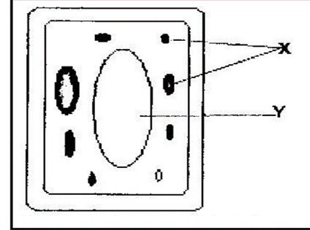

(a) Name two structures that shows this is a plant cell and not an animal cell. (2mks)

………………………………………………………………………………………………………………

………………………………………………………………………………………………………………

………………………………………………………………………………………………………………

b) Name one chemical compound that is only found in the structure labeled X. (1mk)

………………………………………………………………………………………………………………..

c) Name the fluid in the part labeled Y . (1mk)

………………………………………………………………………………………………………………..

d) Other than through enzymatic action, how else can a disaccharide be hydrolyzed to its constituent monosaccharides. (1mk)

……………………………………………………………………………………………………………….

13. Give two skills gained by a student learning Biology. (2 marks)

………………………………………………………………………………………………………………………….

………………………………………………………………………………………………………………………….

14. Name the unit of classification that has the least organisms. (1 mark)

………………………………………………………………………………………………………………………….

15. What is the importance of using a hand lens in classification of organisms. (1 mark)

………………………………………………………………………………………………………………………….

16. What characteristics of living organisms is represented by the following characteristics:

1. A cat producing kittens. (1mk)

………………………………………………………………………………………………………………………….

1. A girl dropping a hot pan. (1mk)

*………………………………………………………………………………………………………………………………………….*

17. a) An electron microscope has a much greater resolving power than a light microscope. Explain the meaning of the term resolving power. (1 mark)

………………………………………………………………………………………………………………………….

………………………………………………………………………………………………………………………….

b) Give a reason why an electron microscope cannot be used to study life specimen. (1 mark)

………………………………………………………………………………………………………………………….

18. During a practical lesson to estimate the size of a cell, using the sketch below which some students observed, calculate the length of one cell in micrometers given that the field of view was 8mm wide. (3 marks)

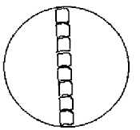

19. The diagram below represents a certain apparatus used by biology students.

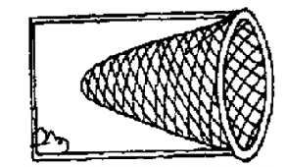

(i) Identify the apparatus above. (1 mark)

……………………………………………………………………………………………………………………………

(ii) State the function of the apparatus named in b) (i) above. (1 mark)

……………………………………………………………………………………………………………………………

20. Black jack (Bidens pilosa) belongs to the family Compositae. What is it’s:

Genus. (1 mk)

………………………………………………………………………………………………………………..

Species. (1 mk)

………………………………………………………………………………………………………………..

21. i) Identify the organelle represented by the diagram below. (1 mk)

……………………………………………………………………………………………………….

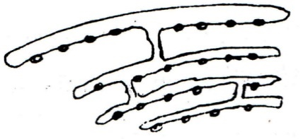

ii) State the function of the organelle identified in 21(i) above. (1 mk)

…………………………………………………………………………………………………………………

22. State the importance of each of the following process in living things. (2 mks)

1. Respiration

………………………………………………………………………………………………………………….

………………………………………………………………………………………………………………….

1. Gaseous exchange

…………………………………………………………………………………………………………………..

…………………………………………………………………………………………………………………..

23. Give a reason why each of the following steps are followed when preparing cross sections

of a leaf for examination under a microscope: (2mks)

1. Cutting very thin section

…………………………………………………………………………………………………………

1. Using sharp razor blade (scalpel) during cutting.

………………………………………………………………………………………………………….

24. Calculate the magnification of the drawing of the termite below given that the actual length of the termite is 0.9cm long . Show your working (2mks)

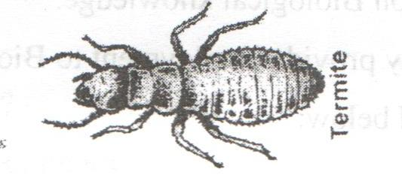

25. Below is a structure of chloroplast. Label on the diagram using the letters provided, the parts where the following processes of photosynthesis take place: (2mks)

1. Photolysis (use letter P)
2. Carbon IV oxide fixation (use letter C)

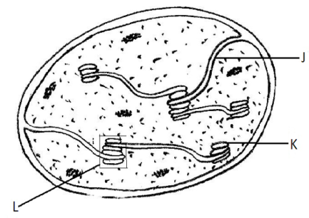

26. Study the figure below and answer the questions that follow.

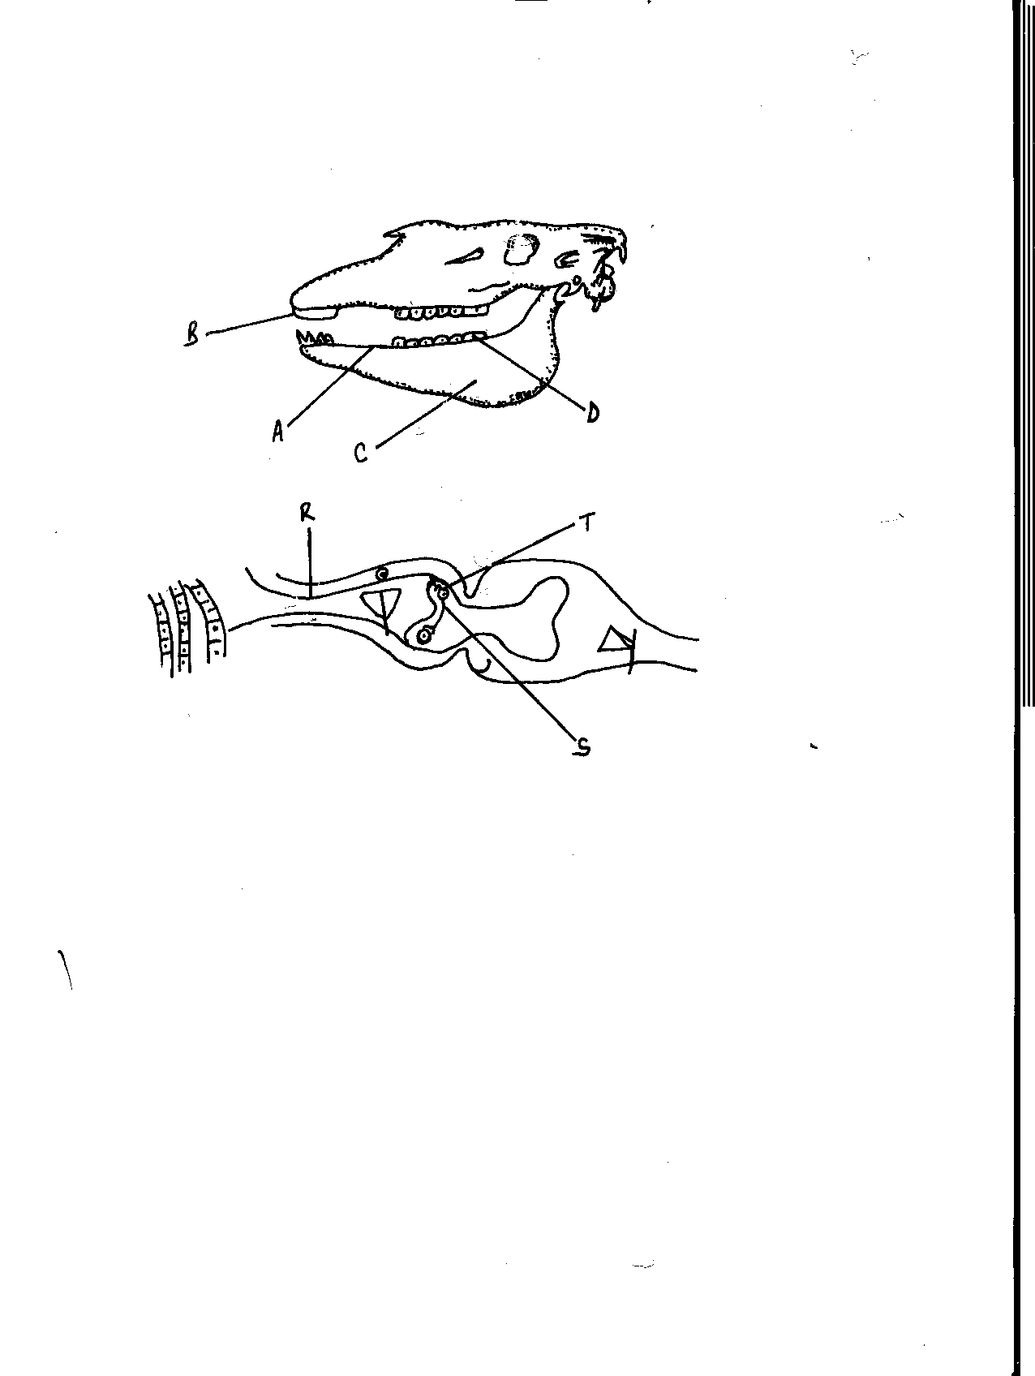

a) Name the parts labeled B, C and D (3 mks)

B……………………………………………………………………………………………………

C…………………………………………………………………………………………………

D…………………………………………………………………………………………………

b) State the function of part labeled A. (1 mk)

………………………………………………………………………………………………………

27. Study the diagrams below and then answer the questions that follow.

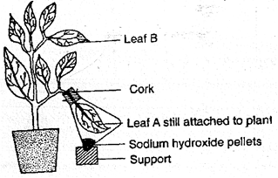

(a) What was the aim of the experiment? (1mk)

…………………………………………………………………………………………………………..

…………………………………………………………………………………………………………..

(b) Explain why leaf A is still attached onto the plant. (1mk)

…………………………………………………………………………………………………………..

…………………………………………………………………………………………………………..

(c) What property of sodium hydroxide enables it to carry out its intended role? (1mk)

…………………………………………………………………………………………………………..

…………………………………………………………………………………………………………..

(d) In the test for starch in either leaf A or B, name the role played by methylated spirit (1mk)

…………………………………………………………………………………………………………

28. The diagram below represents a cell structure. Study it and answer the questions that follow

A

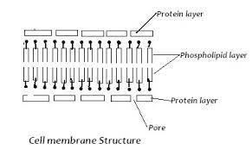

a) Name the cell structure shown above. (1mk)

……………………………………………………………………………………………………………

b) State two functions of the organelle. (2mks)

……………………………………………………………………………………………………………

…………………………………………………………………………………………………………….

c) Name the building blocks part labeled A. (1mk)

……………………………………………………………………………………………………………

29. A group of students set up an experiment to investigate a certain physiological process. The set up was as shown in the figure below.

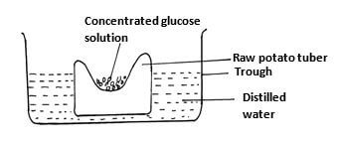

After sometimes the students observed that the level of the glucose solution had risen

a) Name the physiological process being investigated. (1mk)

……………………………………………………………………………………………………………

b) Account for the rise in the level of salt solution in the experiment. (2mks)

…………………………………………………………………………………………………………..

……………………………………………………………………………………………………………

………………………………………………………………………………………………………....

c) Suggest the results that the students would obtain if they repeated the experiment using a piece of boiled potato tuber. (1mk)

……………………………………………………………………………………………………………….

……………………………………………………………………………………………………………….

30. When testing for starch in a leaf, explain the reasons for doing the following: (3mks)

1. Dipping the leaf in boiling water

………………………………………………………………………………………………………………..

………………………………………………………………………………………………………………..

1. Boiling methylated spirit indirectly in water bath

………………………………………………………………………………………………………………..

………………………………………………………………………………………………………………..

1. Washing the leaf in water after boiling in methylated spirit

………………………………………………………………………………………………………………..

………………………………………………………………………………………………………………..