**NAME_______________________________ ADMISSION NO.____________**

**CLASS____________**

**DATE:___________________**

**231**

**BIOLOGY (Theory)**

**FORM 1**

**2 Hours**

**BRAIN QUEST SERIES FORM 1 END OF YEAR** **EXAMS 2023**

Instructions to Candidates

* Write your Name and admission Number in the Spaces Provided.
* Sign and write date of examination in the spaces provided.
* This paper consists of two sections A and B.
* Answer all the questions in Sections A in the spaces provided.
* You should check the question paper to ascertain that all the pages are printed as indicated and that no questions are missing.

SECTION A

*Answer all the questions in Sections A in the spaces provided.*

1. Name the three major branches of biology. (3mks)

2. Explain why the following processes are important during the preparation of temporary slides:-

(a) Staining (1mk)

(b) Use of a sharp cutting blade (1mk

3. Distinguish between the following terms :-

a) Magnification and resolution of a microscope (2mks)

b) Mounting and staining of a specimen (2mks)

4. The diagrams below show an experiment set up to investigate a certain process in a plant tissue.

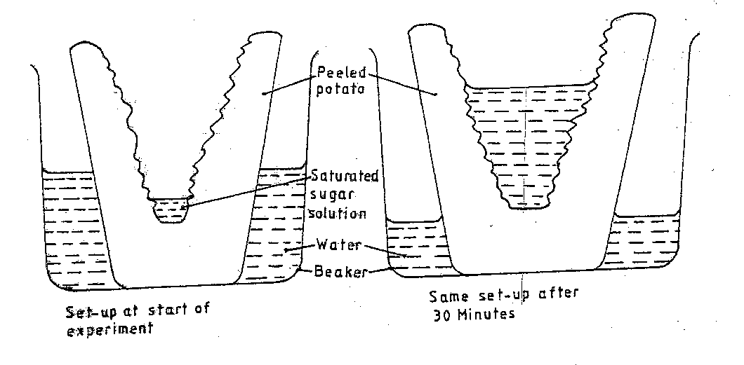

Explain the results obtained after 30 min. (3mks)

5.A student mashed a piece of raw banana and made it into paste by adding water, placed the paste in a visking tubing and suspended it in a beaker containing iodine solution as shown below. The set- up was left for 40 minutes.

**raw banana paste**

**Iodine solution**

**Visking tubing**

a)State the physiological process under investigation. (1 mark)

1. Account for the result obtained in the table. (2 marks)

6. Arrange the following from the largest to the smallest:

Tissue,cell,organism,organelle,organ system,organ, ( 1mk)

7.(a) State two factors that affect enzymatic activities (2 marks)

8.Name the sites where light and dark reactions of photosynthesis take place. ( 2 mks)

Light reaction

Dark reaction

9.The diagram represents part of the human digestive system.

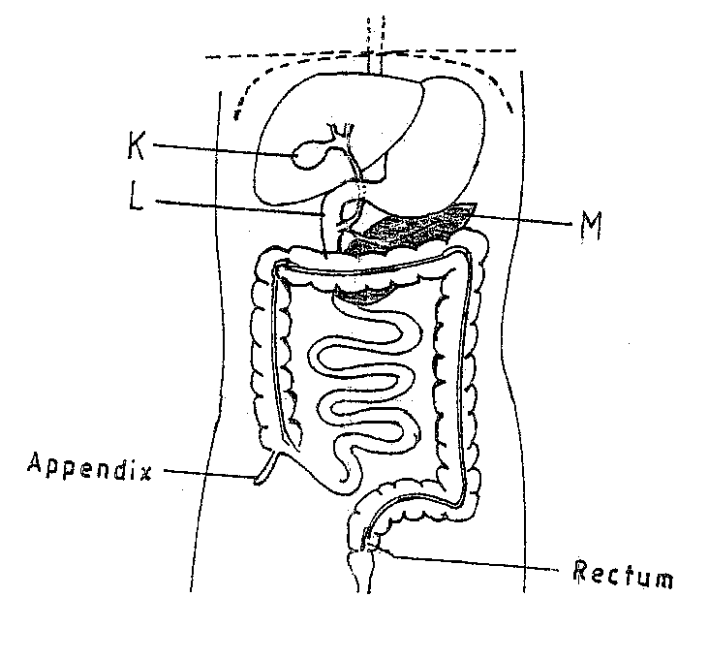

1. Name the organs labeled L and M. (2mks)

L

M

1. (i) Name the juice secreted by K. (1mk)

ii) State the function of the juice named in (b) (i) above (3mks)

(c) Name one enzyme secreted by M (1mks)

10.a)Name two salivary glands found in human mouth (2mks)

b)state two functions of saliva (2mks)

11.i) State two ways in which the guard cells differ from other adjacent epidermal cells 2mks)

ii) Apart from guard cells name other two cells that carryout photosynthesis in a leaf.(2mk)

12. Give the importance of leaf mosaic in the process of photosynthesis. (1mk)

13. State the functions of the following cell organelles. (2 mks

a)Golgi apparatus

b)Ribosomes

14.The table below shows the concentration of important plant nutrients

|  |  |  |
| --- | --- | --- |
| ion | Concentration in pond water(ppm) | Concentration in cell sap(ppm) |
| Potassium | 200 | 50 |
| chloride | 0.5 | 20 |

1. Name the process by which the above ions could have been taken up by the plants.(2mks)
2. Potassium
3. Chloride

15. State two properties of monosaccharide. (2mks)

SECTION B

16.The diagram below illustrates the behaviour of red blood cells when placed into two

different solutions X and Y.

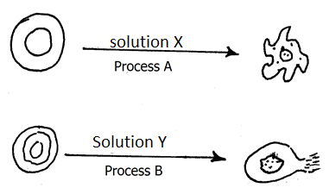

a) i)Suggest the nature of solution X and Y (2mks)

ii) Name the process represented by each of the letters A and B (2mks)

c) Explain the observation made at the end of process B above. (3mks)

d) A plant cell was placed in solution Y, and it did not burst. State the structure in the plant cell that prevented it from bursting.(1mk)

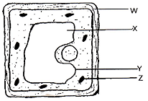17.The figure below shows a diagram of a cell as seen under a light microscope. Study it and answer the questions that follow.

a)Name three structures that show that it is a plant cell and not a animal cell 3mks

b) Name the photosynthetic pigment that is found in the structure labelled Z and state its function. 2mks

c) State the name and function of the fluid found in X 2mks

Name

Function

d) On the diagram label the structure that contains the DNA 1mk

18. A potted plant with healthy leaves was kept in the dark for 48 hours. One of the leaf was then partly enclosed in a wide boiling test tube containing sodium hydroxide solution. The whole set up was then kept in sunlight for six hours. The diagram is shown below.

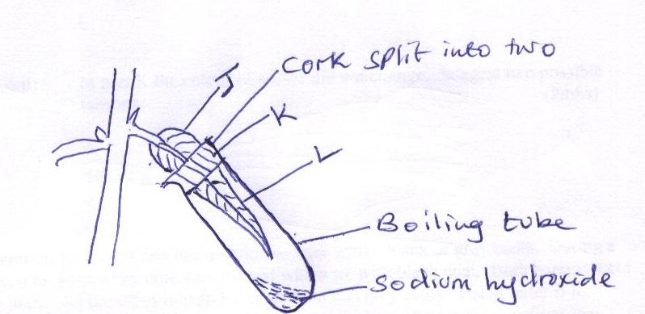

a) Suggest the aim of the experiment. (1mk)

b) Why was the set up kept in the dark for 48 hours? (1mk)

c) Why was the set up kept in the sunlight for six hours? (1mk)

d) What is the importance of sodium hydroxide solution in the set up? (1mk)

e) State the colours observed on each part when the leaf was tested for starch (3mks)

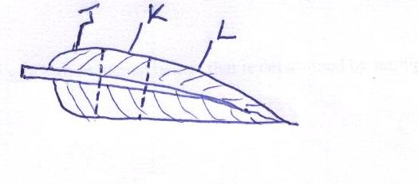

f)State the form in which carbohydrates are stored in the liver. (1mk)

19.The organisms below were collected from a certain habitat. Study them and answer the questions that follow.`

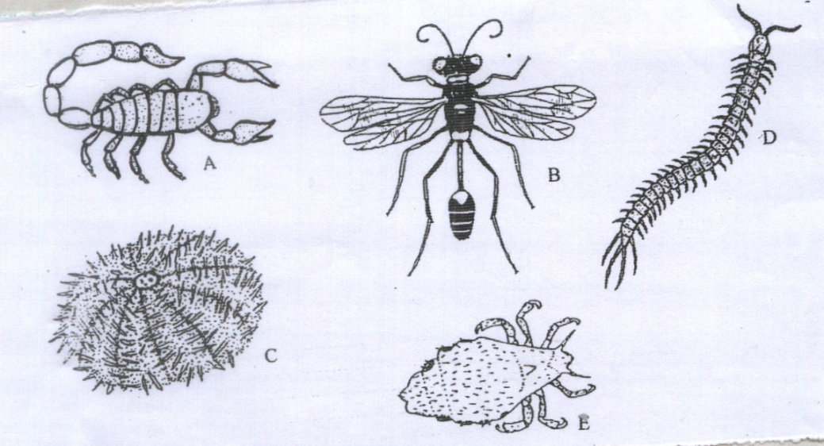

a) In which kingdom do the organisms belong (1mk)

b) State two external features that are found in organism B. 2mks

c) State the method used to collect:

i) Organism B 1mk

ii) Organism D 1mk

d) State one precaution that should be taken when collecting organism A 1mk

e) Identify two modes of locomotion in specimen B ( 2mks)

20.The set-up below illustrates a procedure that was carried out in the laboratory with a leaf plucked from a green plant that had been growing in sunlight. 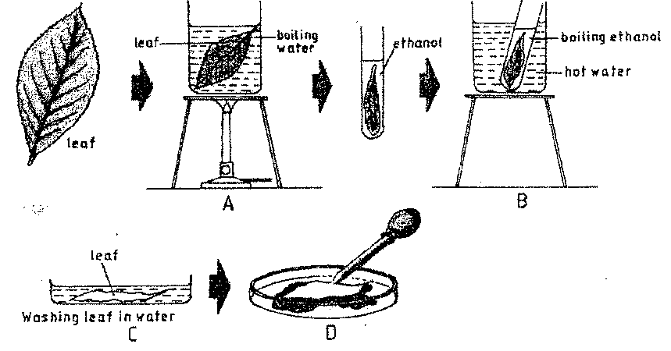

1. What was the purpose of the above procedure? (1mark)
2. Give reasons for carrying out step A,B and C in this procedure. 3marks)

(iii) Name the reagent that was used at the step labeled D . (1mark)

(iv) State the expected result on the leaf after adding the reagent named in (iii) above.(1mark)

21.Describe the adaptations of the ileum to its function 20 marks