**QUALITY ASSUARANCE SERIRS FORM 1 END TERM 3 EXAMS 2023**

**CHEMISTRY (QUESTION PAPER)**

**FORM ONE (1)**

**Time: 2 HOURS**

**Name**: …………………………………………………………. **Adm** **No**: ……………….

**School**: ……………………………………………………….. **Class**: …………………..

**Signature**: …………………………………………………….. **Date**: …………………...

**Instructions to Candidates**

1. Write your name and admission number in the spaces provided
2. Answer **all** questions in this paper
3. All working must be clearly shown in the spaces provided in this paper
4. Non-programmable silent electronic calculators may be used
5. This paper consists of **9 printed pages**
6. Check that the question paper to ascertain that all the pages are printed as indicated and that no questions are missing.
7. Candidates should answer the questions in English.

**For Examiners’ use Only**

|  |  |  |
| --- | --- | --- |
| **Questions** | **Total Score** | **Candidate’s Score** |
| **1 – 29** | **80** |  |

1. State **two** differences between liquids and gases (2 Marks)

______________________________________________________________________________

______________________________________________________________________________

1. State **two** long term effects of drug abuse (2 marks)

______________________________________________________________________________

______________________________________________________________________________

1. Air is considered a mixture. Explain. (2 Marks)

___________________________________________________________________________

___________________________________________________________________________

1. Complete the table below on the components of an air sample (2 Marks)

|  |  |
| --- | --- |
| **Gas** | **% Volume in air** |
| Nitrogen |  |
|  | 20.9% |
| Argon |  |
|  | 0.03% |

1. State the role of the following parts of apparatus used in the distillation of a mixture of water and ethanol:
2. Fractionating column (1 Mark)

___________________________________________________________________________

1. Glass beads (1 Mark)

___________________________________________________________________________

1. On what property does the separation of the mixture mentioned above depend on? (1 Mark)

___________________________________________________________________________

1. Dry ice is preferred to ordinary ice as a refrigerant. Explain (2 Marks)

______________________________________________________________________________

______________________________________________________________________________

1. The table below shows pH values of some substances.

|  |  |  |  |  |
| --- | --- | --- | --- | --- |
| **Solution** | A | B | C | D |
| **pH values** | 13 | 9 | 1 | 6.5 |

Which solution:

1. Would produce carbon (IV) oxide gas when added to a sample of copper (II) carbonate? (1 Mark)

___________________________________________________________________________

1. Would relieve the irritation experienced by a beekeeper stung by a bee? (1 Mark)

___________________________________________________________________________

1. Phosphorous smoulders in air to produce two oxides.
2. Name the two oxides (2 Marks)

___________________________________________________________________________

___________________________________________________________________________

1. State the nature of the solution formed when any of the oxides you have named dissolve in water (1 Mark)

___________________________________________________________________________

1. What is an acid-base indicator? (1 Mark)

______________________________________________________________________________

______________________________________________________________________________

1. The diagram below represents the heating curve of a substance in the laboratory. Study it and use it to answer the questions that follow.

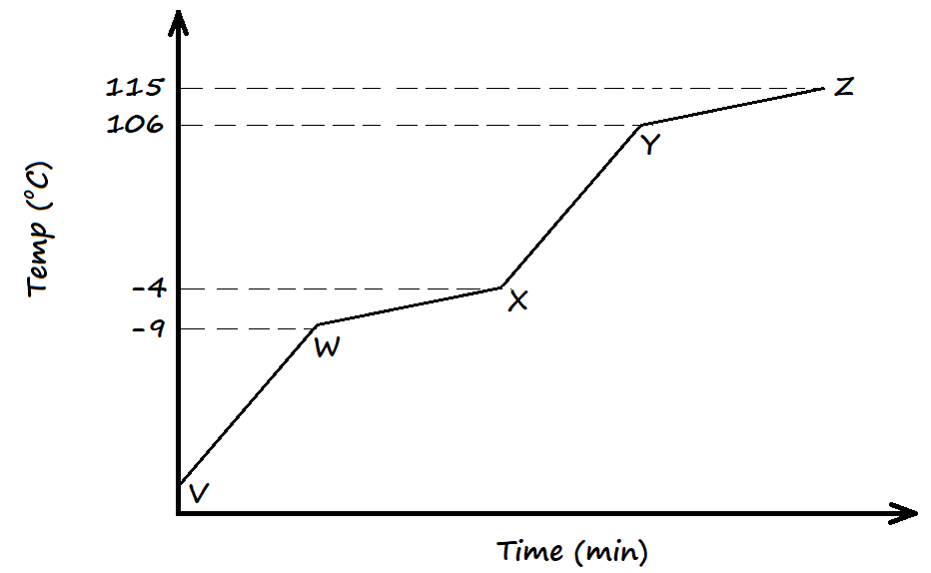

1. At what temperature does the substance begin to boil? (1 Mark)

___________________________________________________________________________

1. The sample was analysed and found to be that of water.
2. Comment on its boiling point (1 Mark)

________________________________________________________________________

________________________________________________________________________

1. Comment on its melting point (1 Mark)

________________________________________________________________________

________________________________________________________________________

1. Complete the following word equations: (3 Marks)
2. Calcium + Nitric acid 🡪
3. Magnesium + Steam 🡪
4. Sodium hydroxide + sulphuric acid 🡪
5. On what principle does paper chromatography work? (1 Mark)

___________________________________________________________________________

___________________________________________________________________________

1. A fountain pen cannot be used to mark the baseline in paper chromatography. Explain (1 Mark)

___________________________________________________________________________

___________________________________________________________________________

1. Describe how one can test for the following in a Chemistry laboratory.
2. Water (2 Marks)

___________________________________________________________________________

___________________________________________________________________________

___________________________________________________________________________

1. Carbon (IV) oxide (2 Marks)

___________________________________________________________________________

___________________________________________________________________________

___________________________________________________________________________

1. Changes are classified as being temporary physical changes, temporary chemical changes, or permanent chemical changes. Classify the following processes by the criteria mentioned above:
2. Heating of lead (II) nitrate crystals to produce brown fumes (1 Mark)

___________________________________________________________________________

1. Heating white zinc oxide to form a yellow substance (1 Mark)

___________________________________________________________________________

1. Obtaining kerosene from crude oil (1 Mark)

___________________________________________________________________________

1. A candle was burnt using the setup below. The initial volume of solution in the inverted measuring cylinder was at the 90cm3 mark. After the experiment, when the setup had cooled, the new level of solution was at the 70cm3 mark.

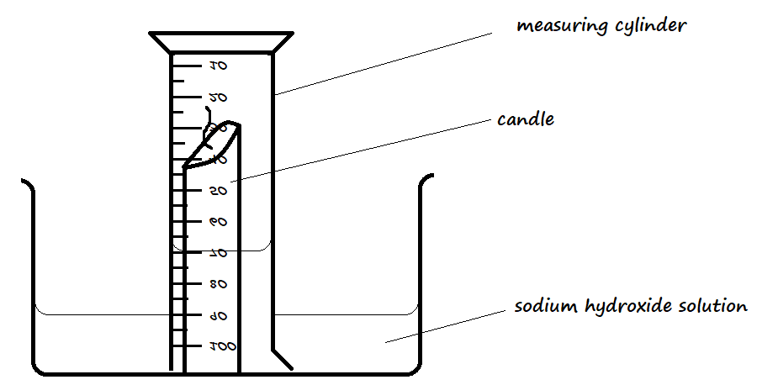

1. Use the stated results to calculate the percentage of oxygen used from the air by the burning candle. (2 Marks)

___________________________________________________________________________

___________________________________________________________________________

___________________________________________________________________________

1. What would be the effect on percentage calculated if the final volume is recorded when the apparatus is hot? (1 Mark)

___________________________________________________________________________

___________________________________________________________________________

1. Why was sodium hydroxide used, and not water? (1 Mark)

___________________________________________________________________________

___________________________________________________________________________

1. A clean iron nail was wrapped using a strip of magnesium ribbon and left exposed in saline conditions for two days.
2. State and explain the observation made after two days. (2 Marks)

___________________________________________________________________________

___________________________________________________________________________

___________________________________________________________________________

1. State and explain the observation that would be made if the iron nail was wrapped with a strip of tin. (2 Marks)

___________________________________________________________________________

___________________________________________________________________________

1. The flow diagram below represents the stages involved in the large-scale fractional distillation of air.

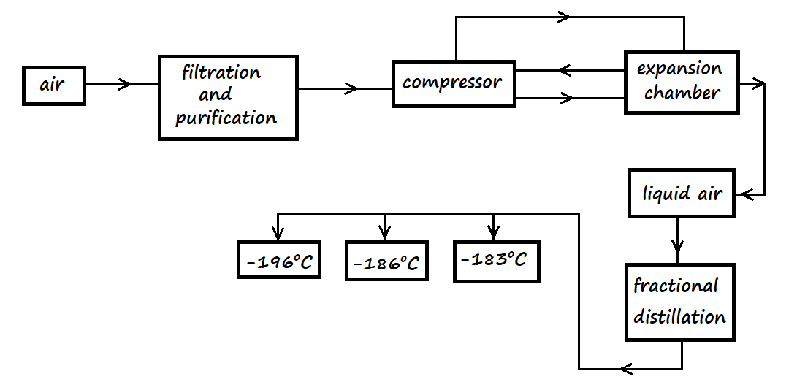

1. Identify the substance that is removed at the filtration and purification stage (1 Mark)

___________________________________________________________________________

1. Carbon (IV) oxide and water are removed before the air sample is compressed. Explain (1 Mark)

___________________________________________________________________________

___________________________________________________________________________

1. Which component is collected at -196oC? (1 Mark)

___________________________________________________________________________

1. An agricultural officer recommended the addition to calcium oxide to a soil sample. State two benefits of adding the calcium oxide. (2 Marks)

______________________________________________________________________________

______________________________________________________________________________

1. Write two word equations for the reactions that occur when magnesium burns in air. (2 Marks)

___________________________________________________________________________

___________________________________________________________________________

1. If one of the products is dissolved in water, a colourless solution is produced which turns red litmus paper blue while blue litmus paper remains blue. Write a word equation for the reaction that produces this colourless solution. (1 Mark)

___________________________________________________________________________

1. Define the following terms:
2. Atom (1 Mark)

___________________________________________________________________________

___________________________________________________________________________

1. Molecule (1 Mark)

___________________________________________________________________________

___________________________________________________________________________

1. Identify the elements in the following compounds, and for each element indicate its symbol
2. Calcium hydrogen carbonate (2 Marks)

___________________________________________________________________________

___________________________________________________________________________

1. Silver chloride (1 Mark)

___________________________________________________________________________

___________________________________________________________________________

1. When a mixture of copper (II) oxide and magnesium metal is heated together, a reaction takes place but when a mixture of magnesium oxide and copper metal is heated, no reaction takes place. Explain this observation. (2 Marks)

______________________________________________________________________________

______________________________________________________________________________

______________________________________________________________________________

1. Describe how a mixture of iron (III) chloride, sand, and sodium chloride can be separated to obtain pure samples of each substance. (3 Marks)

______________________________________________________________________________

______________________________________________________________________________

______________________________________________________________________________

1. Name the techniques that are used to perform the following processes:
2. A mixture of coloured dyes (½ Mark)

___________________________________________________________________________

1. Extracting dye from coloured leaves (½ Mark)

___________________________________________________________________________

1. What is a laboratory? (1 Mark)

___________________________________________________________________________

___________________________________________________________________________

1. State **two** apparatus used in measuring:
2. Accurate volumes of liquids (2 Marks)

________________________________________________________________________

1. Approximate volume of liquids (2 Marks)

________________________________________________________________________

1. State three benefits of the knowledge of Chemistry in the society. (1 Mark)

______________________________________________________________________________

______________________________________________________________________________

______________________________________________________________________________

1. State the functions of the following parts of a Bunsen burner:
2. Air hole (1 Mark)

___________________________________________________________________________

1. Collar (1 Mark)

___________________________________________________________________________

1. Base (1 Mark)

___________________________________________________________________________

1. To extract oil from groundnuts, a student crushed some groundnuts and added propanone while crushing. He later decanted the mixture and placed the liquid sample out in the sun.
2. Why did he crush the groundnuts? (1 Mark)

___________________________________________________________________________

1. Why was the liquid bit of the sample placed outside in the sun? (1 Mark)

___________________________________________________________________________

1. How is the final substance proved to be oil? (1 Mark)

___________________________________________________________________________

1. When hydrogen gas is passed over a heated sample of copper (II) oxide, the solid turns from black to brown substance.
2. Write an equation for the reaction between hydrogen gas and heated copper (II) oxide. (1 Mark)

___________________________________________________________________________

1. Name the type of reaction taking place between the hydrogen gas and copper (II) oxide. (1 Mark)

___________________________________________________________________________