**QUALITY ASSUARANCE SERIRS FORM 2 END TERM 3 EXAMS 2023**

**CHEMISTRY (QUESTION PAPER)**

**FORM TWO (2)**

**Time: 2 HOURS**

**Name**: …………………………………………………………. **Adm** **No**: ……………….

**School**: ……………………………………………………….. **Class**: …………………..

**Signature**: …………………………………………………….. **Date**: …………………...

**Instructions to Candidates**

1. Write your name and admission number in the spaces provided
2. Answer **all** questions in this paper
3. All working must be clearly shown in the spaces provided in this paper
4. Non-programmable silent electronic calculators may be used
5. This paper consists of **11 printed pages**
6. Check that the question paper to ascertain that all the pages are printed as indicated and that no questions are missing.
7. Candidates should answer the questions in English.

**For Examiners’ use Only**

|  |  |  |
| --- | --- | --- |
| **Questions** | **Total Score** | **Candidate’s Score** |
| **1 – 29** | **80** |  |

1. Explain the change in mass expected when each of the following is heated in an open crucible:
2. Copper metal (1 Mark)

__________________________________________________________________________

__________________________________________________________________________

1. Copper (II) nitrate (1 Mark)

___________________________________________________________________________

___________________________________________________________________________

1. The diagram below shows the setup of apparatus used to prepare a dry sample of carbon (IV) oxide gas. Study it and answer the questions that follow

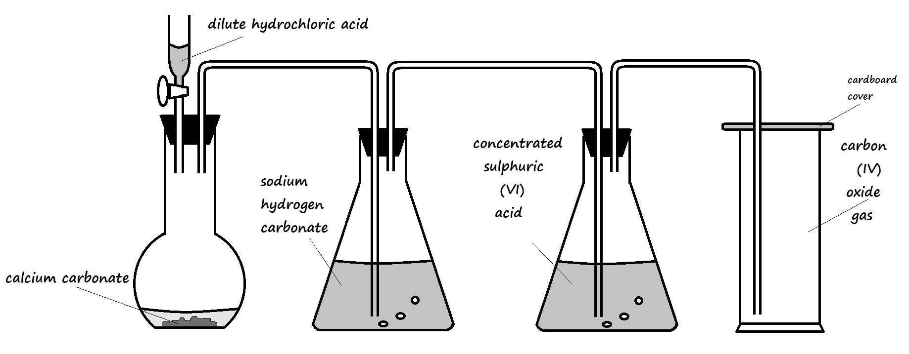

1. State the role of sodium hydrogen carbonate in the setup (1 Mark)

___________________________________________________________________________

___________________________________________________________________________

1. Write the equation for the reaction taking place in the conical flask containing calcium carbonate (1 Mark)

___________________________________________________________________________

1. Give a reason why dilute sulphuric (VI) acid is not suitable for use in place of dilute hydrochloric acid (1 Mark)

___________________________________________________________________________

___________________________________________________________________________

1. The table below shows the melting point and boiling point values of elements across period 3 of the periodic table. Study it and answer the questions that follow.

|  |  |  |  |  |  |  |  |  |
| --- | --- | --- | --- | --- | --- | --- | --- | --- |
|  | Na | Mg | Al | Si | P | S | Cl | Ar |
| Melting point (oC) | 98 | 650 | 660 | 1410 | 44  590 | 119  113 | -101 | -189 |
| Boiling point (oC) | 890 | 1110 | 2740 | 2360 | 280 | 446 | -35 | -186 |

1. Explain the trend in melting point and boiling point values between sodium and aluminium (2 Marks)

___________________________________________________________________________

___________________________________________________________________________

1. Give a reason why both phosphorous and sulphur have **two** **values** of melting point (1 Mark)

___________________________________________________________________________

1. What are isotopes? (1 Mark)

___________________________________________________________________________

___________________________________________________________________________

1. Calculate the relative atomic mass of element E whose isotopic composition, shown below, is in the ratio 80:6:14 (2 Marks)

$\begin{matrix}15 \\ 7\end{matrix}$ E $\begin{matrix}16 \\ 7\end{matrix}$ E $\begin{matrix}17 \\ 7\end{matrix}$ E

___________________________________________________________________________

___________________________________________________________________________

___________________________________________________________________________

1. Write balanced chemical equations for the reactions between:
2. Dilute hydrochloric acid and calcium hydrogen carbonate (1 Mark)

___________________________________________________________________________

1. Dilute sulphuric (VI) acid and potassium hydroxide solution (1 Mark)

___________________________________________________________________________

1. When sodium metal is burnt in air, a white solid is observed. When the metal is burnt in pure oxygen, the product formed is yellow. Name the white solid and yellow solid. (2 Marks)
2. White solid__________________________________________________________________
3. Yellow solid ________________________________________________________________
4. Dilute hydrochloric acid was added to a calcium compound **X** to form a colourless solution **W** and colourless gas **Y**. Gas **Y** formed a white precipitate **L** when bubbled through lime water.
5. Name the following substances:
6. Compound **X** (½ Mark)

________________________________________________________________________

1. Solution **W** (½ Mark)

________________________________________________________________________

1. Gas **Y** (½Mark)

________________________________________________________________________

1. White precipitate **L** (½ Mark)

________________________________________________________________________

1. Write a balanced chemical equation for the reaction that took place (1 Mark)

___________________________________________________________________________

1. Explain the following observations:
2. All group VIII elements are gases at room temperature (1 Mark)

___________________________________________________________________________

___________________________________________________________________________

1. Sodium has a lower melting point than magnesium (2 Marks)

___________________________________________________________________________

___________________________________________________________________________

1. The grid below shows a section of the periodic table. The letters **A**, **B**, **C**, **D**, **E**, **G** and **J** do not represent the actual symbols of elements.

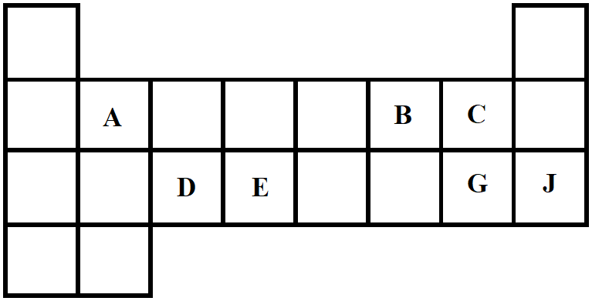

1. Write the formulae of
2. Hydroxide of **D** (½ Marks)

________________________________________________________________________

1. Hydrogen carbonate of **A** (½ Marks)

________________________________________________________________________

1. Draw a dot (•) and cross (×) diagram for the compound formed between elements **A** and **G** (2 Marks)
2. Element **Q** has an electron configuration of **2.8.2** while element **R** has an electron configuration of **2.4.** Solid samples of elements **Q** and **R** were burnt in air, then water added separately to the resultant products. State the effect of the resultant solutions on both red and blue litmus paper:
3. Solution of product of **Q** (1 Mark)

___________________________________________________________________________

___________________________________________________________________________

1. Solution of product of **R** (1 Mark)

______________________________________________________________________________

______________________________________________________________________________

1. The reactivity of the alkaline earth metals increases down the group, while the reactivity of the halogens decreases down the group. Explain this observation. (3 Marks)

______________________________________________________________________________

______________________________________________________________________________

______________________________________________________________________________

1. The following chromatogram was obtained in an experiment to investigate the components present in certain dyes

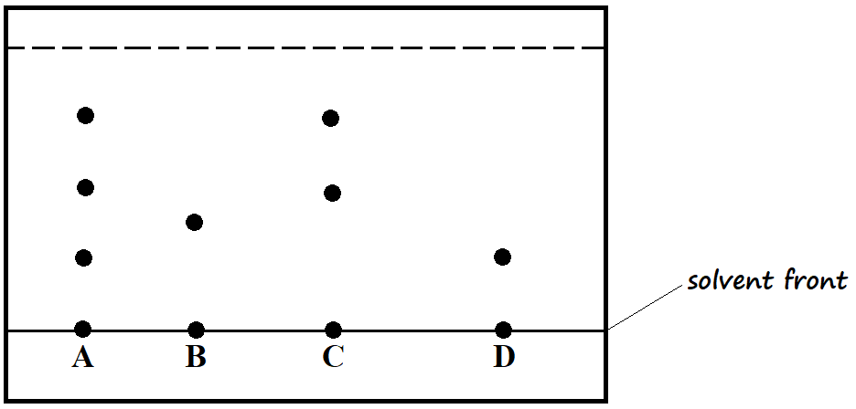

1. Identify a mistake on the diagram (1 Mark)

___________________________________________________________________________

1. Which two dyes, when mixed, would produce dye **A**? (1 Mark)

___________________________________________________________________________

1. Which dye is pure? (1 Mark)

___________________________________________________________________________

1. A mixture contains iron (III) chloride, calcium chloride, and iron filings. Describe how one can separate and obtain pure substances from the mixture. (3 Marks)

______________________________________________________________________________

______________________________________________________________________________

______________________________________________________________________________

______________________________________________________________________________

1. The setup below was used to prepare hydrogen gas in the laboratory

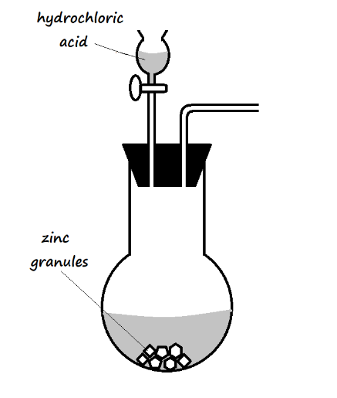

1. Complete the diagram to show how a dry sample of hydrogen gas can be collected (2 Marks)
2. Name a substance which may be added into the flask to speed up the production of the hydrogen gas (1 Mark)

___________________________________________________________________________

1. A certain element formed a compound with the chemical formula **Fe2O3•xH2O** when left open in the atmosphere.
2. Name the compound (1 Mark)

___________________________________________________________________________

1. In temperate countries, salt is put on roads during winter. Explain the reason for this practice (1 Mark)

______________________________________________________________________________

______________________________________________________________________________

1. Why is does this practice raise great concern to motorists? (1 Mark)

___________________________________________________________________________

___________________________________________________________________________

1. Study the diagrams below and answer the questions that follow.

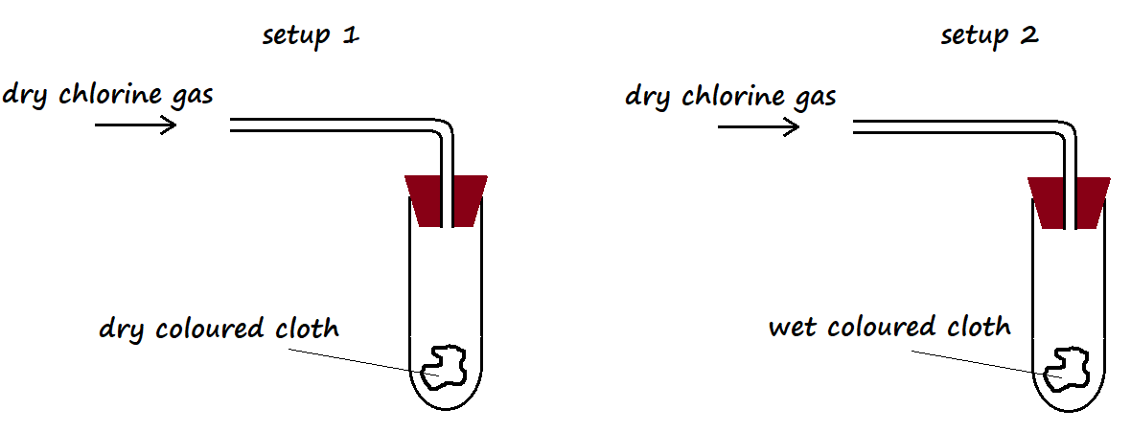

1. State the observation made in
2. Setup **I** (½ Mark)

________________________________________________________________________

________________________________________________________________________

1. Setup **II** (½ Mark)

________________________________________________________________________

________________________________________________________________________

1. Explain the observation made in setup **I** above (2 Marks)

___________________________________________________________________________

___________________________________________________________________________

___________________________________________________________________________

1. In an experiment, a certain volume of air was repeatedly passed between two syringes over heated zinc granules, as shown below.

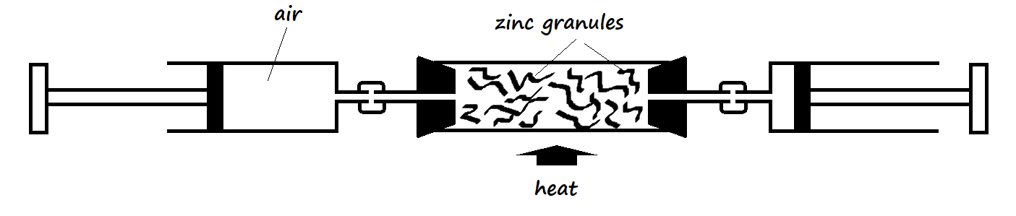

1. Why was air passed repeatedly over the heated copper? (1 Mark)

___________________________________________________________________________

___________________________________________________________________________

1. The experiment was repeated using magnesium ribbon instead of copper turnings. In which experiment was the change in volume greater? Explain. (2 Marks)

___________________________________________________________________________

___________________________________________________________________________

1. Copper (II) oxide and powdered charcoal are both black. How can zinc granules be used to distinguish between the two substances? (2 Marks)

______________________________________________________________________________

______________________________________________________________________________

______________________________________________________________________________

______________________________________________________________________________

1. Explain the main disadvantage of using the method of painting as a method of protecting iron surfaces from rusting (2 Marks)

______________________________________________________________________________

______________________________________________________________________________

______________________________________________________________________________

1. The products of a burning candle were passed through a U-tube as shown in the setup below.

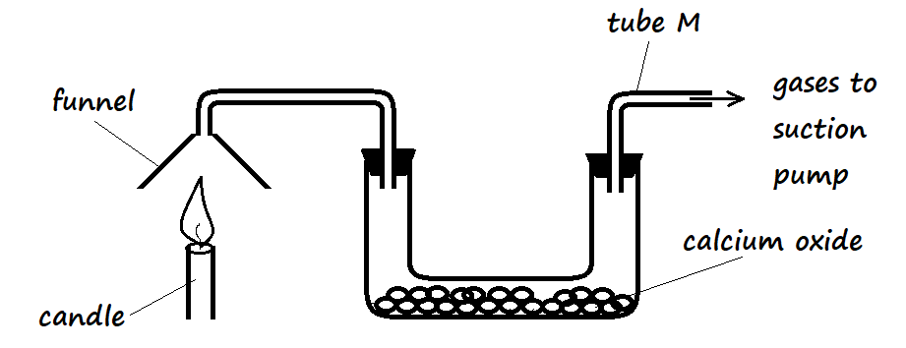

1. State the role of calcium oxide in the setup (1 Mark)

___________________________________________________________________________

1. Name the gas that came out through tube **M** (1 Mark)

___________________________________________________________________________

1. State the observation that would be made in the U-tube if calcium oxide is replaced with anhydrous cobalt (II) chloride (1 Mark)

___________________________________________________________________________

1. The setup below was used to separate two miscible liquids **Q** and **T** whose boiling points are 98oC and 78oC respectively

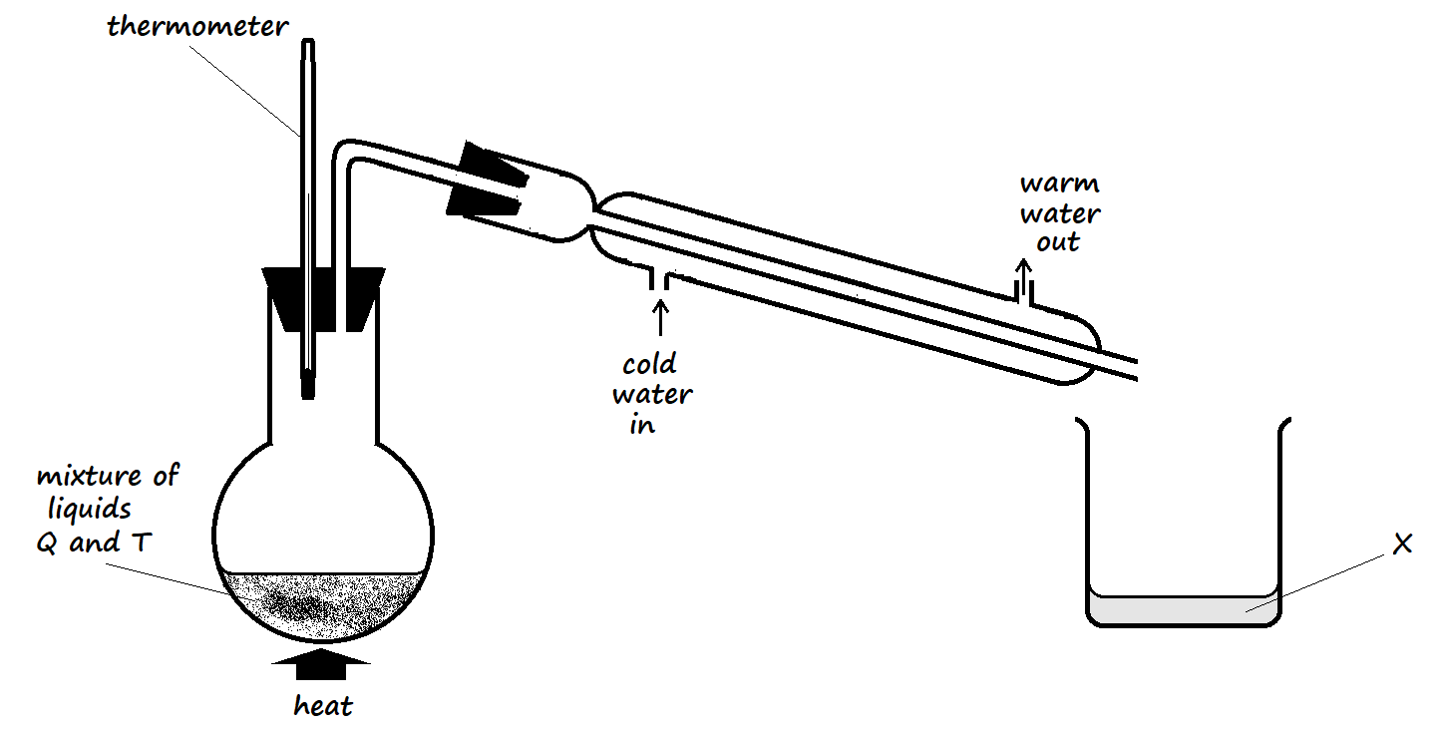

1. Identify **two** mistakes made in arranging the setup (2 Marks)

___________________________________________________________________________

___________________________________________________________________________

1. Identify **X** when the thermometer reads 80oC (1 Mark)

___________________________________________________________________________

1. What property makes the components of the mixture separable using this setup when the necessary corrections have been made? (1 Mark)

___________________________________________________________________________

___________________________________________________________________________

1. The setup below demonstrates an experiment that was carried out on a Bunsen burner flame in the laboratory

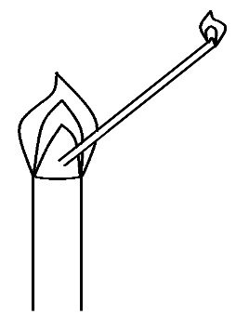

1. What does the experiment show? (1 Mark)

___________________________________________________________________________

1. Which type of flame is this? (1 Mark)

___________________________________________________________________________

1. State **one** other characteristic of this flame, other than the one shown in the setup (1 Mark)

___________________________________________________________________________

1. Pure nitrogen can be obtained from air through fractional distillation of liquefied air. Why is it possible to separate the components of air? (2 Marks)

______________________________________________________________________________

______________________________________________________________________________

1. A spatula of zinc powder was added to a test tube containing hydrochloric acid. A colourless gas was evolved. State the identity of the gas and a test that would confirm your answer (2 Marks)

______________________________________________________________________________

______________________________________________________________________________

1. Explain the following observations:
2. The melting points of alkali metals decrease down the group (2 Marks)

___________________________________________________________________________

___________________________________________________________________________

1. The element hydrogen can be placed in group I and group VII (1 Mark)

___________________________________________________________________________

___________________________________________________________________________

1. When a spatula of calcium metal is put in water, a fizzing sound is heard, and the resultant solution has a white appearance. Explain. (2 Marks)

______________________________________________________________________________

______________________________________________________________________________

1. In the extraction of oil from cashew nut in the laboratory, the seeds were first crushed and then propanone was added as crushing continued.
2. Why were the seeds first crushed? (1 Mark)

___________________________________________________________________________

1. What would be the effect of using water instead of propanone? Explain (2 Marks)

___________________________________________________________________________

___________________________________________________________________________

1. An unknown element is assigned the symbol **Jw**. When the oxide of **Jw** is dissolved in water, the resultant solution turns blue litmus paper red, while red litmus paper remains red.
2. State and explain the relationship between the atomic radius and ionic radius of **Jw**. (2 Marks)

___________________________________________________________________________

___________________________________________________________________________

1. What is the most likely observation made if a spatula of sodium hydrogen carbonate powder is added to the flask containing a solution of the oxide of **Jw**? Explain (2 Marks)

___________________________________________________________________________

___________________________________________________________________________

1. A student used the setup shown in the diagram below to study the reactions of some metals with steam.

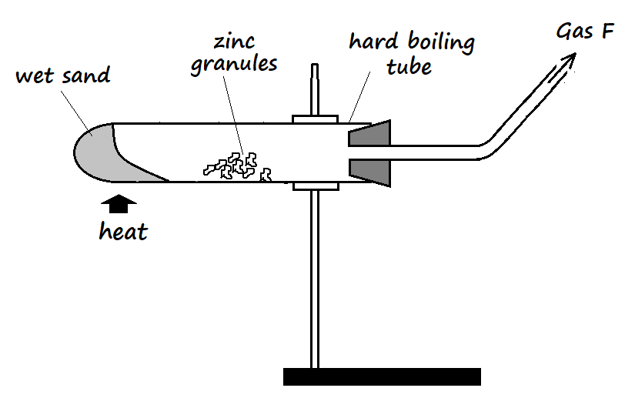

1. What observation is made when **gas F** is ignited? (1 Mark)

___________________________________________________________________________

1. When the experiment was repeated using iron powder instead of zinc granules, only a small volume of **gas F** was obtained. Give a reason for this observation. (1 Mark)

___________________________________________________________________________

___________________________________________________________________________

1. The wet sand was heated before heating the zinc granules. Explain (1 Mark)

___________________________________________________________________________

___________________________________________________________________________