QUALITY ASSUARANCE SERIRS FORM 1 END TERM 3 EXAMS 2023
COMPUTER STUDIES 451/1
FORM ONE (1)
TIME 2 Hours.

Name: …………………………………………………………………. Adm No: ……………….
School: ……………………………………………….………………. Class: ………………….
Signature: ……………………………………………………………. Date: …………………...

Instructions to Candidates
- Write your Name and Adm No. in spaces provided above.
- Answer ALL the questions.

- Give four reasons to justify why many computer users today prefer saving their documents in the google drive (4mark)
__________________________________________________________________________________________________________________________________________________________________________________________________________________________________________________________________________________________________________________________________________________________________________________________________________________________
__________________________________________________________________________________
- Briefly describe four factors to consider when choosing a printer (4marks)
____________________________________________________________________________________________________________________________________________________________________________________________________________________________________________________________________________________________________________________________________________________________________________________________________________________________________________________________________________________________________________
__________________________________________________________________________________
- Describe four ways employed by the operating system to protect its programs, data and information (4marks)
____________________________________________________________________________________________________________________________________________________________________________________________________________________________________________________________________________________________________________________________________________________________________________________________________________________________________________________________________________________________________________
__________________________________________________________________________________
- Describe four application areas of magnetic stripe recognition technology (4marks)
____________________________________________________________________________________________________________________________________________________________________________________________________________________________________________________________________________________________________________________________________________________________________________________________________________________________________________________________________________________________________________
__________________________________________________________________________________

- A storage disk has a capacity of 10GB

- Calculate the precise number of characters that can be stored by the disk (2marks)
______________________________________________________________________________________________________________________________________________________________________________________________________________________________________________________
__________________________________________________________________________________
- Given that 16GB memory card was used to back up the data in the storage disk calculate the remaining space in the memory card in megabytes (2marks)
______________________________________________________________________________________________________________________________________________________________________________________________________________________________________________________
__________________________________________________________________________________

- Describe three main elements of the central Processing Unit (3marks)
__________________________________________________________________________________________________________________________________________________________________________________________________________________________________________________________________________________________________________________________________________________________________________________________________________________________
- List four limitations of cathode ray tube monitors (4marks)
______________________________________________________________________________________________________________________________________________________________________________________________________________________________________________________
______________________________________________________________________________________________________________________________________________________________________________________________________________________________________________________
- State the functions of the following disk management operations (4marks)

- Defragmentation
____________________________________________________________________________________________________________________________________________________________________
__________________________________________________________________________________

- Partitioning
____________________________________________________________________________________________________________________________________________________________________
__________________________________________________________________________________
- Formatting
____________________________________________________________________________________________________________________________________________________________________
__________________________________________________________________________________
- Backing up
____________________________________________________________________________________________________________________________________________________________________
__________________________________________________________________________________

- Identify the interfacing cables in the table below (6marks)
Cable | Name | Cable | Name
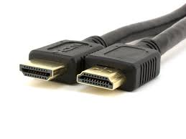 |  | 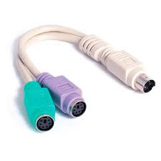
Cable | Name | Cable | Name
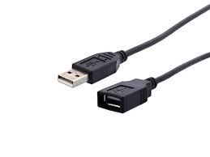 |  | 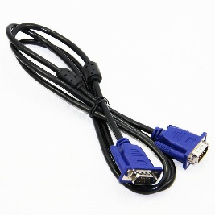
Cable | Name | Cable | Name
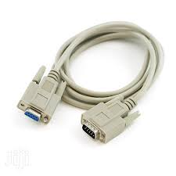 |  | 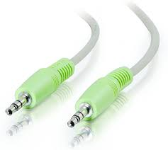

- Identify four resources under the control of the operating system (4marks)
__________________________________________________________________________________________________________________________________________________________________________________________________________________________________________________________________________________________________________________________________________________________________________________________________________________________

- Describe the following concepts as used in computer setup and cabling (2marks)
- Master/slave configuration
______________________________________________________________________________________________________________________________________________________________________________________________________________________________________________________
__________________________________________________________________________________
- Hot swapping
______________________________________________________________________________________________________________________________________________________________________________________________________________________________________________________
__________________________________________________________________________________
- Give three controllers used to connect a hard disk to the motherboard (3marks)
______________________________________________________________________________________________________________________________________________________________________________________________________________________________________________________
__________________________________________________________________________________

- Kavala is a computer student from Naiveté girls she bought a computer for her personal use later she released that her computer memory was very low and therefore need to be upgraded. List four factors that Kavala must consider before purchasing memory modules for upgrade (4marks)
__________________________________________________________________________________________________________________________________________________________________________________________________________________________________________________________________________________________________________________________________________________________________________________________________________________________
- Mention four advantages of solid-state storage devices (4marks)
__________________________________________________________________________________________________________________________________________________________________________________________________________________________________________________________________________________________________________________________________________________________________________________________________________________________

- Give two functions of the graphic adapters (2marks)
____________________________________________________________________________________________________________________________________________________________________
__________________________________________________________________________________
- List four examples of softcopy output devices (4marks)
________________________________________________________________________________________________________________________________________________________________________________________________________________________________________________________________________________________________________________________________________
__________________________________________________________________________________
- State four factors used to measure the performance of a computer monitor (4marks)
__________________________________________________________________________________________________________________________________________________________________________________________________________________________________________________________________________________________________________________________________________________________________________________________________________________________

- Mention four characteristics of the fifth generation computers (4marks)
____________________________________________________________________________________________________________________________________________________________________
______________________________________________________________________________________________________________________________________________________________________________________________________________________________________________________
- What is artificial intelligence (2marks)
______________________________________________________________________________________________________________________________________________________________________________________________________________________________________________________
__________________________________________________________________________________

- Many financial institutions and business enterprises in the World today operate on electronic platforms. State five challenges they usually experience when using this approach (5marks)
____________________________________________________________________________________________________________________________________________________________________________________________________________________________________________________________________________________________________________________________________________________________________________________________________________________________________________________________________________________________________________

- List two devices that can be connected to the computer system unit via VGA cable(2marks)
____________________________________________________________________________________________________________________________________________________________________
__________________________________________________________________________________
- Mention three functions of the power supply unit (3marks)
________________________________________________________________________________________________________________________________________________________________________________________________________________________________________________________________________________________________________________________________________
__________________________________________________________________________________
- Give two reasons to justify why USB interfaces are becoming popular with modern computing devices (2marks)
________________________________________________________________________________________________________________________________________________________________________________________________________________________________________________________________________________________________________________________________________
- Mention five measures that should be observed in a computer laboratory to protect the computer (5marks)
______________________________________________________________________________________________________________________________________________________________________________________________________________________________________________________________________________________________________________________________________________________________________________________________________________________________________________________________________________________________________________________________________________________________________________________________

- ICT can be very useful in the management of farms. Describe five ways in which ICT can be used to management modern agricultural farms (5marks)
____________________________________________________________________________________________________________________________________________________________________________________________________________________________________________________________________________________________________________________________________________________________________________________________________________________________________________________________________________________________________________
- Describe how the operating system discharge the following functions
- Error handling (2marks)
______________________________________________________________________________________________________________________________________________________________________________________________________________________________________________________
__________________________________________________________________________________
- Job scheduling (2marks)
______________________________________________________________________________________________________________________________________________________________________________________________________________________________________________________
__________________________________________________________________________________
- It is advisable to have proper light within a computer lab to avoid headache, fatigue and stress. State four safety precautions that one need to observe to prevent eye-related issues or ailments (4marks)
________________________________________________________________________________________________________________________________________________________________________________________________________________________________________________________________________________________________________________________________________
______________________________________________________________________________________________________________________________________________________________________________________________________________________________________________________

