**QUALITY ASSUARANCE SERIRS FORM 2 END TERM 3 EXAMS 2023**

**HOME SCIENCE (QUESTION PAPER)**

**FORM TWO**

**TIME 2 HOURS**

Name………………………………………………………………… Adm No………………………………..

School…………………………………………………………………. Class…………………………………….

Signature………………………………………………………………Date………………………………………

**Instructions to students**

1. *Write your name, admission number and class in the spaces provided*
2. *Sign and write the date of the examination in the spaces provided*
3. *This paper consists of* ***three*** *sections:* ***A****,* ***B*** *and* ***C***
4. *Answer* ***all*** *the questions in sections* ***A*** *and* ***B*** *and any* ***two*** *questions from section* ***C***
5. *Answers to all the questions must be written in the spaces provided in the paper*
6. ***This paper consists of 13 printed pages***
7. ***Students should check the question paper to ascertain that all the pages are printed as indicated and that no questions are missing***
8. ***Students should answer the questions in English***

**For examiner’s use only**

|  |  |  |  |
| --- | --- | --- | --- |
| **Section** | **Question** | **Maximum Score** | **Student’s Score** |
| **A** | 1. **19** | **40** |  |
| **B** | **20** | **20** |  |
| **C** |  | **20** |  |
|  | **20** |  |
| **TOTAL SCORE** | | **100** |  |

**SECTION A:** (40 marks)

*Answer* ***ALL*** *the questions in this section in the spaces provided.*

1. Give the scientific name of each of the following nutrients. ( 2 marks)

Vitamin B 1...................................................................................................................

Vitamin E ……………………………………………………………………………………….

Vitamin C ……………………………………………………………………………………….

Vitamin A ……………………………………………………………………………………….

1. Give **two** rules to observe when taking body measurements. ( 2 marks )

……………………………………………………………………………………………………………………………………………………………………………………………………………………………………………………………………………………………………………………………………………………………………………………………………………………………………………………………………....

1. Identify **three** factors to consider when buying shoes. ( 3 marks )

………………………………………………………………………………………………………………………………………………………………………………………………………………………………………………………………………………………………………………………………………………………………………………………………………………………………………………………………………....

1. Suggest **two** benefits a consumer may get from advertising. ( 1 mark )

………………………………………………………………………………………………………………………………………………………………………………………………………………………………………………………………………………………………………………………………………………………………………………………………………………………………………………………………………....

1. Give your understanding of each of the following in drainage. ( 3 marks )

Sewer ………………………………………………………………………………………………………………………………………………………………………………………………………………………………

Manhole ………………………………………………………………………………………………………………………………………………………………………………………………………………………………

Septic tank ………………………………………………………………………………………………………………………………………………………………………………………………………………………………

1. Fill the table below on pattern marking and symbols. ( 4 marks )

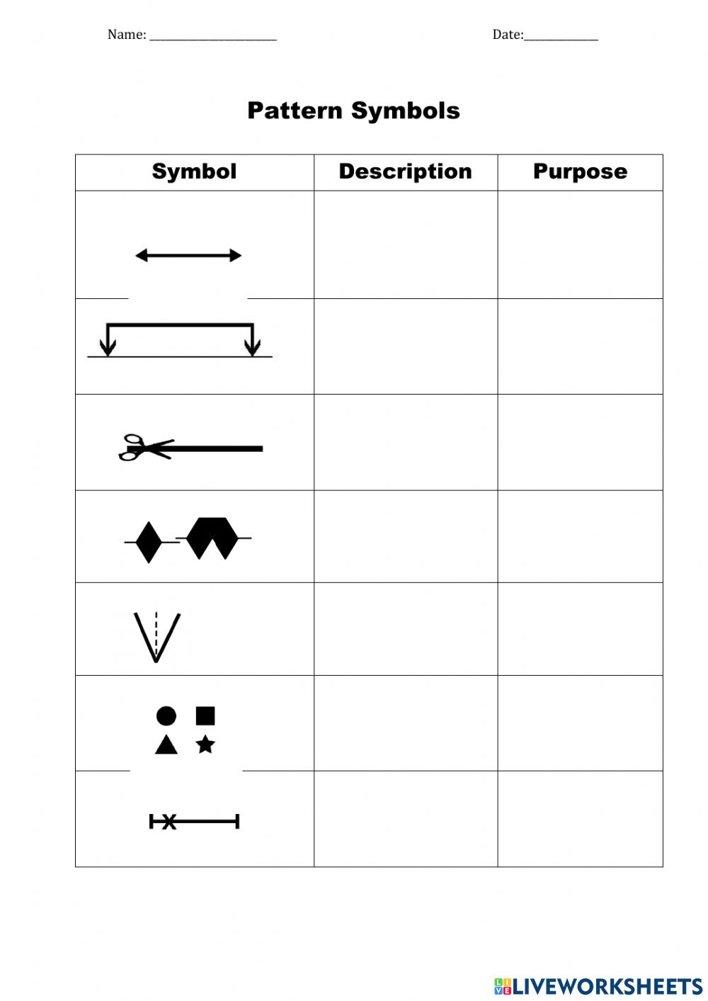

1. Mention **two** differences between dry beriberi and wet beriberi. ( 2 marks )

………………………………………………………………………………………………………………………………………………………………………………………………………………………………………………………………………………………………………………………………………………………………………………………………………………………………………………………………………....

1. List **two** precautions to take when deep fat frying. ( 2 marks )

………………………………………………………………………………………………………………………………………………………………………………………………………………………………………………………………………………………………………………………………………………………………………………………………………………………………………………………………………....

1. Identify **two** diseases that can be transmitted through sharing water bottles. ( 1 mark )

………………………………………………………………………………………………………………………………………………………………………………………………………………………………………………………………………………………………………………………………………………………………………………………………………………………………………………………………………....

1. Give **two** advantages of boiling as a method of cooking. ( 2 mark )

………………………………………………………………………………………………………………………………………………………………………………………………………………………………………………………………………………………………………………………………………………………………………………………………………………………………………………………………………....

1. Mention **two** causes of anaemia other than poor iron intake in food. ( 2 marks )

………………………………………………………………………………………………………………………………………………………………………………………………………………………………………………………………………………………………………………………………………………………………………………………………………………………………………………………………………....

1. Identify **four** measurements that should be taken when making a pair of shorts.( 2 marks )

………………………………………………………………………………………………………………………………………………………………………………………………………………………………………………………………………………………………………………………………………………………………………………………………………………………………………………………………………....

1. State **three** ways of avoiding worm infestation. ( 3 marks )

……………………………………………………………………………………………………………………………………………………………………………………………………………………………………………………………………………………………………………………………………………………………………………………………………………………………………………………………………….............................................................................................................................................................................................................................................................................................................................

1. Mention **three** precautions to take when using an electric iron. ( 3 marks )

……………………………………………………………………………………………………………………………………………………………………………………………………………………………………………………………………………………………………………………………………………………………………………………………………………………………………………………………………….............................................................................................................................................................................................................................................................................................................................

1. Suggest **two** reasons for sorting clothes before washing. ( 2marks )

………………………………………………………………………………………………………………………………………………………………………………………………………………………………………………………………………………………………………………………………………………………………………………………………………………………………………………………………………....

1. Give **two** uses of a seam ripper. ( 1 mark )

……………………………………………………………………………………………………………………………………………………………………………………………………………………………………………………………………………………………………………………………………………………………………………………………………………………………………………………………………….....

1. Outline **two** reasons why consumers should be educated. ( 2 marks )

………………………………………………………………………………………………………………………………………………………………………………………………………………………………………………………………………………………………………………………………………………………………………………………………………………………………………………………………………....

1. Mention **two** reasons for lining a kitchen bin. (1 mark )

…………………………………………………………………………………………………………………………………………………………………………………………………………………………………………………………………………………………………………………………………………………………………………………………………………………………………………………………………………

1. Give **two** points to observe when working permanent stitches. ( 2 marks )

………………………………………………………………………………………………………………………………………………………………………………………………………………………………………………………………………………………………………………………………………………………………………………………………………………………………………………………………………....

**SECTION B:** (20 marks)

**COMPULSORY**

*Answer question 20 in the spaces provided.*

1. Your parents are planning to celebrate their 25th wedding anniversary and they have invited a number of their friends
2. . Give the steps you will follow in laundering and treating the white linen table cloth to be used for the occasion. ( 12 marks )
3. Outline the procedure you will follow in cleaning the polished wooden dining table . (8marks)

………………………………………………………………………………………………………………………………………………………………………………………………………………………………………………………………………………………………………………………………………………………………………………………………………………………………………………………………………………………………………………………………………………………………………………………………………………………………………………………………………………………………………………………………………………………………………………………………………………………………………………………………………………………………………………………………………………………………………………………………………………………………………………………………………………………………………………………………………………………………………………………………………………………………………………………………………………………………………………………………………………………………………………………………………………………………………………………………………………………………………………………………………………………………………………………………………………………………………………………………………………………………………………………………………………………………………………………………………………………………………………………………………………………………………………………………………………………………………………………………………………………………………………………………………………………………………………………………………………………………………………………………………………………………………………………………………………………………………………………………………………………………………………………………………………………………………………………………………………………………………………………………………………………………………………………………………………………………………………………………………………………………………………………………………………………………………………………………………………………………………………………………………………………………………………………………………………………………………………………………………………………………………………………………………………………………………………………………………………………………………………………………………………………………………………………………………………………………………………………………………………………………………………………………………………………………………………………………………………………………………………………………………………………………………………………………………………………………………………………………………………………………………………………………………………………………………………………………………………………………………………………………………………………………………………………………………………………………………………………………………………………………………………………………………………………………………………………………………………………………………………………………………………………………………………………………………………………………………………………………………………………………………………………………………………………………………………………………………………………………………………………………………………………………………………………………………………………………………………………………………………………………………………………………………………………………………………………………………………………………………………………………………………………………………………………………………………………………………………………………………………………………………………………………………………………………………………………………………………………………………………………………………………………………………………………………………………………………………………………………………………………………………………………………………………………………………………………………………………………………………………………………………………………………………………………………………………………………………………………………………………………………………………

**SECTION C:** (40 marks)

*Answer any* ***two*** *questions from this section in the spaces provided at the end of this section.*

2. Discuss **three** ways that the use of an article can affect the laundry process. (6 marks)
3. Explain **three** dangers of drug abuse in students. ( 6 marks )
4. Mention **four** ways a consumer can show integrity when shopping. ( 4 marks )
5. Give **four** ways of avoiding drowning during school holidays. (4 marks)
7. Identify **four** information that a consumer can get from a packet of packed foodstuff. ( 4 marks )
8. Explain **three** reasons why linen is good for making dish cloths. ( 6 marks )
9. Mention **four** reasons why water is important in the diet. ( 4 marks )
10. Discuss **three** factors a young family should consider when choosing on where to live. ( 6 marks)
12. Mention **three** ways of identifying textile fibres. ( 3 marks )
13. Discuss **three** dangers of having raw sewage flowing in a residential area. ( 6 marks )
14. Identify **five** ways conserving nutrients when cooking and preparing spinach. ( 5 marks )
15. Explain **three** qualities of a fabric suitable for making a swimming costume.( 6 marks )

………………………………………………………………………………………………………………………………………………………………………………………………………………………………………………………………………………………………………………………………………………………………………………………………………………………………………………………………………………………………………………………………………………………………………………………………………………………………………………………………………………………………………………………………………………………………………………………………………………………………………………………………………………………………………………………………………………………………………………………………………………………………………………………………………………………………………………………………………………………………………………………………………………………………………………………………………………………………………………………………………………………………………………………………………………………………………………………………………………………………………………………………………………………………………………………………………………………………………………………………………………………………………………………………………………………………………………………………………………………………………………………………………………………………………………………………………………………………………………………………………………………………………………………………………………………………………………………………………………………………………………………………………………………………………………………………………………………………………………………………………………………………………………………………………………………………………………………………………………………………………………………………………………………………………………………………………………………………………………………………………………………………………………………………………………………………………………………………………………………………………………………………………………………………………………………………………………………………………………………………………………………………………………………………………………………………………………………………………………………………………………………………………………………………………………………………………………………………………………………………………………………………………………………………………………………………………………………………………………………………………………………………………………………………………………………………………………………………………………………………………………………………………………………………………………………………………………………………………………………………………………………………………………………………………………………………………………………………………………………………………………………………………………………………………………………………………………………………………………………………………………………………………………………………………………………………………………………………………………………………………………………………………………………………………………………………………………………………………………………………………………………………………………………………………………………………………………………………………………………………………………………………………………………………………………………………………………………………………………………………………………………………………………………………………………………………………………………………………………………………………………………………………………………………………………………………………………………………………………………………………………………………………………………………………………………………………………………………………………………………………………………………………………………………………………………………………………………………………………………………………………………………………………………………………………………………………………………………………………………………………………………………………………………………………………………………………………………………………………………………………………………………………………………………………………………………………………………………………………………………………………………………………………………………………………………………………………………………………………………………………………………………………………………………………………………………………………………………………………………………………………………………………………………………………………………………………………………………………………………………………………………………………………………………………………………………………………………………………………………………………………………………………………………………………………………………………………………………………………………………………………………………………………………………………………………………………………………………………………………………………………………………………………………………………………………………………………………………………………………………………………………………………………………………………………………………………………………………………………………………………………………………………………………………………………………………………………………………………………………………………………………………………………………………………………………………………………………………………………………………………………………………………………………………………………………………………………………………………………………………………………………………………………………………………………………………………………………………………………………………………………………………………………………………………………………………………………………………………………………………………………………………………………………………………………………………………………………………………………………………………………………………………………………………………………………………………………………………………………………………………………………………………………………………………………………………………………………………………………………………………………………………………………………………………………………………………………………………………………………………………………………………………………………………………………………………………………………………………………………………………………………………………………………………………………………………………………………………………………………………………………………………………………………………………………………………………………………………………………………………………………………………………………………………………………………………………………………………………………………………………………………………………………………………………………………………………………………………………………………………………………………………………………………………………………………………………………………………………………………………………………………………………………………………………………………………………………………………………………………………………………………………………………………………………………………………………………………………………………………………………………………………………………………………………………………………………………………………………………………………………………………………………………………………………………………………………………………………………………………………………………………………………………………………………………………………………………………………………………………………………………………………………………………………………………………………………………………………………………………………………………………………………………………………………………………………………………………………………………………………………………………………………………………………………………………………………………………………………………………………………………………………………………………………………………………………………………………………………………………………………………………………………………………………………………………………………………………………………………………………………………………………………………………………………………………………………………………………………………………………………………………………………………………………………………………………………………………………………………………………………………………………………………………………………………………………………………………………………………………………………………………………………………………………………………………………………………………………………………………………………………………………………………………………………………………………………………………………………………………………………………………………………………………………………………………………………………………………………………………………………………………………………………………………………………………………………………………………………………………………………………………………………………………………………………………………………………………………………………………………………………………………………………………………………………………………………………………………………………………………………………………………………………………………………………………………………………………………………………………………………………………………………………………………………………………………………………………………………………………………………………………………………………………………………………………………………………………………………………………………………………………………………………………………………………………………………………………………………………………………………………………………………………………………………………………………………………………………………………………………………………………………………………………………………………………………………………………………………………………………………………………………………………………………………………………………………………………………………………………………………………………………………………………………………………………………………………………………………………………………………………………………………………………………………………………………………………………………………………………………………………………………………………………………………………………………………………………………………………………………………………………………………………………………………………………………………………………………………………………………………………………………………………………………………………………………………………………………………………………………………………………………………………………………………………………………………………………………………………………………………………………………………………………………………………………………………………………………………………………………………………………………………………………………………………………………………………………………………………………………………………………………………………………………………………………………………………………………………………………………………………………………………………………………………………………………………………………………………………………………………………………………………………………………………………………………………………………………………………………………………………………………………………………………………………………………………………………………………………………………………………………………………………………………………………………………………………………………………………………………………………………………………………………………………………………………………………………………………………………………………………………………………………………………………………………………………………………………………………………………………………………………………………………………………………………………………………………………………………………………………………………………………………………………………………………………………………………………………………………………………………………………………………………………………………………………………………………………………………………………………………………………………………………………………………………………………………………………………………………………………………………………………………………………………………………………………………………………………………………………………………………………………………………………………………………………………………………………………………………………………………………………………………………………………………………………………………………………………………………………………………………………………………………………………………………………………………………………………………………………………………………………………………………………………………………………………………………………………………………………………………………………………………………………………………………………………………………………………………………………………………………………………………………………………………………………………………………………………………………………………………………………………………………………………………………………………………………………………………………………………………………………………………………………………………………………………………………………………………………………………………………………………………………………………………………………………………………………………………………………………………