Name……………................................. Admission Number…..........Class…………........

121
MATHEMATICS
2½ hours
FORM TWO
End of Year Exams 2023

THE STANDARD MEASURE SERIES FORM 2 END OF YEAR EXAMS 2023.

INSTRUCTIONS TO CANDIDATES
- Write your name, class and admission number in the spaces provided at the top of this page.
- This paper consists of two sections, section I and section II.
- Answer all questions in section I and ONLY FIVE questions in section II
- Show all the steps in your calculations, giving your answers at each stage in the spaces below each question.
- Marks may be given for correct working even if the answer is wrong.
- KNEC Mathematical tables may be used. Calculators MUST not be used
For Examiner’s Use Only
SECTION I
1 | 2 | 3 | 4 | 5 | 6 | 7 | 8 | 9 | 10 | 11 | 12 | 13 | 14 | 15 | 16 | TOTAL

SECTION II
17 | 18 | 19 | 20 | 21 | 22 | 23 | 24 | TOTAL
100

GRAND TOTAL

This paper consists of 16 printed pages. You are advised to go through this paper before to ascertain that the entire question is clear and none is missing
SECTION I (50 marks) Answer all the questions in this section in the spaces provided
- Without using a calculator evaluate (3marks)
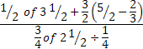

- Simplify the expression: 3x² – 4xy² + y (3marks)
9x² – y²

- Four strings measuring 12cm, 18cm, 24cm and 36cm are cut into pieces of equal length so that exact number of pieces is obtained from each string without wastage. Find the longest length of each string. (2marks)

- All prime numbers between ten and twenty are arranged in descending order to form a number.
    - Write down the number. (1mark)

    - State the total value of the third digit of the number formed in (i) above. (1mark)

- Use tables to evaluate:- (3 marks)
5 - (4.125)³
(0.293)²
.

- The region R in the figure below is defined by the inequalities L1, L2 and L3. Find the three inequalities. (3marks)

.

- Without using tables calculate the value of: $\frac{1 + \text{Cos} A}{1 − \text{Sin} A}$
Where A is an acute angle and tan A = $34$. (3marks)

- .Solve for x in the equation:
$\frac{3^{x}}{9} = \frac{1}{3^{\left(1 − 2x\right)}}$ (3marks)

- Convert the recurring decimal. $0\text{.}\overset{}{0}0\overset{}{9}$into fraction. (2marks)

- .Use logarithm tables to evaluate: $\frac{\text{47}\text{.}\text{81} \text{Log} 5\text{.}\text{623}}{\sqrt{\text{823} × \text{72}\text{.}\text{46}}}$ (4marks)

- The volume of a sphere is given by ³ . Find the radius of a sphere whose volume is 1047.816cm³ (take to be ) (4marks)

- In the figure below, AD is parallel to GJ and GI is parallel to FD. Angle BAH = 300 and angle BGF = 630. Find angle AFD. (3marks)
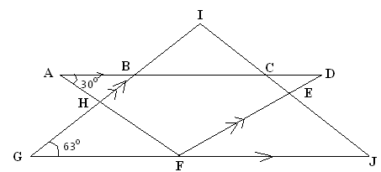

- The figure below (not drawn to scale) shows the cross-section of a metal bar of length 3 metres. They are equal semi circles. Determine the mass of the metal bar in kilograms if the density of the metal is 8.87g/cm3. (3marks)
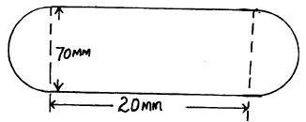

- Find the area of the sector of a circle of radius 3cm if the angle subtended at the centre is 140⁰ (3marks)

- Using ruler and a pair of compasses only:
  - Construct triangle ABC in which BC = 8cm and angle ABC = 105⁰ and angle BAC = 45⁰. (3marks)

  - Drop a perpendicular from A to meet line BC at P. Determine the area of triangle ABC (1mark)

16. A Forex Bureau in Kenya buys and sells foreign currencies as shown below:
Buying Selling
Currency (Kshs) (Kshs)
Chinese Yuan 12.34 12.38
South African Rand 11.28 11.37
A businesswoman from China converted 195 250 Chinese Yuan into Kenya Shillings.
(a) Calculate the amount of money, in Kenya shillings, that she received. (1 mark)

(b) While in Kenya, the businesswoman spent Kshs.1 258 000 and then converted the balance into South African Rand. Calculate the amount of money, to the nearest Rand, that she received. (3 marks)

SECTION II (50 MARKS) Answer any FIVE questions in this section.
- Five members of ‘SILK’, a self supporting enterprise Jane, Jepchoge, Esther, Mama Charo and Chepkoech were given a certain amount of money to share amongst themselves. Jane got 3/8 of the total amount while Jepchoge got 2/5 of the remainder. The remaining amount was shared equally among Esther, Mama Charo and Chepkoech each of which received Kshs. 6,000;
  - How much was shared among the five business women? (3marks)

  - How much did Jepchoge get? (2marks)

  - Jane, Jepchoge and Chepkoech invested their money and earned a profit of Kshs. 12,000. A third of the profit was left to maintain the business and the rest was shared according to their investments. Find how much each got.
(5marks)

- The height of 200 students in a school were measured and recorded in the table below. All heights are given to the nearest cm.
Height (cm) | Class midpoint (x) | Frequency (f) | fx
135- 139 |  | 8
140- 144 |  | 12
145- 149 |  | 35
150- 154 |  | 40
155- 159 |  | 50
160- 164 |  | 25
165- 169 |  | 15
170- 174 |  | 9
175- 179 |  | 6

a) Copy and complete the table. (2mks)

b) State the modal class. (1mk)

c) Use the completed the table to calculate the mean height of the students. (3mks)

d) Draw an histogram and hence a frequency polygon representing the above data. (4mks)

- A ship B is on bearing of 080⁰ from port A and at a distance of 95km. Another ship is stationed at port D which is on a bearing of 200⁰ from A and a distance of 124km from B. A ship leaves B and moves directly to island P which is on a bearing of 140⁰ from A.
  - Using a scale of 1cm to represent 10km, make a scale drawing to show the relative positions of A, B, D and P. (4marks)

- Hence find:-
    - The distance from A to D. (2marks)

    - The bearing of D from B. (1mark)

    - The bearing of P from D. (1mark)

    - The distance from P to D. (2marks)

- A right conical frustum of base radius 6cm is mounted on top of a cylinder of the same base radius and height 10cm. The top of the solid frustum is of radius 3.6cm. The height of frustum is also 6cm.
Take π= $\frac{\text{22}}{7}$. Calculate:
(a) The total surface area of the solid. (6marks)
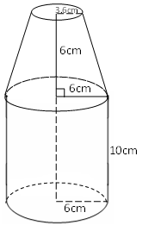

(b) The volume of the solid. (4marks)

21. The diagram below shows two circles, centre A and B which intersect at points P and Q. Angle PAQ = 700 and PBQ = 400 and PA = AQ = 8cm.
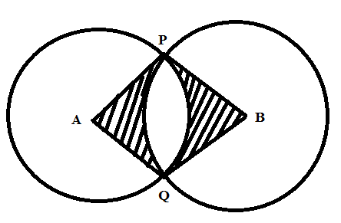

Use the diagram to calculate to two d.p
a) The length PQ (2marks)

b) The length PB (2marks)

c) Area of minor segment circle centre A. (2marks)

d) Area of the shaded region. (4marks)

22. The coordinates of a triangle ABC are A(1, 1) B(3, 1) and C (1, 3).
(a) Plot the triangle ABC. (1 mark)
(c) ABC undergoes a reflection along the line X = 0, obtain the coordinates and plot on the graph points A’ B’ C’, under the transformation (3 marks)
(d) The triangle A’ B’ C’, undergoes an enlargement scale factor -1, centre origin. Obtain the coordinates of the image A’’ B’’ C’’ (3marks)
(e) The triangle A’’ B’’ C’’ undergoes a rotation centre (1, -2) angle 120⁰. Obtain the coordinates of the image A’’’B’’’C’’’ (3 marks)

23. A matatu and Nissan left town A for town B 240km away at 8.00a.m travelling at 90km/hr and 120km/hr respectively. After 20 minutes the Nissan had a puncture which took 30 minutes to mend.
a) How far from town A did the Nissan catch up with the matatu? (6 marks)

b) At what time did the Nissan catch up with the matatu? (1 mark)

c) At what time did the matatu reach town B? (3 marks)

