**QUALITY ASSUARANCE SERIRS FORM 2 END TERM 3 EXAMS 2023**

**MATHEMATICS (QUESTION PAPER)**

**FORM 2**

**TIME 2½ HOURS**

**Name**: …………………………………………………………. **Adm** **No**: ……………….

**School**: ……………………………………………………….. **Class**: …………………..

**Signature**: …………………………………………………….. **Date**: …………………...

**INSTRUCTIONS:**

1. Write your name, Index number in the space provided at the top of the page.
2. Write the date of examination and sign in the spaces provided above.
3. This paper consists of **two** sections: I and II.
4. Answer all the questions in section I and any **five** questions from section II
5. All answers and working must be written on the question paper in the spaces provided below each question.
6. Show all the steps in your calculation, giving your answers at each stage in the space provided.
7. Marks may be given for correct working even if the answer is wrong.
8. Non programmable silent electronic calculator and KNEC Mathematical table may be used, except when stated otherwise.

**FOR EXAMINER’S USE ONLY**

**SECTION I**

|  |  |  |  |  |  |  |  |  |  |  |  |  |  |  |  |  |
| --- | --- | --- | --- | --- | --- | --- | --- | --- | --- | --- | --- | --- | --- | --- | --- | --- |
| **1** | **2** | **3** | **4** | **5** | **6** | **7** | **8** | **9** | **10** | **11** | **12** | **13** | **14** | **15** | **16** | **Total** |
|  |  |  |  |  |  |  |  |  |  |  |  |  |  |  |  |  |

**GRAND TOTAL**

**SECTION II**

|  |  |  |  |  |  |  |  |  |
| --- | --- | --- | --- | --- | --- | --- | --- | --- |
| **17** | **18** | **19** | **20** | **21** | **22** | **23** | **24** | **Total** |
|  |  |  |  |  |  |  |  |  |

***This paper consists of 15 printed pages***

**SECTION I (50 Marks)**

Answer ***all*** the questions in this section

1. Evaluate (3 marks)
$$\frac{2\frac{1}{5}+\frac{2}{3} of 3\frac{3}{4}-4\frac{1}{6}}{1\frac{1}{4}-2\frac{2}{5}÷1\frac{1}{3}+3\frac{3}{4}}$$

2. Three metallic tanks have the capacities of 447 litres, 577 litres and 669 litres. Find the capacity of the largest container that can fill the tanks an exact number of times, leaving a remainder of 7 litres, 5 litres and 9 litres respectively. (3 marks)
3. The marked price of a computer is Kshs. 72,000. Rhenice bought the computer at a discount of 8%. The dealer still made an 20% profit. Calculate the amount of money the dealer paid for the computer. (3 marks)
4. Use tables of squares, square roots and reciprocals only to evaluate (4 marks)
$$\frac{1}{\sqrt{446.9}}-{0.1273}^{2}$$

5. The length of a grass lawn is 2 metres less than twice its width. The area of the lawn is 60 m2, calculate its length (3 marks)
6. The figure below shows part of a solid cuboid ABCDEFGH

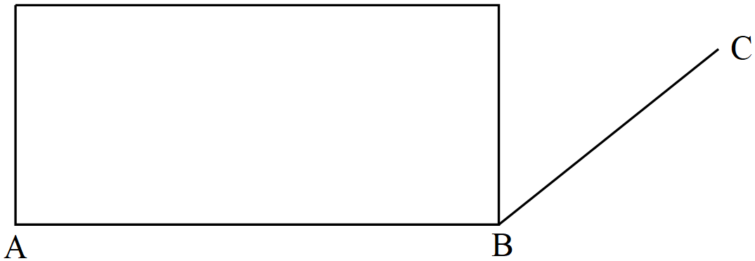

Complete the solid (3 marks)

1. The graph below shows the relationship between the electricity bill (in Kshs.) and the number of units consumed (in kilowatt hours)

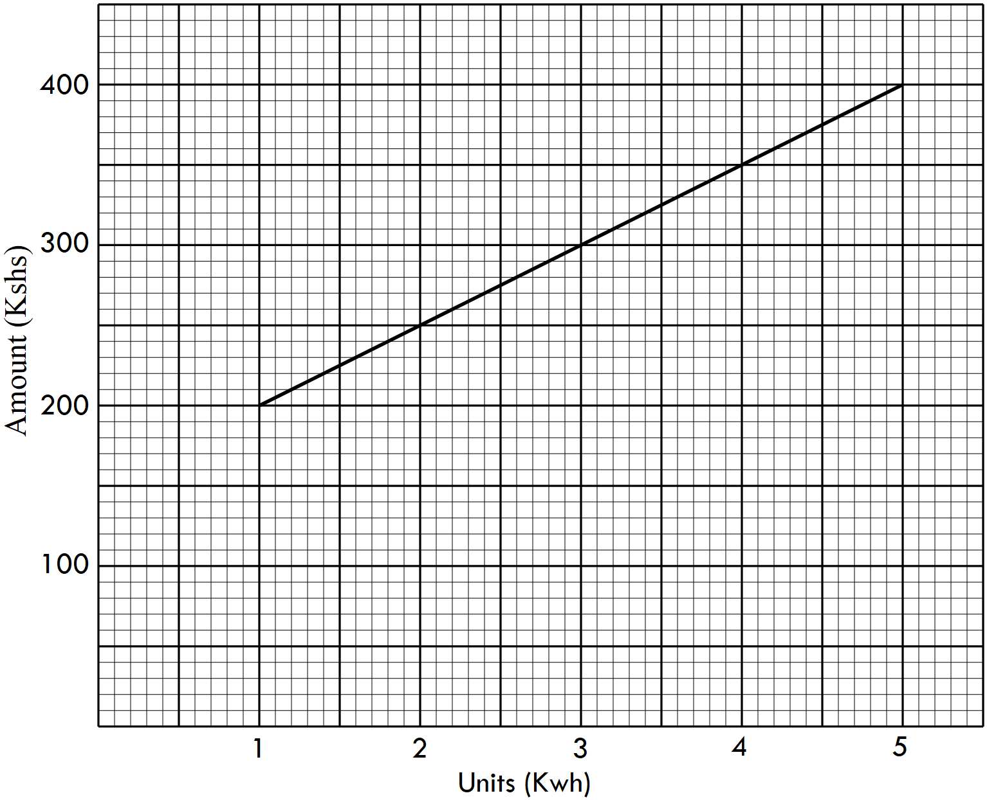

Use a graph to determine the

1. fixed charge of the bill. (1 mark)
2. cost per unit of the consumption (2 marks)
3. Solve for $x$ in the equation (3 marks)

${\left(3^{2x}\right)}^{3 }=81×9^{4}$

1. Given that $p=\left(\begin{matrix}-1 \\ 3\end{matrix}\right)$ and $r=\left(\begin{matrix}3 \\ 2\end{matrix}\right)$ and find $\left|q\right|$ given that $q=3p-2r$. (3 marks)
2. The cost of four exercise books and three pens is Kshs. 630. Five similar exercise books and two similar pens cost Kshs. 70 more. Calculate the cost of each item. (3 marks)
3. Two similar containers have surface areas of 700 cm2 and 1008 cm2 respectively. If the height of the larger container is 29.4 cm, calculate the height of the smaller container. (3 marks)
4. The cross-section of a swimming pool is such that the shallow end is 1 metre deep and the deepest end 1.5 metres deep. The width of the pool is 6 metres. Given that the pool is 15 metres long, calculate the capacity of water if the swimming pool is full. (3 marks)
5. Calculate the distance AB in the figure below. Give your answer correct to 4 significant figures. (4 marks)

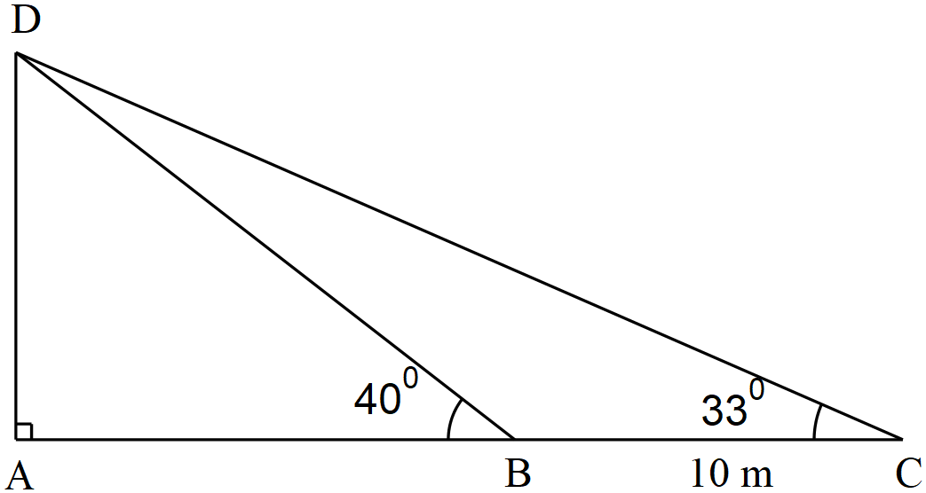

1. A number $P$ is formed by writing all the prime numbers between 0 and 10 is ascending order while another number $Q$ is formed by writing all the square numbers between 0 and 10 in descending order.
2. Find $P-Q$ (2 marks)
3. Hence find the total value of the third digit in the answer of $P-Q$ (1 mark)
4. Using a ruler and a pair of compasses only, construct a triangle PQR in which PQ=8.7 cm, ∠PQR= ${52\frac{1}{2}}^{0}$ and QR=4cm. Measure PR (3 marks)
5. Oscar started a road trip that took him a total of 9 hours 28 minutes and completed the trip on a Tuesday at 6. 03 a.m. At what time did he start the trip? Give your answer in 12 hour clock system (3 marks)

**SECTION II (50 Marks)**

*Answer any* ***five*** *questions in this section*

1. The table below shows the marks scored by 50 students in a Zeraki Achievers’ Examination.

|  |  |  |  |  |  |  |
| --- | --- | --- | --- | --- | --- | --- |
| Marks (%) | 20 – 24 | 25 – 34 | 35 – 39 | 40 – 54 | 55 – 59 | 60 – 74 |
| Number of Students | 7 | 8 | 10 | 13 | 9 | 3 |

1. Calculate
2. The mean mark (4 marks)
3. The median mark (3 marks)
4. The mean age of 14 students is 16 years. If two more students join them, the new mean becomes 16.5 years. If one of the added student is 22 years old, find the age of the other student. (3 marks)
5. (a) On the grid provided, draw the square whose vertices are $P$ (6, $-$ 2), $Q$ (7, $-$ 2), $R$ (7, $-$ 1) and $S$ (6, $-$ 1) (1 mark)



(b) On the same grid, draw:

1. $P'Q'R'S'$ the image of $PQRS$, under an enlargement scale factor 3, centre (9, $-$ 4). State the coordinates of $P'Q'R'S'$ (3 marks)
2. $P''Q''R''S''$ the image of $P'Q'R'S'$ under a reflection in the line $y=0$. (2 marks)
3. $P'''Q'''R'''S'''$ the image of $P''Q''R''S''$ under a rotation of 900 about (0, 0) (2 marks)

(c) Describe a single transformation that maps $P'Q'R'S'$ on to $P'''Q'''R'''S'''$. (2 marks)

1. The diagram below shows a solid frustum whose top and bottom diameters are 35 cm and 28 cm respectively. The height of the frustum is 25 cm. Using $π=\frac{22}{7}$

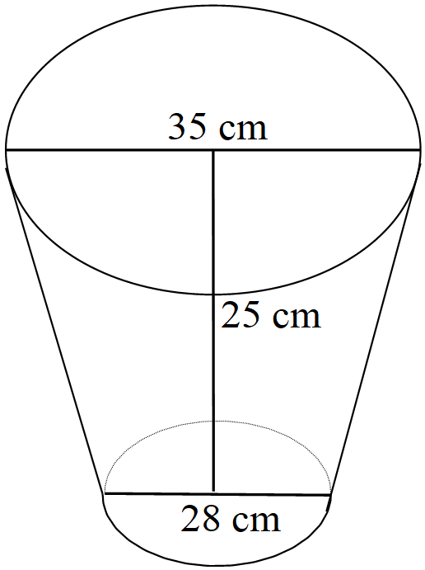

1. Calculate the volume of the solid (6 marks)
2. The frustum is melted and recast into a solid sphere. Calculate the radius of the sphere correct to 2 decimal places . (4 marks)
3. A matatu left a town P at 9.00 a.m. for town Q, 51 km away at an average speed of 48 km/h. Half an hour later, a car left town Q for town P travelling along the same route at an average speed of 60 km/h.

Find;

1. (i) the time they met (3 marks)

(ii) how far they met from town P (2 marks)

1. A body starts from rest and accelerates uniformly attaining a velocity of 40 m/s in three seconds. It maintains this velocity for five seconds, and then decelerates at 8 m/s2 for two seconds. It further decelerates uniformly and comes to rest in four seconds.
2. Using the information above, calculate the value of $a$ and b in the table below. (2 marks)

|  |  |  |  |  |  |
| --- | --- | --- | --- | --- | --- |
| Time (seconds) | 0 | 3 | $$a$$ | 10 | 14 |
| Velocity (m/s) | 0 | 40 | 40 | $$b$$ | 0 |

1. Hence, calculate the total distance covered by the body. (3 marks)
2. Samantha and Kerina entered into a joint business venture in which they contributed Kshs. 150,000 and Kshs. 120,000 respectively every year. After one year, Joyce joined the venture too and contributed Kshs. 90,000.
3. Calculate the ratio of their investment after 3 years of business (3 marks)
4. The agreed as follows; that 30% of the profits after 3 years be used to carter for the operational costs of the business while the rest would be shared proportionately. At the end of the third year, the profit was Kshs. 1,870,000. Calculate each person’s share. (4 marks)
5. Samantha and Kerina put their shares together and bought fish cages at Kshs 25, 500 per cage. Calculate the number of fish cages they bought. (3 marks)
6. A straight line L1 whose equation is $3y – 2x =-2$ meets the x- axisat R
7. Determine the coordinates of R. (2 marks)
8. A second line L2 meets L1 at a right angle at R. Find the equation of L2 in the form $y=mx+c$, where $m$ and $c$ are constants. (4 marks)
9. A third line L3 passing through ($-$ 4, 1) is parallel to L1. Find the equation of L3 in the form $ax+by+c=0$, where $a$, $b$ and $c$ are integers. (2 marks)
10. Calculate the acute angle L2 makes with the line $y=0$ (2 marks)
11. (a) Three schools, Kisumu School, Sinyolo Girls and Thurdibuoro are such that Sinyolo girls is on a bearing of 0620 from Kisumu School at a distance of 32 km. Thurdibuoro is 50 km from Kisumu School and on a bearing of 1670 from Sinyolo girls. Using a scale of 1: 500,000,
12. Show the relative positions of the three schools (3 marks)
13. Use the scale drawing to find:

* Bearing of Kisumu School from Thurdibuoro. (1 mark)
* Distance of Thurdibuoro from Sinyolo girls (1 mark)

1. A talent centre **M**, is to be located such that it is equidistant from each of the three schools.

* On the diagram in (i) above, show the position of **M** (2 marks)
* Hence find the bearing of **M** from Sinyolo girls (1 mark)

(b) The figure below shows a school farm. Using AB=750 metres as the base line, enter the measurements of the farm in a surveyor’s field book (2 marks)

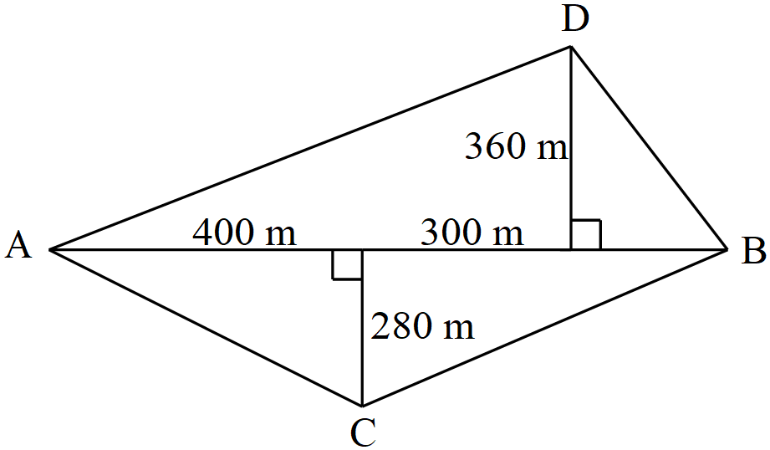

1. In the figure below, O is the centre of the circle, ABCD is a cyclic quadrilateral and that ∠CBD = 420, ∠BAC = 580 ∠DCA = 360

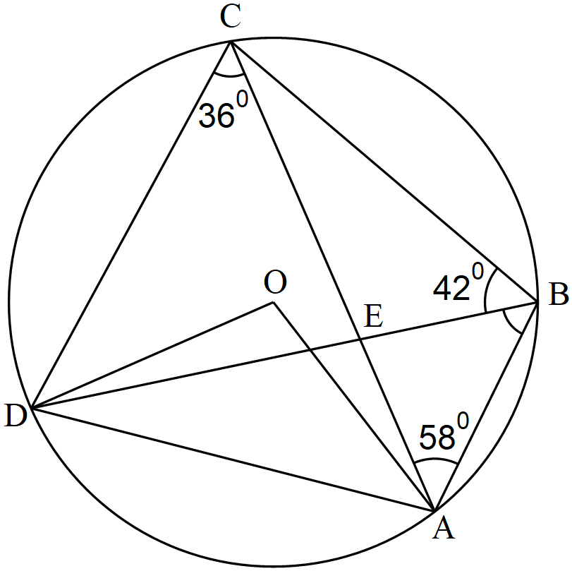

Giving reasons, find the values of:

1. ∠DAC (2 marks)
2. ∠ADB (2 marks)
3. Acute ∠DOA (2 marks)
4. ∠BDO (2 marks)
5. ∠DEC (2 marks)