**NAME ……………………………………….…… ADM NO………..… DATE …….………**

**SCHOOL……………………………………………..……… SIGNATURE …………..……….**

**121**

**MATHEMATICS**

**FORM 1**

**TIME: 2 ½ HOURS**

**BRAIN QUEST SERIES FORM 1 END OF YEAR** **EXAMS 2023**

**INSTRUCTIONS TO CANDIDATES**

1. *Write your name and admission number in the spaces provided at the top of this page.*
2. *This paper consists of two sections:* ***Section I and Section II.***
3. *Answer* ***al****l questions in* ***section I*** *and* ***Section II.***
4. *Show all the steps in your calculations, giving your answers at each stage in the spaces below each question.*
5. *Marks may be given for correct working even if the answer is wrong.*
6. *Non- programmable silent electronic calculators* ***and KNEC*** *Mathematical tables may be used.*

**For Examiner’s Use Only**

|  |  |  |  |  |  |  |  |  |  |  |  |  |  |  |  |
| --- | --- | --- | --- | --- | --- | --- | --- | --- | --- | --- | --- | --- | --- | --- | --- |
| **1** | **2** | **3** | **4** | **5** | **6** | **7** | **8** | **9** | **10** | **11** | **12** | **13** | **14** | **15** | **16** |
|  |  |  |  |  |  |  |  |  |  |  |  |  |  |  |  |

|  |  |  |  |  |  |
| --- | --- | --- | --- | --- | --- |
| **17** | **18** | **19** | **20** | **21** | **Total** |
|  |  |  |  |  |  |

**Grand**

**Total**

**SECTION I (50 MARKS)**

1. Without using a calculator, evaluate; (3 marks)

$\frac{-2\left(5+3\right)-9÷3+5}{-3×5+-2×4}$

1. Evaluate ; (3 marks)
$$3..9÷\sqrt{0.0676}$$

2. Express the numbers 1470 and 7056, each as a product of its prime factors hence evaluate;

$$\frac{{1470}^{2}}{\sqrt{7056}}$$

leaving your answer in prime factor form. (3 marks)

1. Find the difference between the GCD and LCM of 12, 18 and 36. (3 marks)
2. Evaluate the following; (3 marks)

$\frac{\left(8\frac{1}{2}-6\frac{2}{3}\right)÷\frac{4}{9}}{\frac{2}{5} of 6\frac{1}{4}+1\frac{1}{4}}$

1. In the figure below, ABC is an equilateral triangle of sides 7 cm.

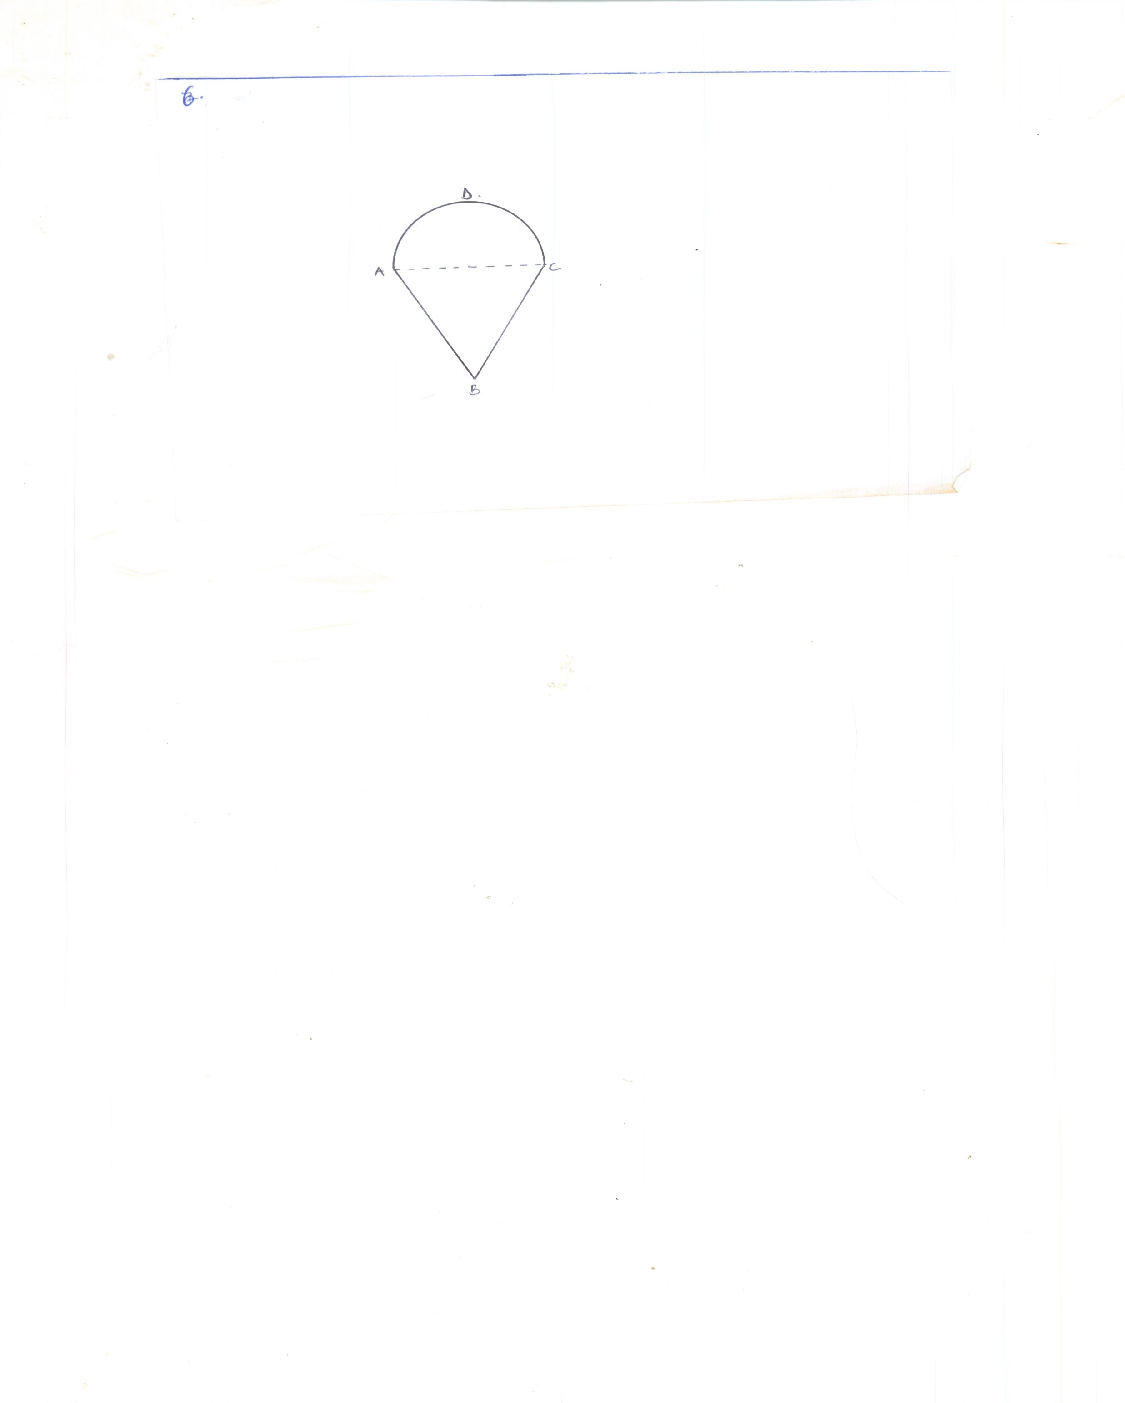

If ADC is a semi circle, calculate the perimeter of the figure. (3 marks)

1. Using a ruler and a pair of compass only, construct a triangle PQR in which $∠PQR=75°,$ $∠QRP=60°$ and QR = 6 cm. Measure PQ and line PR. (4 marks)
2. A trader makes a profit of 20% when he sells a carpet for Ksh. 36 000. In a trade fair he sold one such carpet for Ksh. 33 600. Calculate the percentage profit made on the sale of the carpet during the trade fair. (3 marks)
3. The internal and external diameters of a circular ring are 6 cm and 8 cm respectively. Find the volume of the ring if its thickness is 2 millimetres. (3 marks)
4. Without using mathematical tables, evaluate; (3 marks)

$\sqrt{\frac{15.3×0.18}{0.34×1.6}}$

1. A rectangle is $\frac{3x}{5}$ cm long and $\frac{2x}{3}$ cm wide. Find its perimeter. (3 marks)
2. The figure below shows a solid regular tetra pack of sides 6 cm.

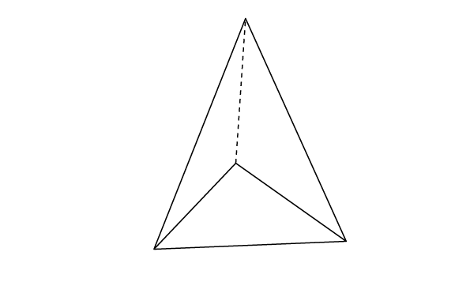

Draw a net of the solid. (3 marks)

1. Solve for $x$; (3 marks)

$\frac{2x-1}{3}-\frac{1-x}{4}=1\frac{3}{7}$

1. A matatu left Mau summit at 8:00 a.m. It arrived in Nakuru 35 minutes later and stopped for 5 minutes. It then took $\frac{3}{4}$ hours to get to Naivasha from Nakuru.
2. How long did the whole journey take? (1 mark)
3. Given that the distance between Mau Summit and Naivasha is 170 km, calculate the speed for the whole journey. (2 marks)
4. A square brass plate is 2 mm thick and has a mass of 1.05 kg. The density of the brass is $8.4 g/{cm}^{3}$. Calculate the length of the plate in centimetres. (4 marks)
5. In the figure below, PQ is parallel to ST, $∠PQR=80°$ and $∠RST=30°$.

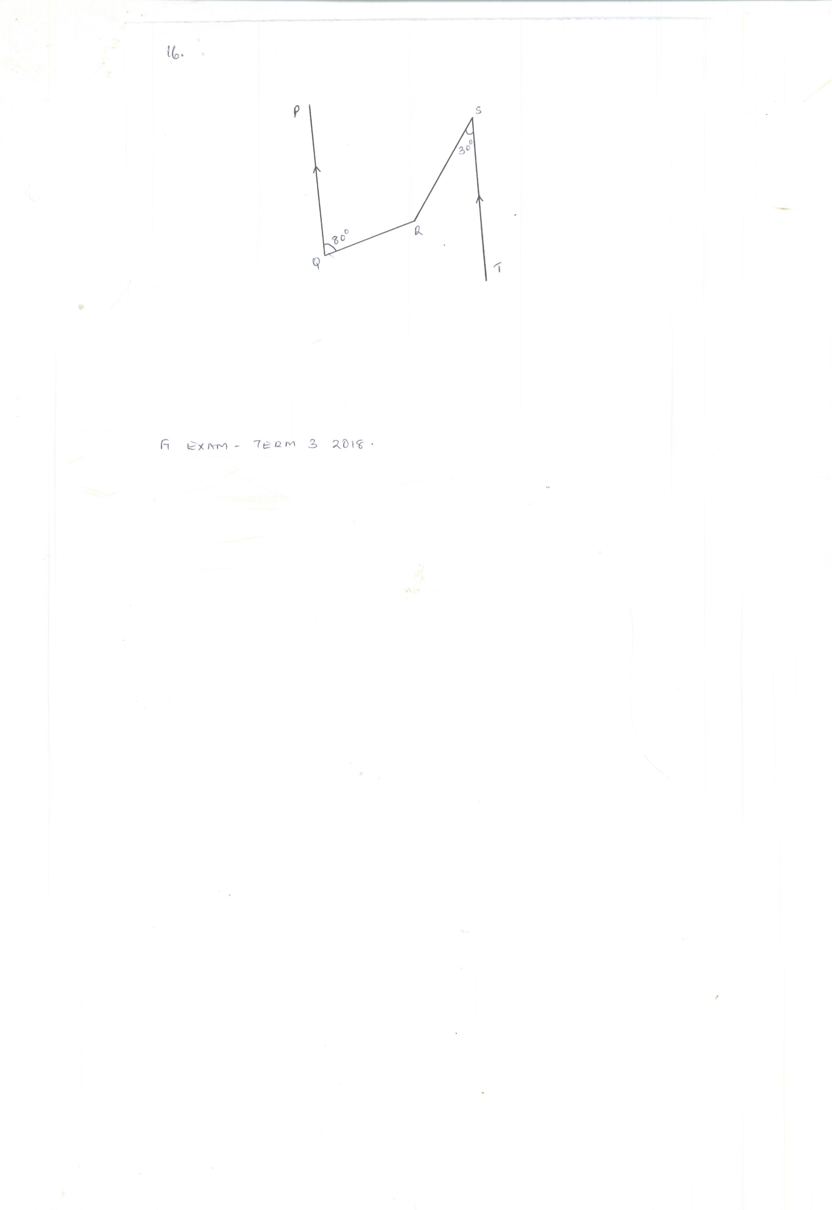

Find $∠QRS$ obtuse. (3 marks)

**SECTION II (50 MARKS)**

1. The table below shows the volume of a gas at various temperatures when heated from $0°C$.

|  |  |  |  |  |  |
| --- | --- | --- | --- | --- | --- |
| Temperature $0°C$ | $$20$$ | $$40$$ | $$60$$ | $$80$$ | $$100$$ |
| Volume (litres) | $$1.82$$ | $$1.95$$ | $$2.07$$ | $$2.20$$ | $$2.35$$ |

1. Using a suitable scale, draw a graph of volume against temperature. (4 marks)
2. Use your graph to find,
3. The initial volume of the gas. (1 mark)
4. The volume of the gas when the temperature is $44°C$ and $70°C$ (2 marks)
5. The temperature of the gas when the volume is 1.8 litres, 2.1 litres and 2.3 litres. (3 marks)
6. The route of a rally has five sections AB, BC, CD, DE and EA. B is 200 km on a bearing of $060°$ from A. C is 500 km from B. The bearing of B from C is $300°$. D is 400 km on a bearing of $230°$ from C. E is 250 km on a bearing of $335°$ from D. Use the scale of 1 cm for 50 km to;
7. Draw the diagram representing the route. (4 marks)
8. Find the distance in km of A from E. (2 marks)
9. Find the bearing of E from A. (1 mark)
10. Find the bearing of A from C. (1 mark)
11. Find the distance in km of A from D. (2 marks)

1. Mr. Kinyua bought three cars A, B and C for a total of Ksh. 1 500 000. The amount he paid for those cars were in the ratio $3:5:7$.
2. Calculate the amount he paid for each car. (3 marks)
3. When he sold all the cars, he made a profit of 12%. Calculate the profit he made on the sale of cars. (1 mark)
4. When he sold the cars, he made a profit of 25% on car A and a loss of 10% on B. calculate;
5. The profit he made on car A. (1 mark)
6. The percentage profit he made on car C. (5 marks)
7. (a) The length of a hollow cylindrical pipe is 6 metres. Its external diameter is 11 cm and has a thickness of 1 cm. calculate the volume, in cm3 of the material used to make the pipe. Use $π=3.142$. (3 marks)

(b) The walls of a room measuring 6 metres long, 5.5 metres wide and 2.8 metres high are to be painted. Each wall has two windows each measuring 1.8 metres by 1.2 metres.

1. Find the area to be painted. (3 marks)
2. If one tin of paint covers 3.1 m2 how many such tins need to be bought. (2 marks)
3. If one tin costs Sh. 250, calculate the total amount required to paint the walls. (2 marks)

1. (a) Stella spent Sh. 166 on the purchase of 5 pens and 3 rulers. James bought four of the pens and two of the rulers for Sh. 124. Find the cost of each item. (4 marks)

(b) Two lines whose equations are $ax+2y=10$ and $6x+by=6$ intersect at point $A (-1, 4)$. Find the value of $a$ and . (4 marks)

(c) Draw a graph showing the two lines. (2 marks)