**BRAIN QUEST SERIES FORM 1 END OF YEAR** **EXAMS 2023**

**FORM 1**

**PHYSICS EXAMINATION**

Students Name: …………………………………………… Adm. No.…………. Class: …………

Date: …………. Time **2 hrs.**

**INSTRUCTIONS TO CANDIDATES**

1. Write your name and admission number.
2. Answer all the questions in the spaces provided after every question.
3. All working for numerical questions must be clearly shown.

**SECTION A (42MKS)**

1. a) Mention 2 branches of physics (2mks)
2. State the relationship between Physics and Biology (1mks)
3. a) What do you understand by S.I units? (1mk)

b) Differentiate between derived physical quantities and basic physical quantities giving an example of each. (4mks)

1. Complete the table below

|  |  |  |
| --- | --- | --- |
| Basic Quantities | SI unit | Symbol |
| Mass |  | Kg |
| Electric current | Ampère |  |
| Temperature |  |  |
| Amount of substance |  | Mol |
| Length |  | m |

Each ½ mark total = 3 marks

1. a) Define force, stating its SI unit. (2mks)

b) State two (2) effect that a force can have when it acts on a body in a particular direction (2mks)

1. a) Define pressure and state its S.I. unit of measurement.

b) A block of copper of density 8900 kg/m3 measures 0.05m x 0.03m x 0.02m. Given that the gravitational field strength, g is 10N/kg, determine the minimum pressure that it can exert on a horizontal surface.

1. a) Some amount of water is heated and its temperature rises from $0^{o}C$ to ${15}^{o}C$. Sketch a graph of volume against temperature (2mks)

b) State two disadvantages of anomalous expansion of water.

c) In an experiment, the set up shown below was used. The ice remained in the solid state for several minutes while the water on the upper part of the boiling tube boiled.

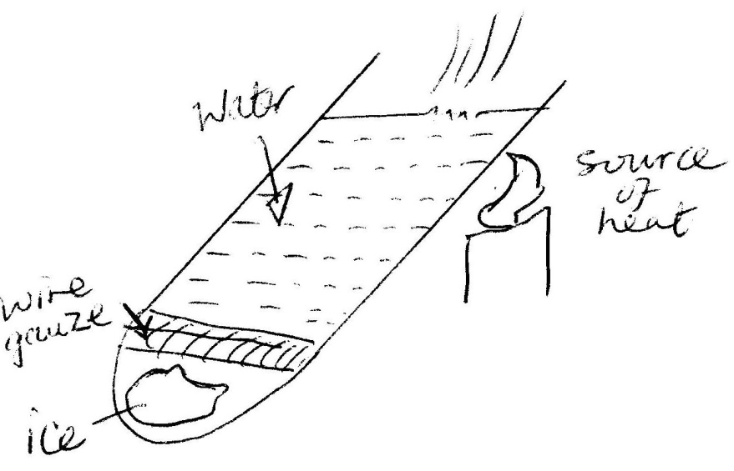

1. What is the purpose of the wire gauze? (1mk)
2. Why did ice take that long to melt? (1mk)
3. Explain the following.
4. The feet feels colder when a person stands on cemented flour than when standing on a wooden floor. (1mk)
5. Ventilation for a room is put nearer the roof of the room and not near the floor. (1mk)
6. a) Define the following terms;
7. A ray of light
8. A beam of light (1mk)

b) Two plane mirrors are placed at an angle to each other. Calculate the angle between the two mirrors if 5 images are formed when an object is placed in front of the mirrors. (3mks)

a) What is electrostatics? (1mk)

b) State the basic law of electrostatic charges. (1mks)

c) Explain why a glass window soon becomes dusty after it has been wiped with a dry piece of cloth. (1mk)

d) State three (3) uses of an electroscope. (3mks)

1. a) Define an electric current, stating its SI unit (2mks)

b) Calculate the amount of current flowing through a bulb if 150 coulombs of charge flows through it in 1.25 minutes. (3mks)

**SECTION B (58MKS)**

1. a) State Pascal’s Principle

b) The figure below shows a simple hydraulic machine used to raise heavy loads.

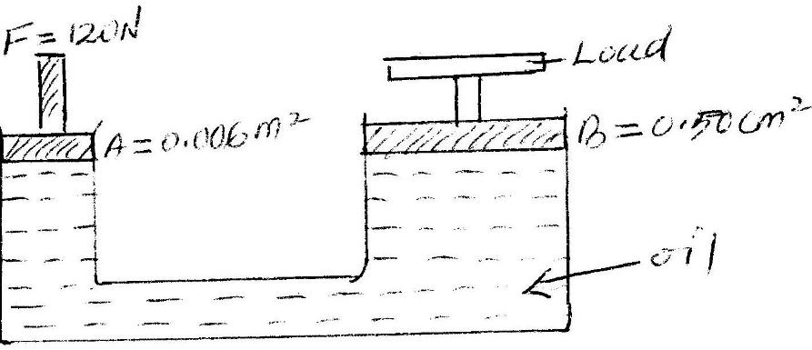

Calculate;

1. The pressure exerted on the oil by the force applied at A. (3mks)
2. The load raised at B. (3mks)
3. Give two properties which make the oil suitable for use in this machine. (3mks)

c) What will be the effect of making cross- sectional areas A and B equal (1mk)

1. a) Name two type of forces that determine the shape of liquid drop on a solid surface. (2mks)

b) State two factors that affect the surface tension of a liquid (2mks)

c) State three differences between mass and weight (3mks)

d) A man has a mass of 70kg. Calculate his weight on earth where gravitational field strength is 10 N/kg.

1. a) Name three (3) states of matter. (3mks)

b) Distinguish the three states of matter in term of arrangement of particles in each of state. (3mks)

c) The figure below shows various changes of state marked with letters A, B, C, D, E and F.

Name each change of state. (2mks)

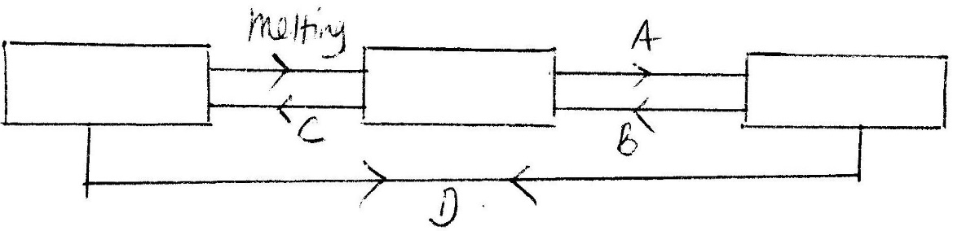

GAS

LIQUID

SOLID

1. Matter can exist in three states, solid, liquid or gas. Complete the table below by filling in the state best described by each molecular property listed. (2mk)

|  |  |  |
| --- | --- | --- |
|  | Molecular properties | State |
| a | Closely packed |  |
| b | Spacing very large |  |
| c | Moving independently |  |
| d | Very strong force of attraction |  |

1. a) The figure below shows a bimetallic strip at room temperature. Brass expands more than invar when heated equally

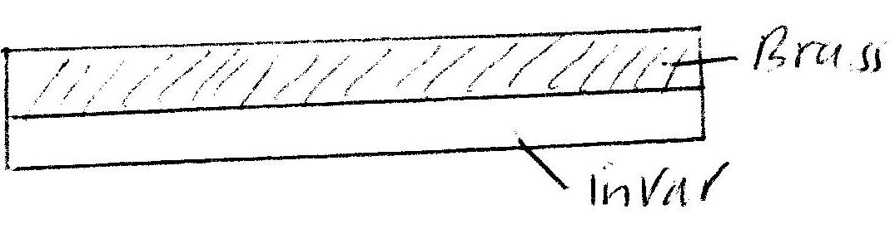

Sketch the bimetallic strip after being cooled several degrees below room temperature. (2mks)

b) The figure shows a flask with a glass tube dipped into a beaker containing water at room temperature. The cork fixing the glass tube to the flask is airtight.

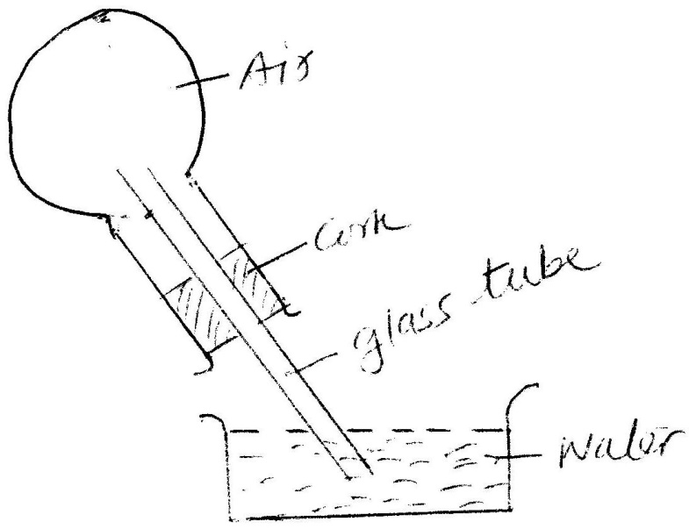

Use the information to answer question below

State what is observed when ice –cold water is poured on flask. (1mk)

c) Give a reason for the observation above. (2mks)

d) State two advantages of mercury over alcohol as a thermal liquid. (2mks)

e) State two factors that must be controlled in an experiment for comparing thermal conductivities of different metal rods. (2mks)

f) The figure below shows a hot water bath with metal rods inserted through one of its end. Some wax is fixed at the end of each rod.

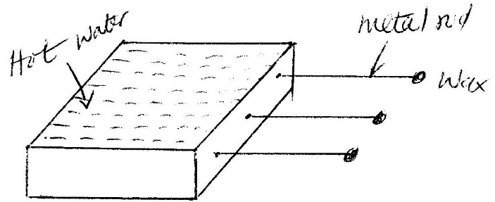

i) What property of metals could be tested using this set-up? (1mk)

ii) Besides the length of the rods that is kept what else should be kept constant when comparing the property for the different metal rods. (1mk)

13. a) What property of light is suggested by the formation of shadows. (1mk)

b) What is a virtual image? (1mk)

c) The figure below shows letters infront of a mirror. Draw the images of the letters behind the mirror. (2mks)

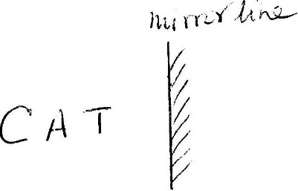

d) State the law of reflection. (2mks)

e) The figure below shows a ray of light being reflected from a plane mirror

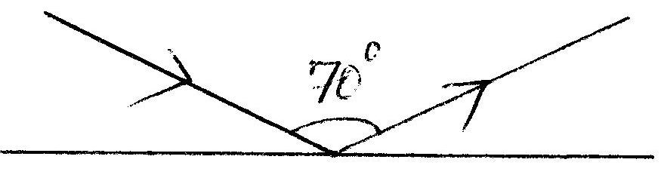

The mirror is rotated clockwise through 20o keeping the incident ray fixed. What is new angle of reflection? (3mks)

f) Calculate to angle between two mirrors such that the number images formed are 5. (2mks)

14. i) Define the term magnification as used in pin-hole camera. (1mk)

ii) The figure below shows a pin-hole camera.

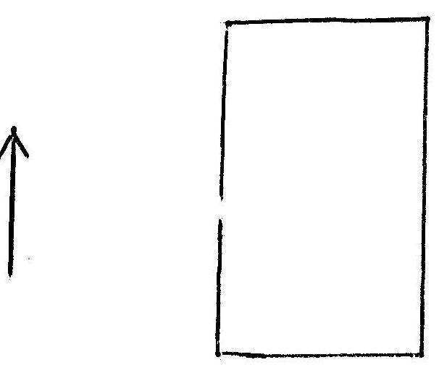

Sketch the rays show how the image is formed on the screen. (2mks)

iii) A Pinhole camera is placed 10m away from tree of height 5m. Calculate.

i) The size of the image if the camera is magnification is 0.02. (2mks)

ii) The distance between the screen of the camera and the pinhole. (2mks)