**QUALITY ASSUARANCE SERIRS FORM 1 END TERM 3 EXAMS 2023**

**PHYSICS (232)**

**FORM ONE (1)**

**Time: 2 Hours**

**Name**: …………………………………………………………. **Adm** **No**: ……………….

**School**: ……………………………………………………….. **Class**: …………………..

**Signature**: …………………………………………………….. **Date**: …………………...

**Instruction to students**

* Write your name, Admission number in the spaces provided.
* This paper consists of TWO sections: A and B
* Answer ALL questions in section A and B in the spaces provided.
* ALL workings MUST be clearly shown.
* Mathematical tables and electronic calculators may be used.
* You may use gravitational pull as ‘10N/kg’

**For examiner’s use only:**

|  |  |  |  |
| --- | --- | --- | --- |
| Section | Question | Maximum score | Candidate’s score |
| A | 1 – 11 | 25 |  |
| B | 12  13  14  15  16 | 11  12  11  13  08 |  |
|  | Total | 80 |  |

*This paper consists of* ***10*** *printed pages. Students should check the question paper to ensure that all the pages are printed as indicated and no questions are missing.*

**SECTION A (25 MARKS)**

1. Explain why physics is considered as a science (1 mark)

……………………………………………………………………………………….…………….

……………………………………………………………………………………………………..

1. Give reason why the study of physics in secondary school is important (2 marks)

……………………………………………………………………………………….…………….

……………………………………………………………………………………………………..

……………………………………………………………………………………….…………….

……………………………………………………………………………………………………..

1. What is the first thing you should do when your classmate experiences an electric shock in the laboratory (1 mark)

……………………………………………………………………………………….…………….

……………………………………………………………………………………………………..

1. Define length and state its SI unit (2 marks)

……………………………………………………………………………………….…………….

……………………………………………………………………………………………………..

……………………………………………………………………………………….…………….

……………………………………………………………………………………………………..

1. Express the following in SI unit:
2. 0.000008 km2 (2 marks)

……………………………………………………………………………………….…………….

……………………………………………………………………………………………………..

……………………………………………………………………………………….…………….

……………………………………………………………………………………………………..

1. 800cm2  (2 marks)

……………………………………………………………………………………….…………….

……………………………………………………………………………………………………..

……………………………………………………………………………………….…………….

……………………………………………………………………………………………………..

1. The figure below shows part of a metre rule used for measuring the length of a metal rod. Determine the length of the rod: (2 marks)

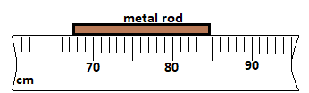

Figure 1

……………………………………………………………………………………….…………….

……………………………………………………………………………………………………..

……………………………………………………………………………………….…………….

……………………………………………………………………………………………………..

1. The diameter of the rod (in figure 1) was found to be 3.5 mm. Determine the volume of the metal rod (3 marks)

……………………………………………………………………………………….…………….

……………………………………………………………………………………………………..

……………………………………………………………………………………….…………….

……………………………………………………………………………………………………..

……………………………………………………………………………………….…………….

……………………………………………………………………………………………………..

1. The figure 2 below shows map of a certain ranch.

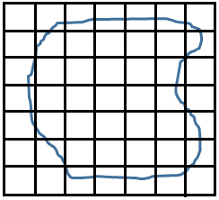

Figure 2

The squares are similar and measures 1km2 each. Determine the area of the ranch in m2.

(3 marks)

……………………………………………………………………………………….…………….

……………………………………………………………………………………………………..

……………………………………………………………………………………….…………….

……………………………………………………………………………………………………..

……………………………………………………………………………………….…………….

……………………………………………………………………………………………………..

1. Define force and state it’s SI unit (2 marks)

……………………………………………………………………………………….…………….

……………………………………………………………………………………………………..

……………………………………………………………………………………….…………….

……………………………………………………………………………………………………..

1. When a thin capillary glass tube is dipped in a basin of water, the level of water rises in the tube. Explain (2 marks)

……………………………………………………………………………………….…………….

……………………………………………………………………………………………………..

……………………………………………………………………………………….…………….

……………………………………………………………………………………………………..

1. What is frictional force (1 mark)

……………………………………………………………………………………….…………….

……………………………………………………………………………………………………..

1. Give two advantages of frictional force (2 marks)

……………………………………………………………………………………….…………….

……………………………………………………………………………………………………..

……………………………………………………………………………………….…………….

……………………………………………………………………………………………………..

**SECTION B (55 MARKS)**

1. Define the term ‘surface tension’ (1 mark)

……………………………………………………………………………………….…………….

……………………………………………………………………………………………………..

1. A steel pin is placed on a bloating paper resting on the surface of water as shown below.

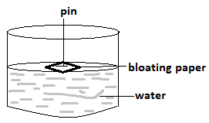

Figure 3

1. State and explain what happens after some time (2 marks)

……………………………………………………………………………………….…………….

……………………………………………………………………………………………………..

……………………………………………………………………………………….…………….

……………………………………………………………………………………………………..

1. Some soap solution is now added to the water. State and explain the observation made (2 marks)

……………………………………………………………………………………….…………….

……………………………………………………………………………………………………..

……………………………………………………………………………………….…………….

……………………………………………………………………………………………………..

1. Suggest any other one way through which the observation made (in b,ii) above could be achieved (1 mark)

……………………………………………………………………………………….…………….

……………………………………………………………………………………………………..

1. Identify any two differences between weight and mass (2 marks)

……………………………………………………………………………………….…………….

……………………………………………………………………………………………………..

……………………………………………………………………………………….…………….

……………………………………………………………………………………………………..

1. A loop of wire with a loose thread tied on it was dipped in soap solution and the soap film was formed on it as shown below:

Soap solution

A B

Wire loop

Figure 4

Draw another diagram showing what will be observed when the soap film is broken with an object pin at point, A. (1 mark)

……………………………………………………………………………………….…………….

……………………………………………………………………………………………………..

1. Using a labelled diagram, show the resultant force acting on the body in the figure below:

(2 marks)

1 N

3 N

Figure 5

……………………………………………………………………………………….…………….

……………………………………………………………………………………………………..

……………………………………………………………………………………….…………….

……………………………………………………………………………………………………..

1. Define pressure and state its SI unit (2 marks)

……………………………………………………………………………………….…………….

……………………………………………………………………………………………………..

……………………………………………………………………………………….…………….

……………………………………………………………………………………………………..

1. Water jets out of a tall measuring cylinder as shown below. Complete the diagram to show how the jet of water comes out of holes A and C (2 marks)

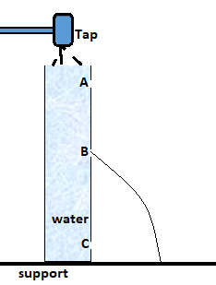

Figure 6

……………………………………………………………………………………….…………….

……………………………………………………………………………………………………..

……………………………………………………………………………………….…………….

……………………………………………………………………………………………………..

1. A coin is dropped on water in a swimming pool and it sinks to the bottom of the pool. State any two factors that would affect the amount of pressure it experiences. (2 marks)

……………………………………………………………………………………….…………….

……………………………………………………………………………………………………..

……………………………………………………………………………………….…………….

……………………………………………………………………………………………………..

1. The difference between the atmospheric pressure at the top and bottom of a hill is 4000 N/m2. If the density of air is 1.25 Kg/m3, calculate the height of the hill. (3 marks)

……………………………………………………………………………………….…………….

……………………………………………………………………………………………………..

……………………………………………………………………………………….…………….

……………………………………………………………………………………………………..

……………………………………………………………………………………….…………….

……………………………………………………………………………………………………..

1. The diagram below shows an arrangement for drawing petrol from tank P to tank Q.

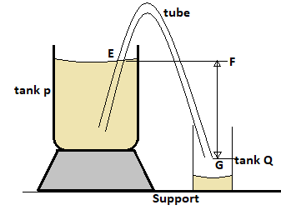

Figure 7

1. Suggest a name for the arrangement above (1 mark)

……………………………………………………………………………………….…………….

……………………………………………………………………………………………………..

1. Explain what must be done before the arrangement could be used for transferring the petrol (2 marks)

……………………………………………………………………………………….…………….

……………………………………………………………………………………………………..

……………………………………………………………………………………….…………….

……………………………………………………………………………………………………..

2. Distinguish between heat and temperature (1 mark)

……………………………………………………………………………………….…………….

……………………………………………………………………………………………………..

1. Figure 8 shows a clinical thermometer.
2. Identify the parts labelled A and B. (2 marks)

……………………………………………………………………………………….…………….

……………………………………………………………………………………………………..

……………………………………………………………………………………….…………….

……………………………………………………………………………………………………..

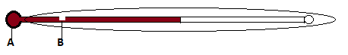

Figure 8

1. State the function of the part labelled B (1 mark)

……………………………………………………………………………………….…………….

……………………………………………………………………………………………………..

1. Alcohol is sometimes preferred to mercury as a thermometric liquid. Explain (2 marks)

……………………………………………………………………………………….…………….

……………………………………………………………………………………………………..

……………………………………………………………………………………….…………….

……………………………………………………………………………………………………..

1. The figure below is an illustration of a fire alarm. Describe how it works (4 marks)

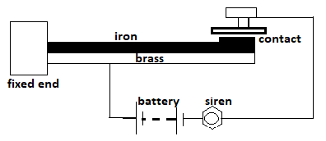

Figure 9

1. Convert 10oC to kelvin (1 mark)

……………………………………………………………………………………….…………….

…………………………………………………………………………………………………….

1. Define ‘matter’ (1 mark)

……………………………………………………………………………………….…………….

……………………………………………………………………………………………………..

1. The figure 10, shows salt solution inside a flask before and after the flask is shaken.

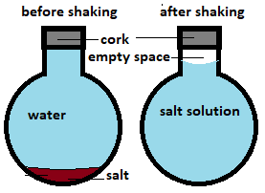

Figure 10

Explain the presence of the empty space above (2 marks)

……………………………………………………………………………………….…………….

……………………………………………………………………………………………………..

……………………………………………………………………………………….…………….

……………………………………………………………………………………………………..

1. A porous pot containing air is connected to a water manometer as shown in figure 11. The hydrogen is let in while the tap is closed.

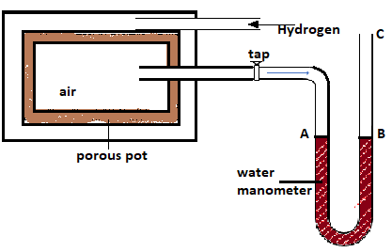Figure 11

1. State and explain the observation made when the tap is open while the hydrogen continue to flow in (3 marks)

……………………………………………………………………………………….…………….

……………………………………………………………………………………………………..

……………………………………………………………………………………….…………….

……………………………………………………………………………………………………..

……………………………………………………………………………………….…………….

……………………………………………………………………………………………………..

1. The water is now replaced with mercury. Compare, the observation made on the manometer, with that of part (c, i) above and explain your answer (2 marks)

……………………………………………………………………………………….…………….

……………………………………………………………………………………………………..

……………………………………………………………………………………….…………….

……………………………………………………………………………………………………..

1. During a smoke cell experiment to investigate Brownian motion, smoke particles are observed to be in random motion. Explain (1 mark)

……………………………………………………………………………………….…………….

……………………………………………………………………………………………………..

1. Suggest the effect of temperature on the motion of the smoke particles (1 mark)

……………………………………………………………………………………….…………….

……………………………………………………………………………………………………..

1. Matter can exist in three states. Identify the processes labelled A, B and C (3 marks)

SOLID

LIQUID

GAS

A

B

C

Figure 12

……………………………………………………………………………………….…………….

……………………………………………………………………………………………………..

……………………………………………………………………………………….…………….

……………………………………………………………………………………………………..

……………………………………………………………………………………….…………….

……………………………………………………………………………………………………..

1. State two means by which conduction occurs (2 marks)

……………………………………………………………………………………….…………….

……………………………………………………………………………………………………..

……………………………………………………………………………………….…………….

……………………………………………………………………………………………………..

1. A form one set-up an experiment as shown below:

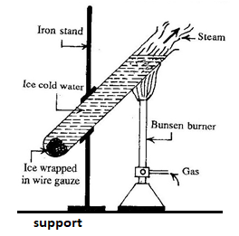

Figure 13

1. Suggest the aim of the experiment (1 mark)

……………………………………………………………………………………….…………….

……………………………………………………………………………………………………..

1. State and explain what is observed after some time (2 marks)

……………………………………………………………………………………….…………….

……………………………………………………………………………………………………..

……………………………………………………………………………………….…………….

……………………………………………………………………………………………………..

1. What is the purpose of the wire gauze in this experiment (1 mark)

……………………………………………………………………………………….…………….

……………………………………………………………………………………………………..

1. A shadow is formed when light is incident on an opaque object. Identify the property of light responsible for this. (1 mark)

……………………………………………………………………………………….…………….

……………………………………………………………………………………………………..

1. One of the laws of reflection of light at plane surfaces is that ‘the angle of incidence and the angle of reflection are equal.’ State the other law of reflection of light at plane surface (1 mark)

……………………………………………………………………………………….…………….

……………………………………………………………………………………………………..