**COMPETENCE BASED CURRICULUM**

**THE QUALITY ASSURANCE SERIES 1**

**GRADE 7 TERM 1 OPENER (ENTRY) EXAM 2024**

**CRE**

**NAME: _______________________________CODE; _____________DATE: _______________**

1. Write down values that Christian acquire by learning Christian Religious Education. (3 mks)
2. ……………………………………………….
3. ……………………………………………….
4. ……………………………………………….
5. Why should **CRE** be taught in schools?(3 mks)
6. …………………………………………………………………………………
7. ………………………………………………………………………………..,.
8. ………………………………………………………………………………….
9. List down the similarities and differences between the two Biblical accounts of creation. (4 mks)

|  |  |
| --- | --- |
| Similarities (2mks) | Differences (2mks) |
|  |  |
|  |  |
|  |  |

1. Explain the attribute of God from the two creation accounts. (3 mks)

……………………………………………………………………………………………………………………………………………………………………………………………………………………………………………………………………………………………………………………………………………………………………………………………………………………………………………………………………

1. Explain different ways in which people promote and protect the animals, fish and birds.(2 mks)
2. …………………………………………………………………………………..
3. …………………………………………………………………………………..
4. Why is the Bible important to the society?(2 mks)
5. ……………………………………………….…………………………………….
6. ……………………………………………………………………………………..
7. Explain the two dimensions of the Bible. (2 mks)
8. ………………………………………………………………………………………………………………………………………………………………………………
9. ………………………………………………………………………………………………………………………………………………………………………………
10. How can Christians participate in charity work in the community to serve God and others?(2 mks)
11. ………………………………………………………………………………………
12. 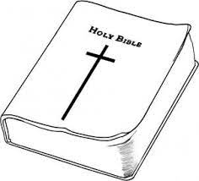………………………………………………………………………………………
13. List the Poetic books of the Old Testament. (4 mks)
14. ………………………………………..
15. ………………………………………..
16. ………………………………………..
17. ………………………………………..
18. God created us and gave us different unique_________________________
19. List down two examples of Christian Values;
20. ____________________________________
21. __________________________________
22. We become God’s __________________ when we use our abilities and talents to care for His creation.
23. Forcing young children into difficult tasks or work for payment is known as child ___________________
24. The disobedience of Adam and Eve led to the _________________ of human beings.
25. There is _________________ when family members work together and stay in agreement.
26. A _________________ is a difficult situation that one can find himself or herself in.
27. The twelve followers of Jesus Christ were known as _____________________
28. The ability to make good judgement and give good advice on an issue is known as ____________________
29. God wants us to _________________ our elders.
30. Name the three men who were thrown in the furnace of fire;
31. ____________________
32. ____________________
33. ____________________
34. Which prophet challenged the prophets of Baal ____________________
35. State what is happening in the following pictures people in the bible.

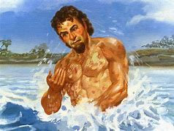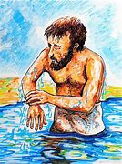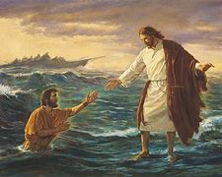

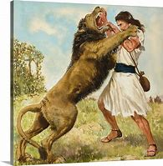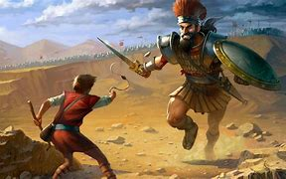

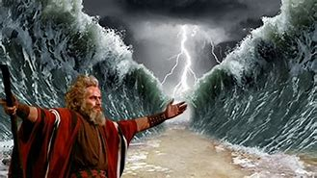

1. Who was found by pharaoh’s daughter as a baby in a cot on water ________________ and adopter him as her son in the palace?
2. Moses saw a _______________________ one day as he was attending to the flock.
3. Carrying out an activity assigned for without complaining is described as _____________________
4. The holy book of God is referred to as the ___________________
5. The bible is divided into two sections called;
6. ____________________________
7. ____________________________
8. __________________ means doing the right thing without fear.
9. The two disciples who healed the lame man at the temple gate were _________ and _________________
10. Moses’ father-in-law was called _________________________
11. Baptism is a sign that one has repented from _______________
12. Jesus Christ was baptized in River __________________ by ________________
13. Jesus calmed a great storm on Lake _________________
14. Which disciple of Jesus was called to walk on water during the calming of storm? _____________________
15. The 5000 people were fed with __________________________ and _____________
16. The feeding of the 5000 people teaches us the value of ________________
17. The man lowered through the roof to the feet of Jesus for healing was suffering from _____________________