**COMPETENCE BASED CURRICULUM**

**THE QUALITY ASSURANCE SERIES 1**

**GRADE 7 TERM 1 OPENER (ENTRY) EXAM 2024**

**ENGLISH**

**NAME: _______________________________CODE; _____________DATE: _______________**

|  |  |  |
| --- | --- | --- |
| PART A/60 | PART B/40 | TOTAL |
|  |  |  |

1. Give two examples of common nouns and two examples of proper nouns.

|  |  |
| --- | --- |
| Common nouns | Proper nouns |
|  |  |
|  |  |

1. Give the synonyms of the underlined words
2. The goods this trader sells are very **dear………………………………..**
3. James never makes a single **mistake** in his grammar…………………….
4. We seriously need **vigilant** security officers………………………………..
5. **a.** Arrange the following sentences to make a suitable paragraph.
   * 1. But as soon as they drove away with the baby
     2. When I handed the baby to the couple.
     3. I sobbed my heart out.
     4. I could see happiness on their face.

Answer : …………………………………………………………………………….

* + 1. In addition, he must be at least 30 years old.
    2. A hotel wishes to employ a manager
    3. Finally, he/she must be fluent in Kiswahili and English
    4. The applicant must be a university graduate.

Answer: …………………………………………………………………………….

1. **Give the antonyms of the following words.**
   1. Empty …………………………………. d. Poverty…………………………
   2. Generous……………………………… e. Difficult………………………….
   3. Cheap ……………………………………….
2. ***Use the correct collective noun to fill in the gaps;***
   1. A ____________________ bees was flying over.
   2. We saw a _____________________ pupils sitting here.
   3. Mr. Munene owns a large _________________ of cattle.
   4. Our school has a big ______________________ of books.
   5. A _______________________ of teachers will arrive tomorrow.
3. ***Read the passage below and fill in the gaps with appropriate words;***

Tortoise and hare were _____________friends. They ______________ in a small hut in the _________________. Hare kept sheep, goats _______________ camels__________ tortoise grew cabbages, carrots and __________________. They loved _____________ and helped one another whenever there was any ___________________. However, hare started _______________ his friend’s carrots once they were ready for _____________.

Every morning tortoise found a ______________________ of his carrots missing. He ______________ in disbelief. This continued for________________ until tortoise ___________________________ to visit the wise, lizard who lived by the rocks. The lizard made him a sticky ____________________________ and instructed him to fix it in the farm.

[**scarecrow long decided wondered bunch stealing harvesting trouble each other and forest treat lived pumpkin ]**

1. ***Write the opposites of the words in the bracket;***
   1. All _________________ were singing in the choir. [**men**]
   2. Our _____________ is very kind and honest. [**king**
   3. We should water our flowers in the __________________. [**morning**]
   4. My aunt gave ______________ medicine last night. [**sweet**]
   5. Who _______________ our school gate? [**closed**]
   6. All the late comers were ____________ this morning. [**forgiven**]
   7. Several ___________ were in the park. [ **lionesses**]
2. ***Change the words in the bracket into plural;***
   1. Most ____________ were absent from school. [**child**]
   2. There are forty seven __________ in Kenya. [**county**]
   3. Several ___________ sharpened last evening. [**knife**]
   4. How many _________ were in the farm? [**ox**]
   5. Are these the __________ that were bought? [**dress**]
3. ***Make words with, ‘ry’ as shown below;***

**ry**

Count**ry**

1. ***Change the words in the bracket into suitable tense;***
   1. You __________ all my exercise books. [**take**]
   2. Some children ________ these nice pictures. [**draw**]
   3. The baby ________ all the milk. [**drink**]
   4. Nancy __________ very well at the party. [**dance**]
   5. The fat boy _________ in the ditch. [**fall**]
2. ***What do they do?***

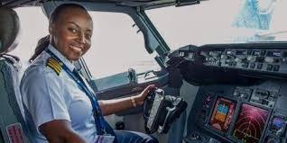

Abigael flies an aeroplane, she is a _______________

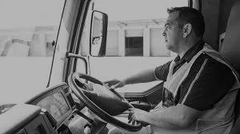

Sulai drives a lorry. He is a ________________

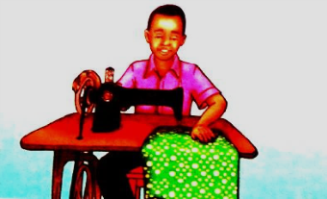

Salaton mends clothes. He is a __________________

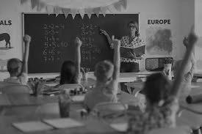

Madam Doreen teaches children. She is a ____________

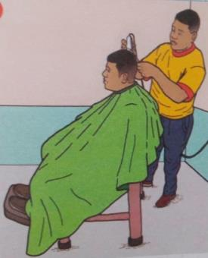

Otiende shaves hair. He is a ______________

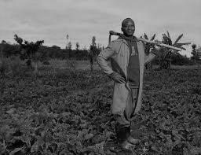

Zamba grows crops. He is a _________________

**PART 2**

**WRITING**

**Write a letter to your friend in another school informing him/ her on how you are doing in your school. (20 marks)**

……………………………………………………………………………………………………………………………………………………………………………………………………………………………………………………………………………………………………………………………………………………………………………………………………………………………………………………………………………………………………………

…………………………………………………………………………………………………………………………………………………………………………………………………………………………………………………………………………………………………………………………………………………………………………………………………………………………………………………………………………………………………………………………………………………………………………………………………………………………………………………………………………………………………………………………………………………………………………………………………………………………………………………………………………………………………………………………………………………………………………………………………………………………………………………………………………………………………………………………………………………………………………………………………………………………………………………………………………………………………………………………………………………………………………………………………………………………………………………………………………………………………………………………………………………………………………………………………………………………………………………………………………………………………………………………………………………………………………………………………………………………………………………………………………………………………………………………………………………………………………………………………………………………………………………………………………………………………………………………………………………………………………………………………………………………………………………………………………………………………………………………………………………………………………………………………………………………………………………………………………………………………………………………………………………………………………………………………………………………………………………………………………………………………………………………………………………………………………………………………………………………………………………………………………