Name: …………………………………………………………. Adm no: ……………….
School: ……………………………………………………….. Class: …………………..
Signature: …………………………………… Date: …………………...
PHYSICS
FORM 4
PAPER 1
TIME: 2 ½ HOURS

FORM 4 TERM 1 OPENER (ENTRY) 2024 EXAMS
THE TOP SCHOOLS MULTILATERAL SERIES 1

Instruction to candidates
- This paper consist of two sections A and B
- Answer all questions in section A and B in the spaces provided
- All workings must be clearly shown, and use the CONSTANTS given.
- Ensure that the paper has all the questions
- Take g=10N/kg, Atmospheric pressure=760mmHg, density of mercury=13600Kg/m³

FOR EXAMINERS USE ONLY
SECTION | QUESTION | MAXIMUM SCORE | CANDIDATE SCORE
A | 1-7 | 25
B | 8-12 | 55
TOTAL |  | 80

SECTION A(25MKS)
- The fig below shows a measuring cylinder, which contains water initially at level A.
A solid of mass 11g is immersed in the water, the level rises to B.
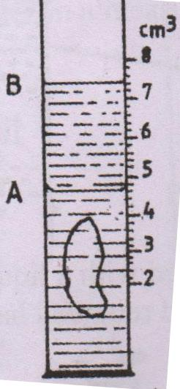

Determine the density of the solid [Give your answer to 1 decimal point.] [3mks]

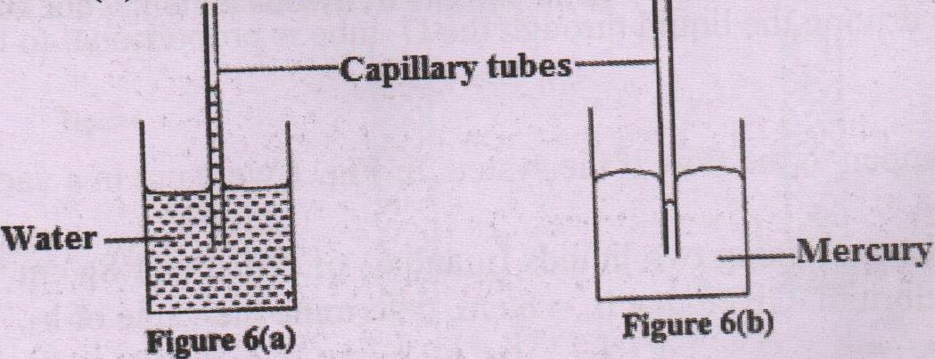
- Fig (a) and (b) below shows capillary tubes inserted in water and mercury respectively.

It is observed that in water the meniscus in the capillary tube is higher than the meniscus in the beaker.
While in mercury the meniscus in the capillary tube is lower than the meniscus in the beaker.

Explain these observations. [ 2mks]

- A hole of area 2.0 cm² at the bottom of a tank 2.0 m deep is closed with a cork. Determine the force on the cork when the tank is filled with water. [ Density of water is 1000kg/m³ and acceleration due to gravity is 10m/s²] [4mks]

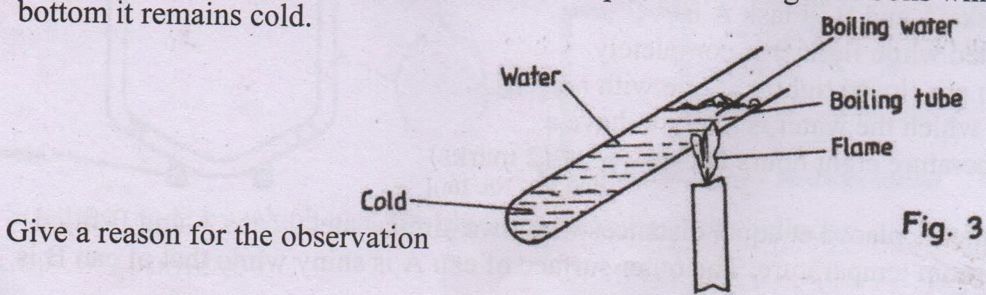
- In the set up shown in the fig below, water near the top of the boiling tube boils while at the bottom remains cold.

Give a reason for the observation. [2mks]

- State three ways of increasing the sensitivity of a liquid – in – glass thermometer. [3mks]

- .i) Define friction. [1mks]

ii) A wooden box of mass 30kg rests on a rough floor. The coefficient of friction between the floor and the box is 0.6.
Calculate the force just required to just move the box. [3mks]

iii) State three methods of minimising friction. [3mks]

- .i) State two factor that affect conduction of heat in solids. [2mks]

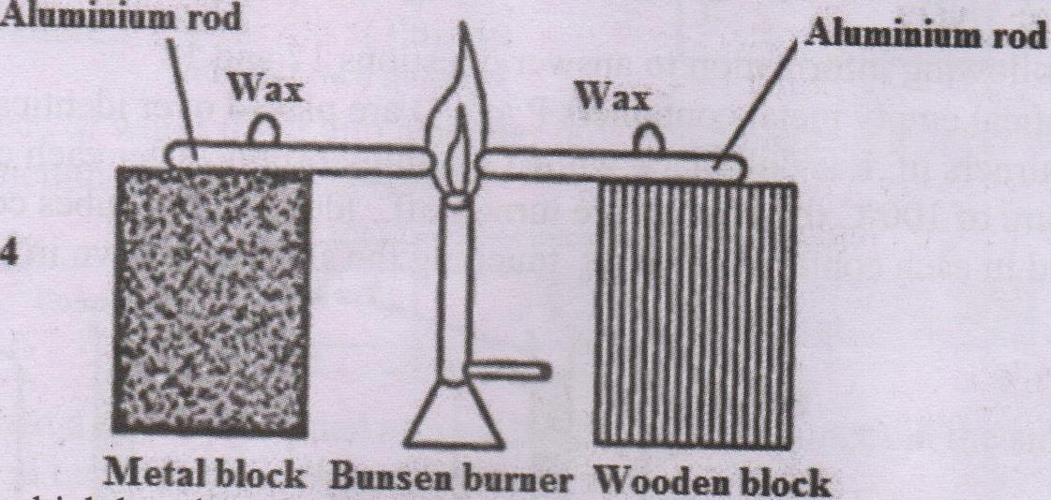
ii) Two identical aluminium rods are shown in the figure below. One rests on metal block and the other on a wooden block. The protruding ends are heated on a Bunsen burner as shown.

State with reason on which bar the wax is likely to melt sooner. [2mks]

SECTION B. (55MKS)

- A man uses an inclined plane to lift a 50kg load through a vertical height of 4m. The inclined plane makes an angle of 30˚ with the horizontal. If the efficiency of the inclined plane is 72%. Calculate
- The effort needed to move the load up the inclined plane at a constant velocity. [3mks]

- The work done against friction in raising the load through a height of 4.0 m.
[Take g = 10N /kg] [3mks]

- A certain machine raises 2.0 tonnes of water through 22m. If the efficiency of the machine is 80%, how much work is done by the machine? [3mks]

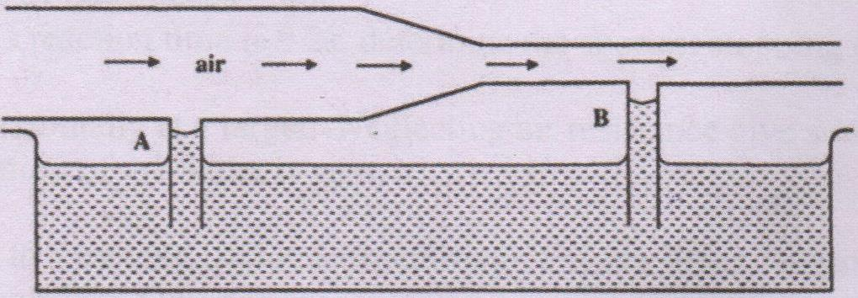
- (a) i) The fig below shows air flowing through a pipe of different cross-section areas. Two pipes A &B. are dipped into water.

Explain the cause of difference in the levels of water in the pipes A and B. [2mks]

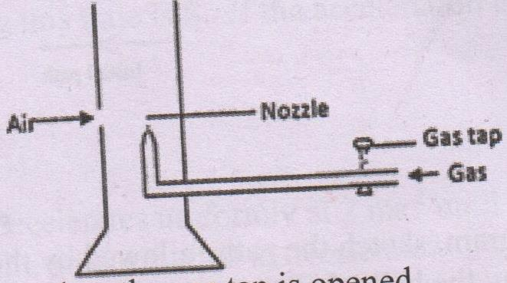
ii)The fig below shows Bunsen burner.

Explain how air is drawn into the burner when the gas tap is opened. [3mks]

- i) What is meant by the centre of gravity of a body? [1mk]

ii) The figure below is at equilibrium.
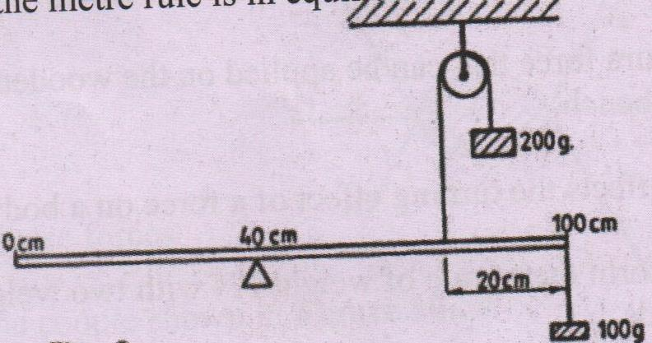

Given that the meter rule is uniform, determine its weight. [5mks]

- (a)Explain why a drop of methylated spirit on the back of the hand feels colder than a drop of water at the same temperature. [2mks]

b) State the meaning of the term ‘specific latent heat of fusion’ [1mks]

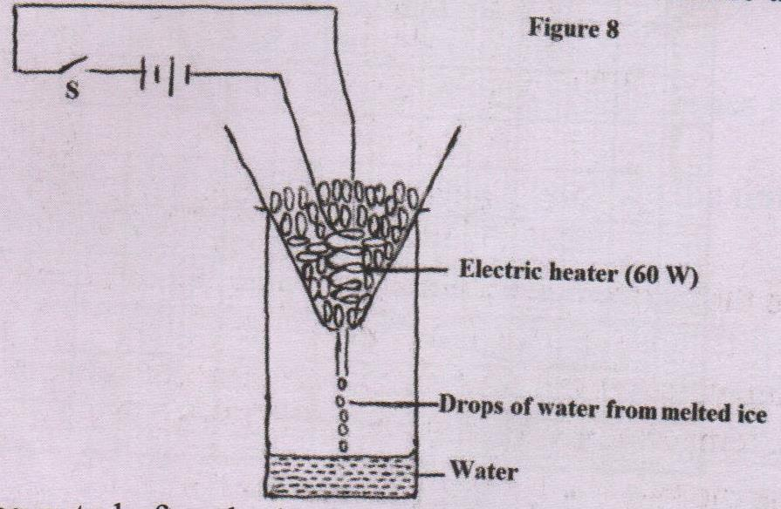
- The fig below shows a setup of apparatus set in an experiment to determine the specific latent heat of fusion.

The following reading was noted after the heater was switched on for 5 minutes.
- Mass of beaker = 130g
- Mass of beaker + melted ice = 190g
- Determine the,
- Energy supplied by the 60W heat in 5 minutes. [3mks]

- Specific latent heat of fusion of ice. [4mks]

- It was observed that some of the crushed ice melted even before the heater was switched on. State the reason for this observation. [1mk]
…………………………………………………………………………………………
…………………………………………………………………………………………
- Brownian motion of smoke particles can be studied by using the apparatus shown in the figure below. To observe the motion some smoke is enclosed in the smoke cell and then observed through the microscope..
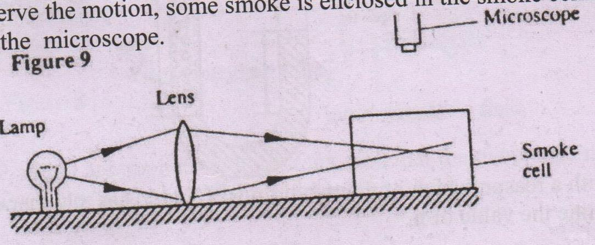

- Explain the role of the
- Smoke particles [2mks]

- Lens [2mks]

- Microscope [2mks]

- State and explain the nature of the observed motion of the smoke particles. [3mks]

- State what will be observed about the motion of the smoke particles if the temperature surrounding the smoke cell is raised slightly. [1mks]

- (a) The fig below shows a velocity – time graph for the motion of a certain body.
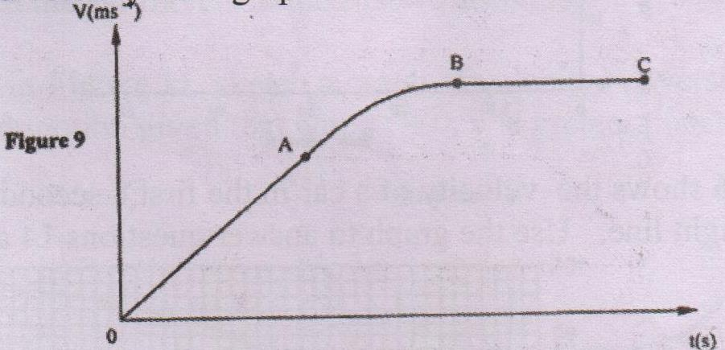

Describe the motion of the body in the region. [3mks]
- OA

- AB

- B C

b) A car initially at 10m/s decelerates at2.5m/s².
Determine,
I. Its velocity after 1.5 s [2mks]

- The distance travelled in 1.5 s. [2mks]

III. The time taken for the car to stop. [2mks]

(c)
- State Newton’s first law of motion. [1mks]

- A stone of mass 0.01kg is released from a catapult of mass 0.25kg. If the release velocity of the stone is 175m/s, determine the recoil velocity of the catapult. [4mks]

