**COMPETENCE BASED CURRICULUM**

**THE STANDARD MEASURE SERIES 1**

**GRADE 7 TERM 1 OPENER (ENTRY) EXAM 2024**

**JUNIOR SECONDARY SCHOOL**

HEALTH EDUCATION

**NAME: ___________________________________________________**

**SCHOOL ____________________________________________________**

1. Write down four health practices that one should observe to maintain wellness. (3 mks)
   1. **………………………………………………………………………………**
   2. **………………………………………………………………………………**
   3. **……………………………………………………………………………..**
   4. **……………………………………………………………………………..**
2. Name three career opportunities related to health education . (3 mks)
3. **……………………………………………**
4. **……………………………………………**
5. **……………………………………………**
6. Write three examples of vitamins. (3 mks)
7. **……………………………..**
8. **…………………………….**
9. **…………………………….**
10. What is constipation? (2 mks)

**……………………………………………………………………………………………………………………………………………………………………………………**

1. Levi drinks water regularly. Explain four importance of water in promoting health. (4 mks)
2. **……………………………………………………………………………………**
3. **……………………………………………………………………………………..**
4. **…………………………………………………………………………………….**
5. **…………………………………………………………………………………….**
6. What are the challenges facing health promotion in the community?(4 mks)
7. **……………………………………………………………………………………….**
8. **……………………………………………………………………………………….**
9. **……………………………………………………………………………………….**
10. **……………………………………………………………………………………….**
11. What is the role of good governance for sustainable health promotion? (3 mks)
12. **………………………………………………………………………………………**
13. **………………………………………………………………………………………**
14. **………………………………………………………………………………………**
15. Give two examples of macro-nutrients. (2 mks)
16. **………………………………………………..**
17. **………………………………………………..**
18. identify the following parts of the digestive system.(5 mks)

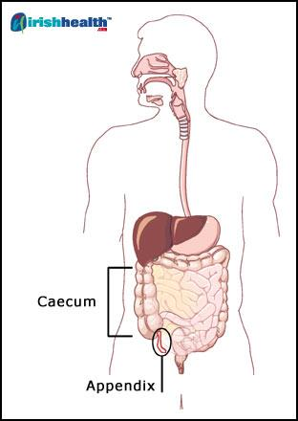

1. State the function of the following organs.(3 mks)
2. Liver: **……………………………………………………………………………………………………………………………………………………………………………………**
3. Pancreas: **…………………………………………………………………………………………………………………………………………………………………………………..**
4. Colon……………………………………………………………………………………………………………………………………………………………………………
5. Write three roles of fibre in promoting health. (3 mks)
   1. **…………………………………………………………………………………………………**
   2. **…………………………………………………………………………………………………**
   3. **…………………………………………………………………………………………………**
6. Define the term digestion (2 mks)

**…………………………………………………………………………………………………………………………………………………………………………………………….**