**COMPETENCE BASED CURRICULUM**

**THE QUALITY ASSURANCE SERIES 1**

**GRADE 7 TERM 1 OPENER (ENTRY) EXAM 2024**

**HOMESCIENCE**

**NAME: _______________________________CODE; _____________DATE: _______________**

1. 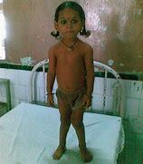Write the name of the following nutritional deficiency disease**.(4 mks)**

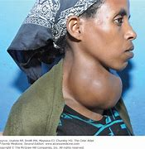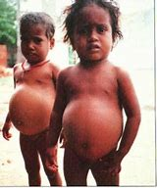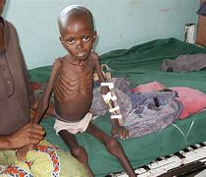

1. Briefly outline the effects of heat on the colour, taste and texture of vegetables. **(2 mks)**
2. ____________________________________________________________
3. ____________________________________________________________
4. List **two** safety precautions to follow when Steaming food**.(2 mks)**
5. ____________________________________________________________
6. ____________________________________________________________
7. Which locally available foods are suitable for roasting?**(2 mks)**
8. ____________________________
9. ____________________________
10. What is the meaning of ***food fortification***?**(1 mk)**

__________________________________________________________________________________________________________________________________________

1. You have been invited to grade four to give a talk on the importance of conserving food nutrients. Write down three points that you would need to share with them. **(2 mks)**
2. ____________________________________________________________
3. ____________________________________________________________
4. Why is it important to use different methods when cooking food?**(2 mks)**
5. ____________________________________________________________
6. ____________________________________________________________
7. State some kitchen tools and equipment that can be used by; **(2 mks)**
8. Re-using ________________________________
9. Re-cycling ______________________________
10. What do you understand by the following terms?**(3mks)**
11. Grilling

________________________________________________________________

1. Steaming

________________________________________________________________

1. Roasting

________________________________________________________________

1. Which food in your locality are suitable for preparation and cooking using **;(3 mks)**
2. Grilling _________________________________________
3. Steaming ______________________________________
4. Roasting ______________________________________
5. Why is it important to improvise equipment for the preparation and cooking of food?**(2 mks)**
6. _________________________________________________________________
7. ________________________________________________________________
8. Which safety guidelines should we observe when grilling, roasting and steaming foods?(**1 mk)**
9. ________________________________________________________________
10. 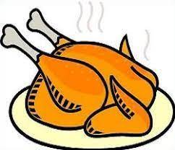Match the picture with the type of nutrient it provides**.(3 mks)**

**CARBOHYDRATE**

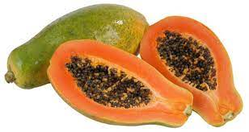

**PROTEIN**

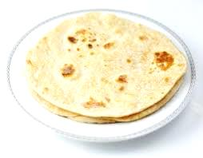

**MINERAL**

1. Kakenya was asked by her parents to make a menu for the dinner. Write the best menu in the plates that is well balanced.(**1 mk)**

╫ ╫