**COMPETENCE BASED CURRICULUM**

**THE STANDARD MEASURE SERIES 1**

**GRADE 7 TERM 1 OPENER (ENTRY) EXAM 2024**

**JUNIOR SECONDARY SCHOOL**

HOMESCIENCE EDUCATION

**NAME: ___________________________________________________**

**SCHOOL ____________________________________________________**

1. Why is it important to use different methods when cooking food?**(2 mks)**
2. **………………………………………………………………………………..**
3. **………………………………………………………………………………..**
4. **……………………………………………………………………………….**
5. Which safety guidelines should we observe when grilling, roasting and steaming foods?(**1 mk)**
6. **……………………………………………………………………………………..**
7. 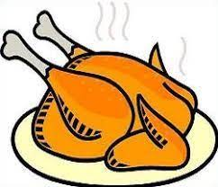state that type of nutrient it provides**.(3 mks)**

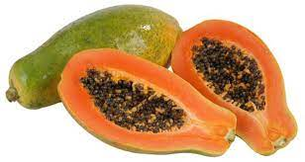

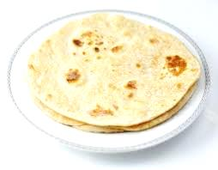

1. 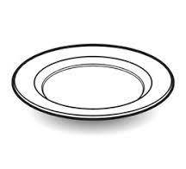Kakenya was asked by her parents to make a menu for the dinner. Write the best menu in the plates that is well balanced.(**1 mk)**

╫ ╫

1. State some kitchen tools and equipment that can be used by; **(2 mks)**
2. Re-using **……………………………………………………….**
3. Re-cycling **……………………………………………………**
4. What do you understand by the following terms?**(3mks)**
5. Grilling

**…………………………………………………………………………………………………………………………………………………………………………**

1. Steaming

**…………………………………………………………………………………………………………………………………………………………………………**

1. Roasting

**…………………………………………………………………………………………………………………………………………………………………………**

1. List **two** safety precautions to follow when Steaming food**.(2 mks)**
2. **………………………………………………………………………………………**
3. **………………………………………………………………………………………**
4. Which locally available foods are suitable for roasting?**(2 mks)**
5. **……………………………………………….**
6. **……………………………………………….**
7. What is the meaning of ***food fortification***?**(1 mk)**

**……………………………………………………………………………………………………………………………………………………………………………………**

1. You have been invited to grade four to give a talk on the importance of conserving food nutrients. Write down three points that you would need to share with them. **(2 mks)**
2. **………………………………………………………………………………………….**
3. **…………………………………………………………………………………………**
4. **………………………………………………………………………………………….**
5. 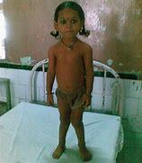Write the name of the following nutritional deficiency disease**.(4 mks)**

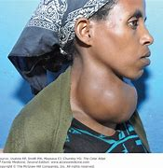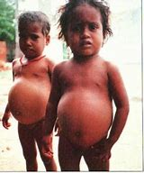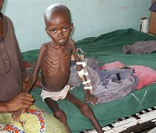

1. Briefly outline the effects of heat on the colour, taste and texture of vegetables. **(2 mks)**

|  |  |
| --- | --- |
| **Quality** | **Effect of heat** |
| **Colour of vegetable** |  |
| **Texture** |  |
| **Taste or flavour** |  |

1. Which food in your locality are suitable for preparation and cooking using **;(3 mks)**
2. Grilling **……………………………………………………………………**
3. Steaming **………………………………………………………………..**
4. Roasting **……………………………………………………………….**
5. Why is it important to improvise equipment for the preparation and cooking of food?**(2 mks)**
6. **………………………………………………………………….……………………….**
7. **……………………………………………………………………..……………………**
8. **…………………………………………………………………………………………..**