**COMPETENCE BASED CURRICULUM**

**THE STANDARD MEASURE SERIES 1**

**GRADE 7 TERM 1 OPENER (ENTRY) EXAM 2024**

**JUNIOR SECONDARY SCHOOL**

MATHEMATICS

**NAME: ___________________________________________________**

**SCHOOL ____________________________________________________**

1. What is the **place value** of **digit 4** after working out the **sum** of **725,183** and **17,286,305**? (2 marks)
2. Maria bought $6\frac{2}{3}$ metres of white cloth material and $2 ¾$ metres of yellow cloth material to be used in a home science project. How many metres of material did she buy altogether? (3 marks)
3. Work out the following .
   1. $33\frac{7}{12}+40\frac{2}{3}$ (2 marks)
   2. $14\frac{5}{8}-2\frac{2}{5}-4 ½$ (3 marks)
4. Work out the following.

$5\frac{5}{8}×24$ (2 marks)

1. Find the area of the figure below. (2 marks)

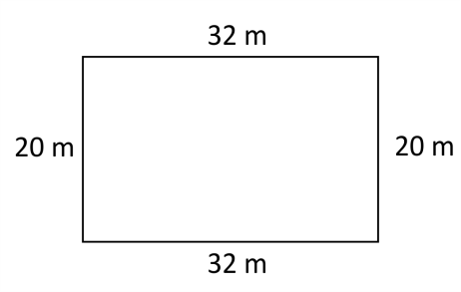

1. Name the angle shown below. (1 mark)

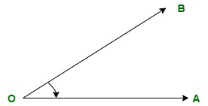

1. What is the time in digital form? (1 mark)

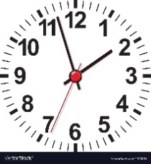

1. What is 25% written as a fraction in its simplest form? (1 mark)
2. What is the volume of the cuboid below? (2 marks)

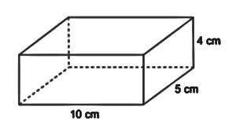

1. What is the total value of digit **2** after working out the **product** of **255 and 49**? (2 marks)
2. What is **seventy eight million, two hundred and fifty three thousand and eighty less ten thousand**? (3 marks)
3. **Round off 537,862** to the nearest **hundreds of thousands**. (1 mark)
4. What is the **sum** of **all prime numbers** between **70 and 80**? (2 marks)
5. Work out the following. (2 marks)
$$63-9×12÷4+28$$

6. Express **80** as a product of its **prime factors** using a factor tree. (2 marks)
7. What is the sum of the **GCD** and the **LCM** of **6, 12 and 18**? (3 marks)
8. A trader stored milk in three containers of **24 litres, 30 litres and 60 litres**. The milk in each container was then repacked into smaller containers. The amount of milk in each of the small container was the same. What was the capacity of the largest container used to repack the milk? (3 marks)
9. How many days are there in total in the months of November, December and January? (1 mark)
10. Marangi used $\frac{3}{8}$ litres of paint to paint a $2\frac{2}{3}$ square metre room. What fraction of the paint did he use to paint one square metre? (2 marks)