**COMPETENCE BASED CURRICULUM**

**THE STANDARD MEASURE SERIES 1**

**GRADE 7 TERM 1 OPENER (ENTRY) EXAM 2024**

**JUNIOR SECONDARY SCHOOL**

PHYSICAL EDUCATION AND SPORTS

**NAME: ___________________________________________________**

**SCHOOL ____________________________________________________**

1. 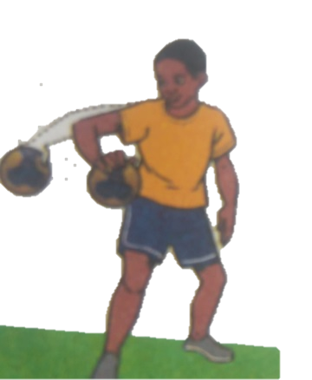Identify the type of pass demonstrated below.(3 mks)

……………………………..

1. 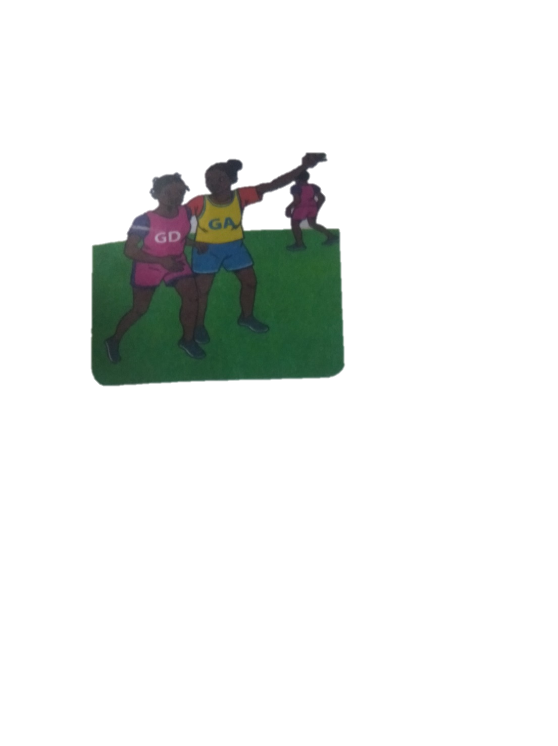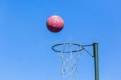Which type of game is shown below? (1 mk)

**………………………………………………………………………**

1. Identify the type of marking illustrated below.( 2 mks)

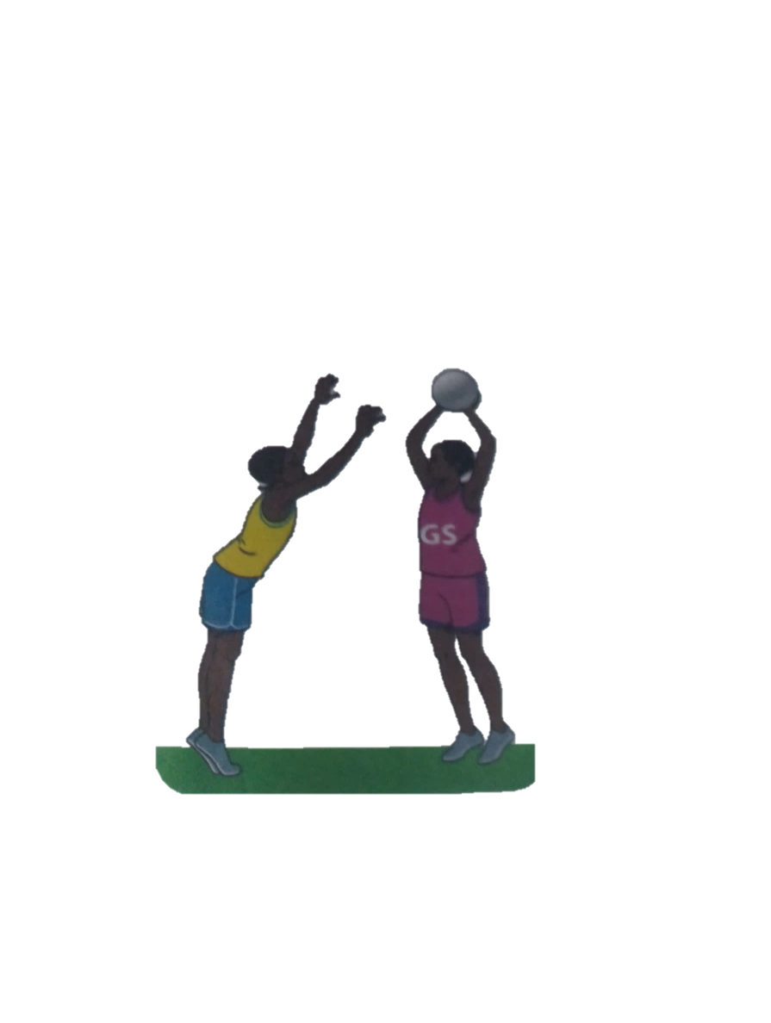

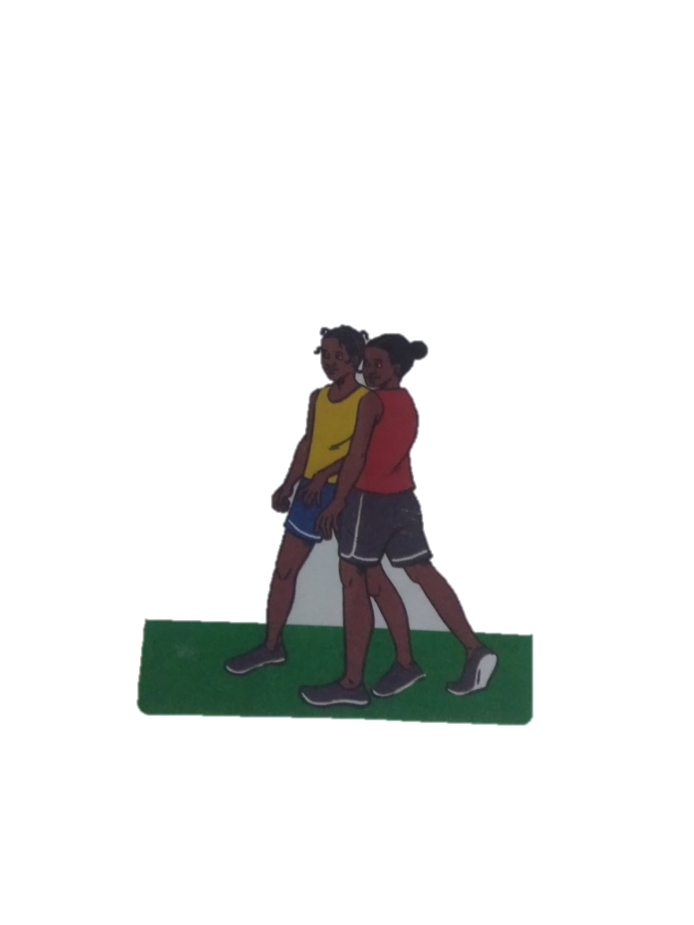

**…………………………………………………………………………………………….**

1. From the game of netball, what do you think these two players are doing? (1 mk)

1. Which of the following is not a punishment in the game of handball?
2. 5 minutes suspension
3. Yellow card
4. 2 minutes suspension
5. Red card
6. A centre player if offside whether he of she enters which part of the netball court?**.................................** (1 mk)
7. Which is the most common type of injury in a netball game?**_......................................................**(1 mk)
8. What does a referee do to start a netball game ?(1 mk)

**…………………………………………………………..**

1. Identify the materials needed in the game of handball.(2 mks)
2. **…………………………………..**
3. **………………………………….**
4. **………………………………….**
5. Give two types of passes in a game of handball. (2 mks)
6. 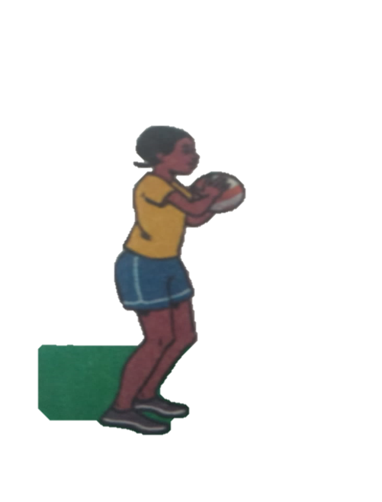**…………………………………….**
7. **………………………………………**
8. Define the following terms. (4 mks)
9. Reception.

**………………………………………………………………………………………………**

1. Passing

**………………………………………………………………………………………………**

1. Pivoting

**………………………………………………………………………………………………**

1. Marking

**……………………………………………………………………………………………..**

1. What size is a handball court?(1 mk)
2. 20 by 30m
3. 20 by 40m
4. 20 by 50 m
5. 20 by 60 m
6. Penalties are thrown from what distance in a game of handball? **……………………………………………………..**1 mk)
7. Identify the type of game played using the ball below.(1 mk)

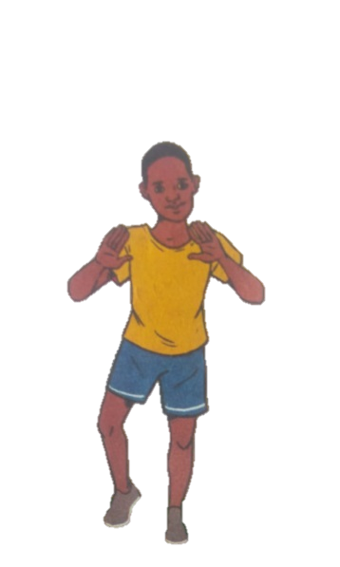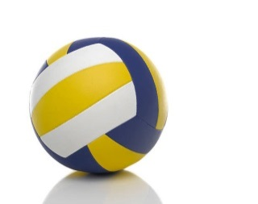

1. How many seconds after catching the ball does a player have to pass or shoot in netball game?**..................................................**1 mk)
2. 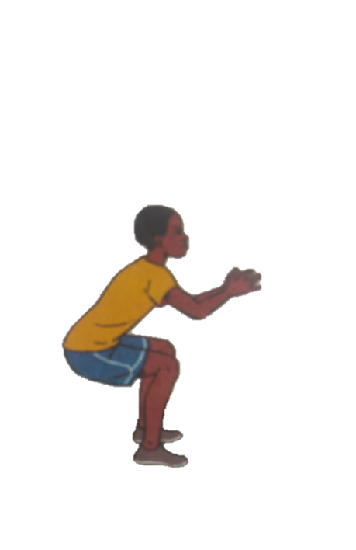Identify two landing techniques in footwork in netball.(2 mks)
3. How many players from each team are allowed to be on the field in a netball game?**.............................................(**1 mk)
4. How long does a netball game last?**..................................**(1 mk)