**COMPETENCE BASED CURRICULUM**

**THE STANDARD MEASURE SERIES 1**

**GRADE 7 TERM 1 OPENER (ENTRY) EXAM 2024**

**JUNIOR SECONDARY SCHOOL**

PRETECHNICAL EDUCATION

**NAME: ___________________________________________________**

**SCHOOL ____________________________________________________**

1. Give the colour of the following metals

a. Iron- **……………………………………………………**

Gold-**………………………………………………………**

Bronze-**……………………………………………………**

Aluminium-**……………………………………………….**

1. Name four types of injuries 3 mks)
2. **………………………………..**
3. **………………………………..**
4. **………………………………..**
5. **…………………………………**
6. Give any four examples of metals.
7. **………………………….**
8. **……………………………**
9. **………………………….**
10. **…………………………..**
11. Metals can be further grouped into four categories. Name 3 of them;
12. **……………………………………**
13. **……………………………………**
14. **……………………………………**
15. Give two examples of ferrous metals.
16. **………………………..**
17. **……………………….**
18. **……………………….**
19. Name one use of the following metal;
20. Copper -**……………………………………………………………………………………..**
21. Iron-**…………………………………………………………………………….**
22. Steel**……………………………………………………………………………..**
23. Lead -**…………………………………………………………………………..**
24. Silvermake -**………………………………………………………………………**
25. Gold **-……………………………………………………………………………………………..**
26. Name any two magnetic metals.
27. **………………………………………………..**
28. **…………………………………………………**
29. State the meaning of the following hazard symbols.

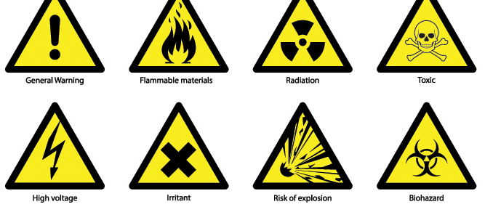

1. Name two examples of synthetic materials.
2. 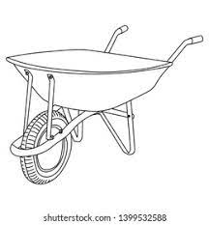**……………………………………………….**
3. **………………………………………………..**
4. What is the use of the following material?

**.**

**.**

1. Name two careers related to safety.
2. **……………………………………….**
3. **………………………………………..**
4. Draw and name three tool used in the construction industry.

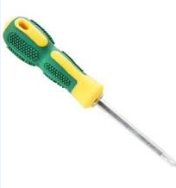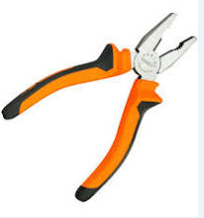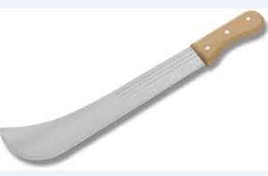

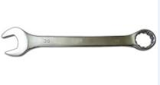

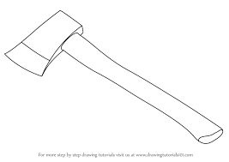



1. Identify four physical properties of materials found in your locality.
2. **……………………………………..…………………………….**
3. **…………………………………………………………………….**
4. **………………………………………………………………………**
5. **………………………………………………………………………**