**COMPETENCE BASED CURRICULUM**

**THE QUALITY ASSURANCE SERIES 1**

**GRADE 7 TERM 1 OPENER (ENTRY) EXAM 2024**

INTEGRATED SCIENCE

**NAME: _______________________________CODE;_____________DATE: _______________**

1. 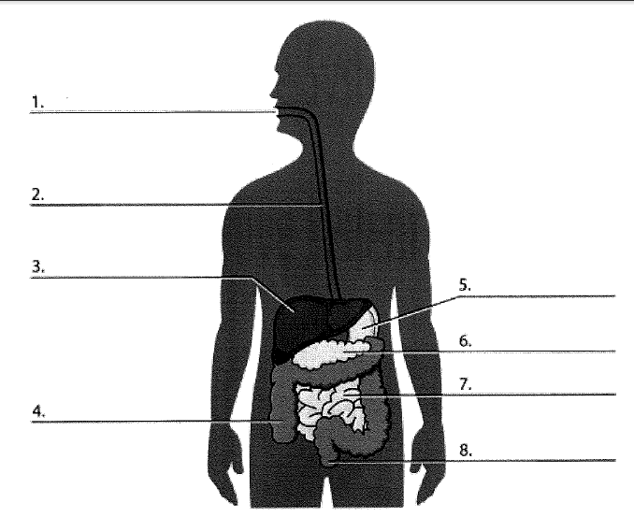Name the following parts of the digestive system.
2. Digestion of food begins in the _________________and ends in the ___________________________.
3. Give two other names of the oesophagus.
4. _____________________________
5. _____________________________
6. Absorption of most of the digested food occurs in the ________________.
7. Name three substances that pollute the air.
8. _________________________________
9. _________________________________
10. _________________________________
11. Name the two sets of teeth in a human being.
12. ______________________________
13. ______________________________
14. What are the three components of integrated science?
15. ______________________b ________________________c ___________________________
16. Fill the table below appropriately.

|  |  |  |  |
| --- | --- | --- | --- |
| Tooth | Number | Roots | Function |
| Incisor |  |  |  |
| Canine |  |  |  |
| Premolar |  |  |  |
| Molar |  |  |  |

1. Name three careers that are related to the knowledge and skills gained in integrated science.
2. ___________________ b___________________ c___________________
3. 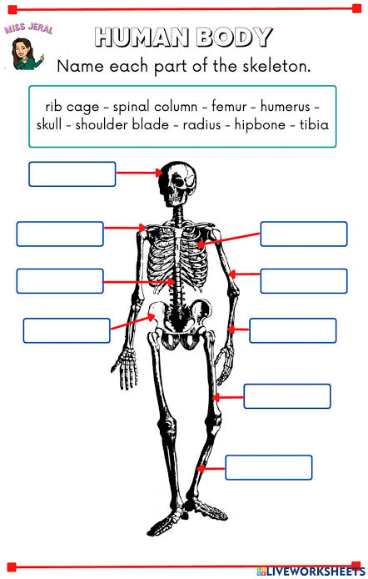Below is an illustration of the skeleton. Name the parts shown by letters.
4. Name three common accidents in the laboratory.
5. _______________________________________________
6. _______________________________________________
7. _______________________________________________
8. ___________________expands most when heated. **(solid, gas, liquid)**
9. Sound travels fastest in ______________________**(solid, gas, liquid)**
10. Name three protective wear for safety in the laboratory.
11. _______________________________
12. _______________________________
13. _______________________________
14. Identify four basic science skills one gains in science practical.
15. _______________________________________________
16. _______________________________________________
17. _______________________________________________
18. _______________________________________________
19. Name the parts of the breathing system shown below.



1. Identify four types of blood groups.
2. _____________________________
3. _____________________________
4. _____________________________
5. _____________________________
6. Blood group___________ is known as the universal donor while blood group_________ is also called the universal recipient.
7. Identify the four components of blood.
8. ______________________________________
9. ______________________________________
10. ______________________________________
11. ______________________________________
12. Name two apparatus used for measuring length.
13. __________________________
14. __________________________
15. Give two differences between luminous and non-luminous flame.

|  |  |
| --- | --- |
| Luminous flame | Non luminous flame |
|  |  |
|  |  |

1. The following table represents basic quantities. Write their SI units and their symbols.

|  |  |  |  |
| --- | --- | --- | --- |
|  | quantity | SI Unit | Symbol |
| 1 | Length |  |  |
| 2 | Mass |  |  |
| 3 | Time |  |  |
| 4 | Electric current |  |  |
| 5 | Temperature |  |  |
| 6 | Amount of substance |  |  |
| 7 | Luminous intensity |  |  |

1. Name two laboratory apparatus used for measuring mass of substances.
2. _____________________________
3. _____________________________
4. Name three heat instruments used in the lab for heating purposes.
5. ______________________________________
6. ______________________________________
7. ______________________________________
8. 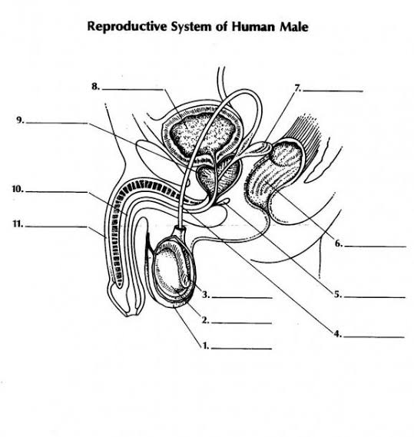Identify the following parts of the human reproductive system.