COMPETENCE BASED CURRICULUM
TISMA 001
GRADE 4 TERM 1 OPENER (ENTRY) EXAM 2024
SOCIAL STUDIES & C.R.E
QUESTIONS
SECTION A: SOCIAL STUDIES (30mks)
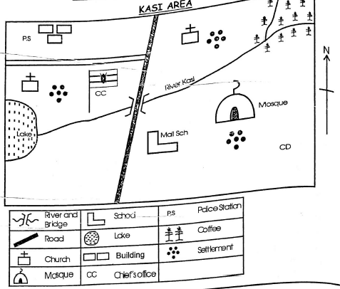
- People of Kasi area get water from a________________________
- The main cash crop in the area is_____________________________
- The main means of transport is Kasi area is______________________
- River Kasi starts from which direction?________________________________
- What is the name of the school in Kasi Area.___________________________
- There are_________________counties in Kenya
- __________________ is an instrument used to show direction of one place from another.
- Densely populated areas have______________________________
- Densely populated areas have______________________________
- Name any 3 physical features (3mks)
- The best time for harvesting is during the___season
- Name three counties that are neighbouring your county.
- Draw and name two artefacts from your community. (4mks)
- List two economic activities carried out in your county (2mks)
- Name two religious leaders in your community (2mks)
- Crops grown mainly for sale are known as______________________
- The raw material used in making shoes is___________________________
RELIGIOUS ACTIVITIES
- Write three good thoughts (3mks
- Name three members of the extended family.
- Write three attributes of God property. (3mks)
  - YLHO
  - GNIVLO
  - TOTAERC
- _____________climbed a sycamore tree. (1mk)
- Which animal spoke to Baalam?(1mk)
- Samson and his parents were going to the vineyards at____________when he killed a lion. (1mk)
- Who interpreted pharaoh's dream?(1mk)
- List the four gospel books. (4mks)
- Where was Abram living when God called him?
- The Birth of Jesus was announced by Angel_____________
- The parents of John the Baptist were _________and_____________ (2mks)
- Blind Bartimaeus was the son of__________________
- A leper is a person suffering from a disease called______________(1mk)
- The widow whose son was raised by Jesus was from the town of______________(1mk)
- How many lepers went back to give thanks to Jesus?(1mk)

