**COMPETENCE BASED CURRICULUM**

**THE QUALITY ASSURANCE SERIES 1**

**GRADE 7 TERM 1 OPENER (ENTRY) EXAM 2024**

VISUAL ARTS

**NAME: _______________________________CODE; _____________DATE: _______________**

1. State two categories of arts.(2 mks)
2. __________________________________
3. __________________________________
4. Identify any four element of art.( 4mks)
5. _____________________________________
6. _____________________________________
7. _____________________________________
8. _____________________________________
9. Identify and label the components of perspective from the image below.(3 mks)

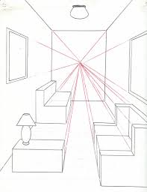

1. State four elements of a presentation.(4 mks)
2. ________________________________
3. ________________________________
4. ________________________________
5. ________________________________
6. Name the three types of perspective viewpoints.(3 mks)
7. _______________________________
8. _______________________________
9. _______________________________
10. 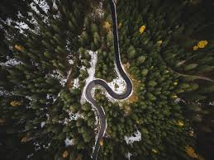The photograph below is of a road through a forest. Which type of view was the photograph taken? _________________________(1mk)
11. Differentiate between analogous and complementary colours. (2 mks)

________________________________________________________________________________

________________________________________________________________________________

________________________________________________________________________________

1. Name two examples of analogous colours. (2 mks)
2. ______________________________________________
3. ______________________________________________
4. Name three properties of colour.(3 mks)
5. ___________________________________
6. ___________________________________
7. ___________________________________
8. 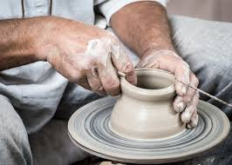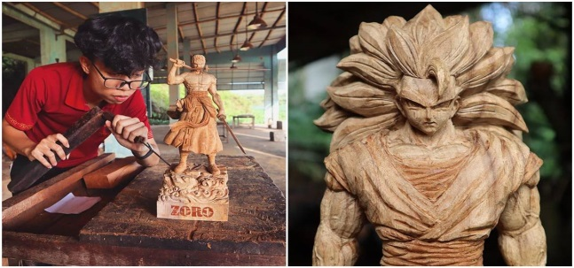Name the type of art activity illustrated below(4 mk)

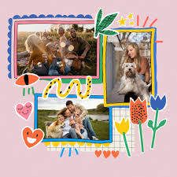

**(Collage, Montage, Pottery, Carving)**

**PRACTICAL**

1. By adding white colour to make another colour lighter is called_______________________________ while adding black colour to make another colour darker is called______________________. (2 mks)
2. Value gradation uses _____________________________technique while intensity scale uses the _____________________ technique.(2 mks)
3. Fill in the following using a colour to make value gradation strip.(5 mks)
4. Fill the following boxes to make colour intensity strip.(5 mks)
5. 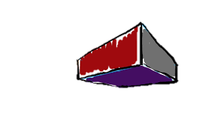Complete the following drawing to show the different components of perspective.( 3 mks)
6. Draw a colour wheel and show analogous and complementary colours.(5 mks)