**COMPETENCE BASED CURRICULUM**

**THE STANDARD MEASURE SERIES 1**

**GRADE 7 TERM 1 OPENER (ENTRY) EXAM 2024**

**JUNIOR SECONDARY SCHOOL**

VISUAL ARTS

**NAME: ___________________________________________________**

**SCHOOL ____________________________________________________**

1. State two categories of arts.(2 mks)
2. **………………………………………….**
3. **………………………………………….**
4. State four elements of a presentation.(4 mks)
5. **…………………………………………**
6. **…………………………………………**
7. **………………………………………….**
8. **………………………………………….**
9. Name three properties of colour.(3 mks)
10. **…………………………………………….**
11. **…………………………………………….**
12. **……………………………………………**
13. Identify any four element of art.( 4mks)
14. **………………………………………………**
15. **……………………………………………….**
16. **………………………………………………..**
17. **………………………………………………..**
18. 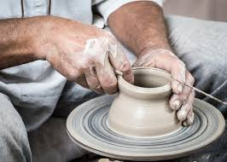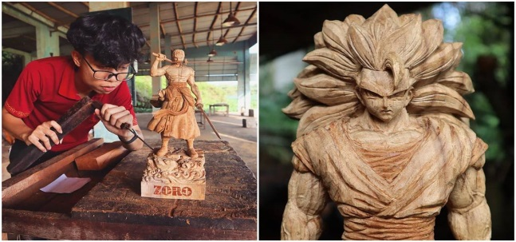Name the type of art activity illustrated below(4 mk)

1. Name the three types of perspective viewpoints.(3 mks)
2. **……………………………………………..**
3. **……………………………………………….**
4. **……………………………………………….**
5. Differentiate between analogous and complementary colours. (2 mks)

**………………………………………………………………………………………………………………………………………………………………………………………………………………………………………………………………………………………………………………………………………………………………………………………………………………………………………….**

1. Name two examples of analogous colours. (2 mks)

|  |
| --- |
| Analogous colours |
|  |
|  |