

**COMPETENCE BASED CURRICULUM**

**THE STANDARD MEASURE SERIES 1**

**GRADE 8 TERM 1 OPENER (ENTRY) EXAM 2024**

 JUNIOR SCHOOL

AGRICULTURE

**SCHOOL: .............................................................................................................**

NAME………………………………………………………………………………

ANSWER ALL QUESTIONS

1. Describe the safe farming practices that prevent soil pollution.
2. *…………………………………………………………………………………………………*
3. *………………………………………………………………………………………………..*
4. *………………………………………………………………………………………………..*
5. Name three minimum tillage practices for water conservation carried out in farming.

*…………………………………………………………………………………………………*

*………………………………………………………………………………………………..*

*………………………………………………………………………………………………..*

1. Explain three minimum tillage practices for water conservation in farming.
   1. *Uprooting weeds-……………………………………………………………………………………………………………………………………………………………………………………………………………..*
   2. *Slashing weeds-*
   3. *Restricted cultivation-…………………………………………………………………………………………………………………………………………………………………………………………………….*
   4. *Mulching-…………………………………………………………………………………………………………………………………………………………………………………………………..*
2. What is the importance of agroforestry trees in conserving the environment?
3. *…………………………………………………………………………………………………*
4. *………………………………………………………………………………………………..*
5. *………………………………………………………………………………………………..*
6. Give four characteristics of agroforestry trees.
7. *…………………………………………………………………………………………………*
8. *………………………………………………………………………………………………..*
9. *………………………………………………………………………………………………..*
10. Give five factors to consider when choosing agroforestry trees.
11. *…………………………………………………………………………………………………*
12. *………………………………………………………………………………………………..*
13. *………………………………………………………………………………………………..………*
14. *………………………………………………………………………………………………..*
15. *………………………………………………………………………………………………..*
16. Give three types of planting materials used for establishing agroforestry.
17. *…………………………………………………………………………………………*
18. *…………………………………………………………………………………………*
19. *…………………………………………………………………………………………*
20. Name the practices carried out when caring for established agroforestry trees.
21. *………………………………………………………………………………*
22. *………………………………………………………………………………*
23. *………………………………………………………………………………*
24. Give four types of sites that can be used for planting crops.
25. *………………………………………….*
26. *…………………………………………..*
27. *…………………………………………*
28. Give two categories of planting materials.
    1. *………………………………………….*
    2. *………………………………………..*
29. Name five types of vegetative planting materials.
    1. *…………………………………………………….*
    2. *……………………………………………………*
    3. *…………………………………………………..*
    4. *……………………………………………………*
    5. *……………………………………………………*
30. Name five examples of common weeds.
31. *……………………………………*
32. *……………………………………*
33. *……………………………………*
34. *…………………………………..*
35. *…………………………………..*
36. Give three physical methods of controlling weeds B.
37. *………………………………………….*
38. *…………………………………………*
39. *………………………………………..*
40. Name three tuber crops that require earthing up.
41. *……………………………..*
42. *……………………………..*
43. *………………………………*
44. a.) Name two crops that require hardening.
    1. *………………………….*
    2. *…………………………..*
45. Identify the following weed.

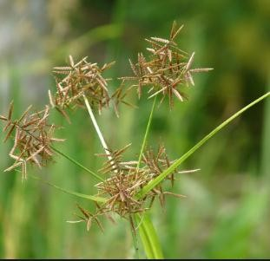

* …………………………*.*

1. What is the management practice that:

a.) Reduces overcrowding in a growing crop

* *…………………………………………………………………*

b.) Replaces crops that refuse to germinate

* + *………………………………………………………………….*

1. What is the importance of thinning?
   * *…………………………………………………………………………………………….*
2. Identify the materials required for processing honey using the crushing and straining method.
3. *………………………………………….*
4. *………………………………………….*
5. *………………………………………….*
6. How many eggs are packed in a tray?

* *……………………………………………………..*

1. Why is it important to add value to animal products?
2. *……………………………………………………………………………………*
3. *……………………………………………………………………………………*
4. *……………………………………………………………………………………*
5. Identify the following agricultural technologies

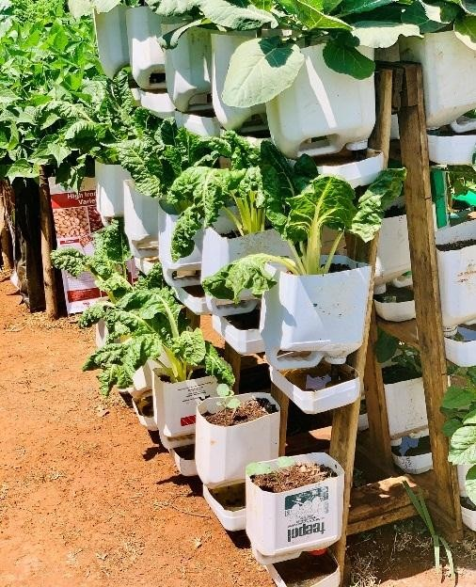

* ………………………………………………..

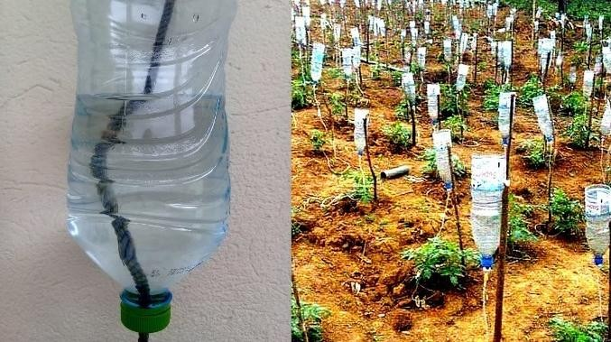

* *…………………………………………………………*

1. State the factors that help to increase food security in the country.
   1. ………………………………………………………………………….
   2. ………………………………………………………………………….
   3. ………………………………………………………………………….
2. State the Importance of off season cropping techniques for food security
3. *…………………………………………………………………………………………………….*
4. *……………………………………………………………………………………………………..*
5. Name two qualities of the Materials used in the Construction of the Framed Suspended Gardens
6. *………………………………………………………….*
7. *…………………………………………………………..*