

**COMPETENCE BASED CURRICULUM**

**THE STANDARD MEASURE SERIES 1**

**GRADE 8 TERM 1 OPENER (ENTRY) EXAM 2024**

 JUNIOR SCHOOL

**BUSINESS STUDIES**

**SCHOOL: ......................... ………………………………....................................................................................**

**NAME……………………………………………………………………………..………………………………**

**ANSWER ALL QUESTIONS**

1. State the Importance of Studying Business studies in schools
2. *………………………………………………………………………………………………….*
3. *…………………………………………………………………………………………………..*
4. *…………………………………………………………………………………………………..*

#### State the meaning of the Components of Business

|  |  |  |
| --- | --- | --- |
|  | Component of Business | Meaning. |
| A | Economics |  |
| B | Commerce |  |
| C | Accounting |  |
| D | Entrepreneurship |  |
| E | Financial literacy |  |

#### What are the uses of Money?

1. ………………………………………………………………………………
2. ………………………………………………………………………………
3. ………………………………………………………………………………

#### What are the security features of Kenyan denominations below?

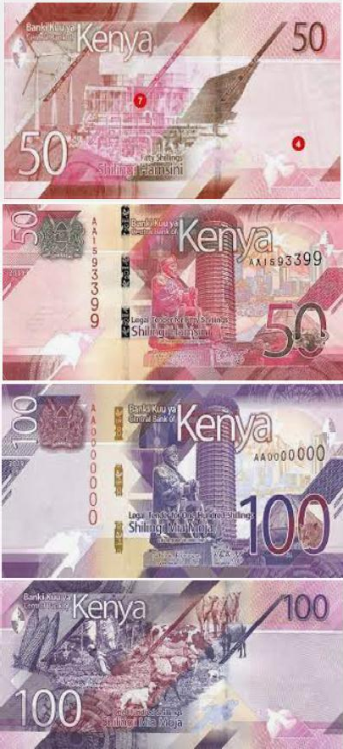

KEY SECURITY FEATURES;

1. ………………………………………………………
2. …………………………………………………….
3. …………………………………………………….
4. …………………………………………………….

##### Which devices can be used when setting up personal goals easily.

1. *……………………………………………………*
2. *…………………………………………………..*
3. *……………………………………………………*

#### State three differences between talent and ability.

|  |  |
| --- | --- |
| TALENT | ABILITY |
|  |  |
|  |  |
|  |  |

#### What are the Differences between Needs and Wants?

|  |  |
| --- | --- |
| NEEDS | WANTS |
|  |  |
|  |  |

1. Define the following terms
   1. Scarcity

……………………………………………………………………………………………………………………………………………………………………………………………………………………………………………..

#### Opportunity cost.

………………………………………………………………………………………………………………………………………………………………………………………………………...

#### Choice.

………………………………………………………………………………………………………………………………………………………………………………………………………..

#### Scale of preference.

………………………………………………………………………………………………………………………………………………………………………………………………………………………………………..

#### State and explain three Categories of Business Activities.

………………………………………………………………………………………………………………………………………………………………………………………………………………………………………..

………………………………………………………………………………………………………………………………………………………………………………………………………………………………………..

………………………………………………………………………………………………………………………………………………………………………………………………………………………………………..

1. Outline four Types of large-scale retail outlets
2. *…………………………………………………..*
3. *…………………………………………………..*
4. *………………………………………………….*
5. *………………………………………………….*

##### Distinguish the following goods

##### Free goods and economic goods.

Free goods ………………………………………………………………………………….

Economic goods ……………………………………………………………………………

##### Producer goods and consumer goods.

Producer goods …………………………………………………………………………….

Consumer …………………………………………………………………………………..

##### Perishable goods and durable goods.

Perishable goods ……………………………………………………………………………..

Durable goods …………………………………………………………………….....

##### Public goods and private goods.

Public goods …………………………………………………………………………….

Private goods …………………………………………………………………………..

1. Distinguish between goods and services.

|  |  |
| --- | --- |
| GOODS | SERVICES |
|  |  |
|  |  |
|  |  |
|  |  |

1. What is
   1. Resources ……………………………………………………………………………………………………………………………………………………………………………………
   2. Economic resources …………………………………………………………………………………………………………………………………………………………………………………………………….
2. There are four factors of production namely:
   1. …………………………………
   2. …………………………………
   3. …………………………………
   4. …………………………………
3. State the Legal requirements for Starting and Operating a simple business in Kenya
4. ……………………………………………………………………………..
5. …………………………………………………………………………….
6. ……………………………………………………………………………..
7. Identify the following business documents

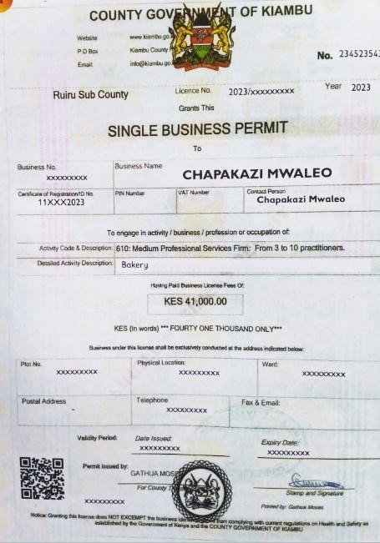

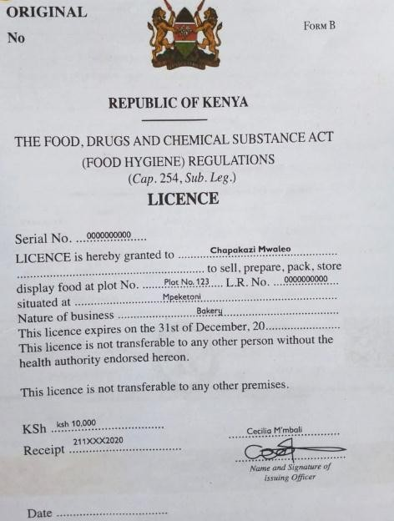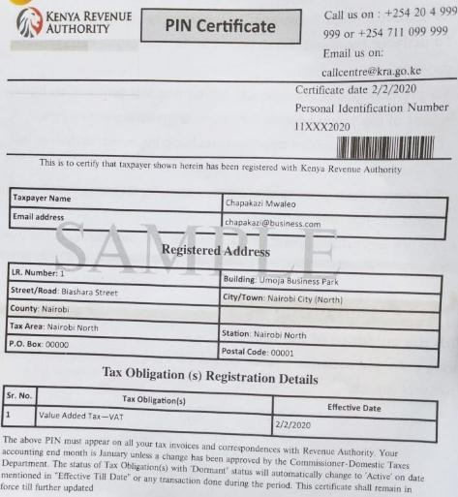

#### State the Importance of paying taxes in Kenya.

1. ……………………………………………………………………………………….
2. ………………………………………………………………………………………..
3. Name the Financial documents used in buying and selling in business.
   1. ……………………………………..
   2. ……………………………………..
   3. ……………………………………..
4. Name the Methods of payment:
5. *………………………………………………*
6. *………………………………………………*
7. *………………………………………………*
8. State the Stages followed during a credit transaction
9. ………………………………………
10. ……………………………………….
11. ……………………………………….
12. ……………………………………….
13. ………………………………………